# Redis入门基础

## 第1节 Redis笔记概述

### 1.1什么是Redis

·高性能Key-Value服务器，特定场景10万OPS

·多种数据结构，字符串、哈希、链表、有序集合，衍生的数据结构，HyperLogLog、Geo、Pub/Sub

·丰富的功能，pipeline、慢查询、发布订阅、位图、Geo

·高可用分布式支持，Redis Cluster、tmp procosse、codis

### 1.2笔记结构

·Redis初识

·API的理解和使用（单线程、批量处理）

·Redis客户端的使用（Java、Python、Go）

·瑞士军刀Redis

·Redis持久化的取舍和选择

·Redis复制的原理和优化

·Redis Sentinel（减少高可用故障）

·Redis Cluster（容量、性能）

## 第2节Redis初识

### 2.1Redis是什么

·开源

·基于键值对的存储服务

·多种数据结构

·高性能、功能丰富

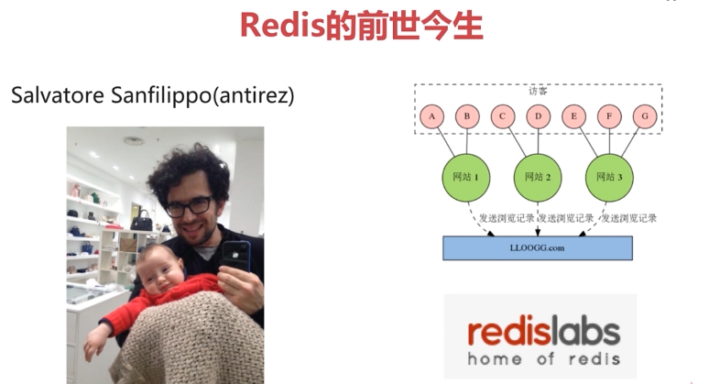



·Key-value

Java Map ==> String value = map.get(“key”)

Python Dict ==> dictionary[“key”] = value

支持Ruby、C++、NodeJS

·数据结构

·String/Blobs/Bitmaps

·HashTable（objects!）

·Linked Lists

·Sets

·Sorted Sets

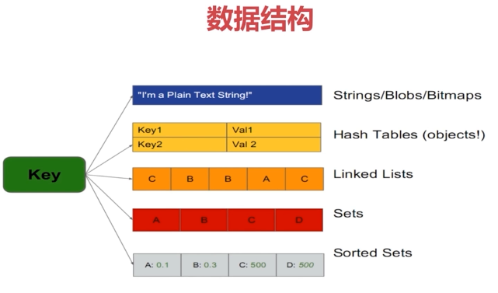

·哪些公司在使用Redis

·GitHub

·Twitter

·Stack Overflow

·Alibaba

·百度

·微博

·美团

·搜狐（cache cloud管理Redis平台）

...

### 2.2Redis的特性回顾

·速度快

·持久化

·多种数据结构

·支持多种编辑语言

·功能丰富

·简单

·主从复制

·高可用、分布式

1）速度快

·10万OPS

·数据 ==> 内存

·语言 ==> C语言（50000行）

·线程模型 ==> 单线程

·缓存层次

·Register 寄存器

·L1 缓存

·L2 缓存

·Main Memory 主内存

·Local Disk 本地磁盘



|  |  |  |  |
| --- | --- | --- | --- |
| **类型** | **每秒读写次数** | **随机读写延迟** | **访问带宽** |
| 内存 | 千万级 | 80ns | 5GB |
| SSD盘 | 35000 | 0.1-0.2ms | 100~300MB |
| 机械盘 | 100左右 | 10ms | 100MB左右 |

1. 持久化

Redis所有数据保持在内存中，对数据的更新将异步地保存到磁盘是哪个

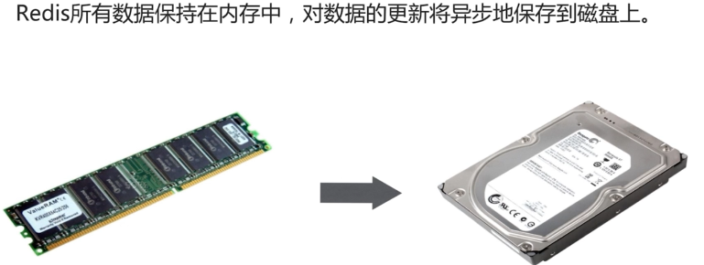

3）多种数据结构

·String/Blobs/Bitmaps

·HashTable（objects!）

·Linked Lists

·Sets

·Sorted Sets

·BitMaps：位图（字符串）

·HyperLogLog：超小内存唯一值技术12k（上亿用户在线数）（字符串）

·GEO：地理信息定位（集合）

1. 多种客户端语言

·java

·PHP

·Python

·Ruby

·Lua

·NodeJs

......

5）功能丰富

·发布订阅

·事务

·Lua脚本

·pipeline

6）简单

·C语言，23000行代码

·不需要依赖外部库

·单线程模型

7）复制

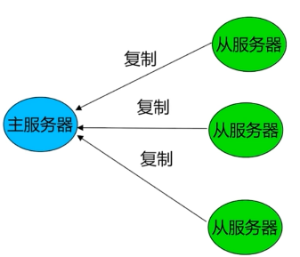

8）高可用、分布式

Redis-SentinelV2.8支持高可用；

Redis-ClusterV3.0支持分布式；

### 2.3Redis典型场景

·缓存系统

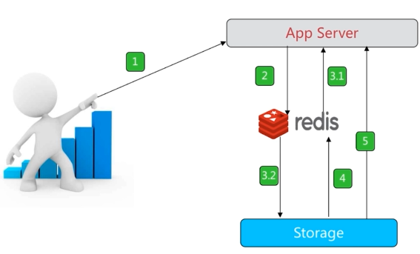

·计数器



·消息队列系统

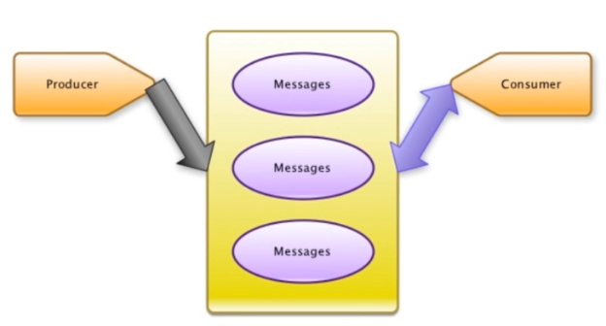

·排行榜

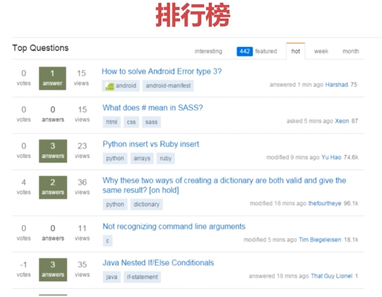

·社交网站



·实时系统



### 2.4Redis单击安装

$ wget [http://download.redis.io/releases/redis-3.0.7.tar.gz](http://download.redis.io/releases/redis-5.0.3.tar.gz)

$ tar xvf redis-3.0.7.tar.gz

$ ln -s redis-3.0.7 redis

$ cd redis

$ make MALLOC=libc

$ make install

### 2.5Redis可执行文件说明

·redis-server --> Redis服务器

·redis-cli --> Redis命令行客户端

·redis-benchmark --> Redis性能测试工具

·redis-check-aof --> AOF文件修复工具

·redis-check-dump --> RDB文件检测工具

·redis-sentinel --> Sentinel服务器（V2.8以后）

### 2.6三种启动方法

·最简启动：redis-server

·配置文件启动：redis-server redis-6379.conf

·动态参数启动：redis-server --port 6380

**验证启动**

**$ ps -ef | grep redis**

**$ netstat -antpl | grep redis**

**$ redis-cli -h ${ip} -p ${port} ping**

注意：

·生产环境选择配置启动

·单机多实例配置文件可以用端口区分开

·Standallon单机启动配置

|  |
| --- |
| 1004 cd /soft/redis  1005 mkdir conf  1006 cp redis.conf conf/  1007 cd conf/  1010 cat redis.conf | grep -v "#" | grep -v "^$" > redis-6381.conf  1011 vi redis-6381.conf  daemonize yes  port 6381  dir "/soft/redis/data"  logfile "6381.log"  1012 cd ..  1013 mkdir data  1014 redis-server conf/redis-6381.conf  1015 ps -ef | grep redis-server | grep 6381 |

·Redis客户端连接

|  |
| --- |
| $ redis-cli -h 192.168.0.200 -p 6381  192.168.0.200:6381> ping  PONG  192.168.0.200:6381> set hello world  OK  192.168.0.200:6381>get hello  “world” |

·Redis客户端返回值

|  |
| --- |
| # 状态回复  192.168.0.200:6381> ping  PONG  # 错误回复  192.168.0.200:6381>hget hello field  (error) WRONGTYPE Operation against  # 整数回复  192.168.0.200:6381>incr counter  (integer) 1  # 字符串回复  192.168.0.200:6381> get hello  “world”  # 多行字符串回复  192.168.0.200:6381> mget hello foo   1. “world” 2. “bar” |

·Redis常用配置

|  |
| --- |
| # 是否守护进程no|yes  daemonize yes  # Redis对外端口  port 6379  # Redis系统日志  logfile “/opt/redis/logs”  # Redis工作目录  dir “/opt/redis” |

·Redis默认端口6379



6379在老式键盘手机对应MERZ取自意大利歌女Alessa Merz的名字

## 第3节API的理解和使用

### 3.1概诉

·Redis API的使用和理解

·通用命令

·字符串类型

·哈希类型

·列表类型

·集合类型

·有序集合类型

### 3.2 通用命令

·通用命令

·keys

·dbsize

·exists key

·del key [key...]

·expire key seconds

·type key

·数据结构和内部编码

·单线程架构

API keys *

|  |
| --- |
| # 遍历所有key  192.168.0.200:6381> set hello world  OK  192.168.0.200:6381> set php good  OK  192.168.0.200:6381> set java best  OK  192.168.0.200:6381> keys *  1)”java”  2)”php”  3)”java”  192.168.0.200:6381> dbsize  (integer) 3 |

API keys [pattern]

|  |
| --- |
| # 按正则匹配所有的key  192.168.0.200:6381> mset hello world hehe haha php good phe his  OK  192.168.0.200:6381> keys he*  1)”hehe”  2)”hello”  192.168.0.200:6381> keys he[h-l]*  1)”hehe”  2)”hello”  192.168.0.200:6381> keys ph?  1)”phe”  2)”php” |

注意：

·Keys命令一般不在生产环境使用，单线程扫描，可能会导致生产环境阻塞；

·keys *怎么用：热备从节点；scan；

API dbsize

|  |
| --- |
| # 计算key的总数  192.168.0.200:6381>mset k1 v1 k2 v2 k3 v3 k4 v4  OK  192.168.0.200:6381>dbsize  (integer) 4  192.168.0.200:6381>sadd myset a b c d e  (integer) 5  192.168.0.200:6381>dbsize  (integer) 5 |

API exists

|  |
| --- |
| # exists key 检查key是否存在：0|1  192.168.0.200:6381>set a b  OK  192.168.0.200:6381>exists a  (integer) 1  192.168.0.200:6381>del a  (integer) 1  192.168.0.200:6381>exists a  (integer) 0 |

API del

|  |
| --- |
| # 删除指定的key  192.168.0.200:6381>set a b  OK  192.168.0.200:6381>get a  “b”  192.168.0.200:6381>del a  (integer) 1  192.168.0.200:6381>get a  (nil) |

API expire、ttl、persist

|  |
| --- |
| # key在seconds秒后过期  expire key seconds  # 查看key的剩余过期时间  ttl key  # 去掉key的过期时间，永久有效  persis key  192.168.0.200:6381>set hello world  OK  192.168.0.200:6381>expire hello 20  (integer) 1  192.168.0.200:6381>ttl hello  16  192.168.0.200:6381> get hello  “world”  192.168.0.200:6381>ttl hello  (integer) -2 (-2表示key以及不存在了)  192.168.0.200:6381> get hello  (nil)  192.168.0.200:6381>set hello world  OK  192.168.0.200:6381>expire hello 20  (integer) 1  192.168.0.200:6381>ttl hello  16  192.168.0.200:6381>persist hello  (integer) -1（-1代表key存在，并没有过期时间） |

API type

|  |
| --- |
| # 返回key的类型string|hash|list|set|zset|none  192.168.0.200:6381>set a b  OK  192.168.0.200:6381>type a  string  192.168.0.200:6381>sadd myset 1 2 3  (integer) 3  192.168.0.200:6381>type myset  set |

·时间复杂度

|  |  |
| --- | --- |
| **命令** | **时间复杂度** |
| keys | O(n) |
| dbsize | O(1) |
| del | O(1) |
| del | O(1) |
| exists | O(1) |
| expire | O(1) |
| type | O(1) |

### 3.3数据结构和内部编码

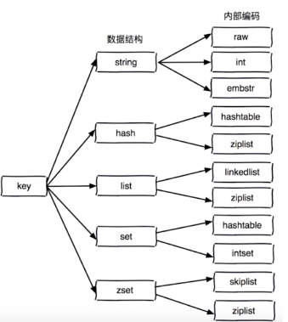

·redsObject

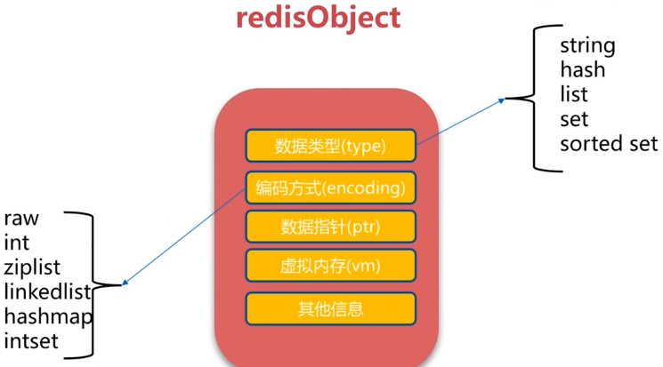

·单线程

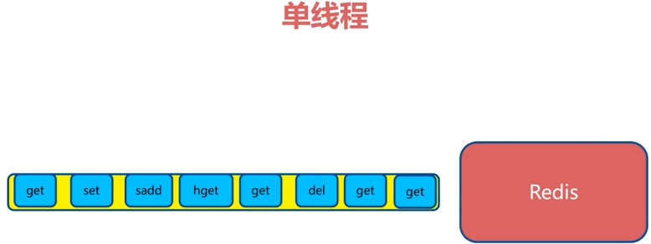

·纯内存

·非阻塞IO

·避免线程切换和竞态消耗

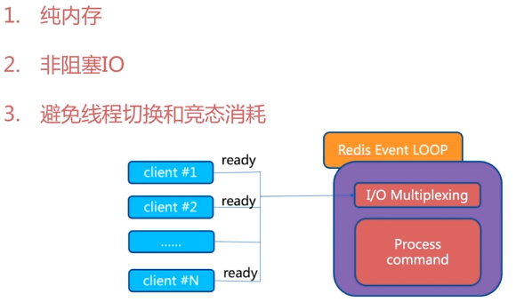

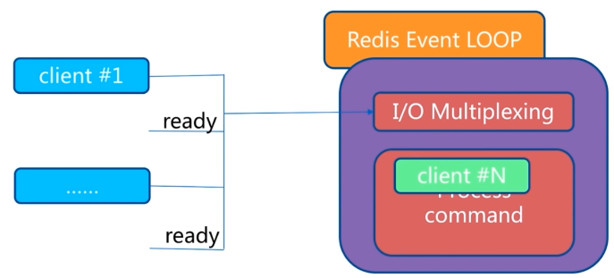

·单线程

·一次只运行一条命令

·拒绝长（慢）命令：keys|flushall|flushdb|slow lua script|mutil/exec|operate|big value（Collections）

·其实不是单线程

·fsync file desctiptor

·close file descriptor

### 3.4字符串

·结构和命令

·快速实战

·内部编码

·查漏补缺

·字符串键值结构

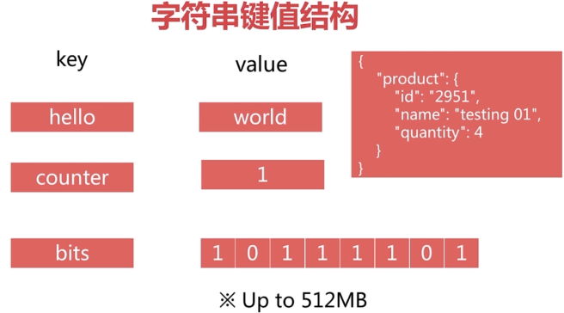

·场景

·缓存

·计数器

·分布式锁

·...

API get、set、del

|  |
| --- |
| #获取key对应的value  get key  # 设置key-value  set key value  # 删除key-value  del key  redis> set hello “world”  OK  redis>get hello’  “world”  redis>del hello  1  redis>get hello  nil |

API incr、decr、incrby、decrby

|  |
| --- |
| # key自增1，如果key不存在，自增后get(key)=1  incr key  # key自减1，如果key不存在，自减后get(key)=-1  decr key  # key自增k，如果key不存在，自增后get(key)=k  incrby key k  # key自减k，如果key不存在，自减后get(key)=-k  decrby key k  redis>get counter  nil  redis>incr counter  (integer) 1  redis>get counter  “1”  redis>incrby counter 99  (integer) 100  redis>decr counter  (integer) 99  redis>decrby counter 99  (integer) 0 |

·使用场景：

·记录网站每个用户个人主页的访问量：incr userid:pageview（单线程：无竞争）

·缓存视频的基本信息（数据源在MySQL中）伪代码

|  |
| --- |
| public VideoInfo get(long id) {  String redisKey = redisPrefix + id;  VideoInfo videoInfo = redis.get(redisKey);  if( videoInfo == null) {  videoInfo = mysql.get(id);  if( videoInfo != null ) {  // 序列化  redis.set(redisKey, serialize(videoInfo);  }  }  return videoInfo;  } |

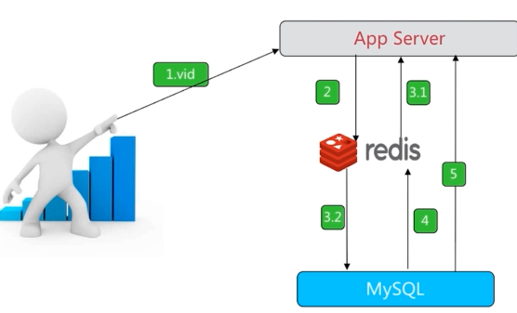

·使用场景

·分布式id生成器：incr id（原子操作）

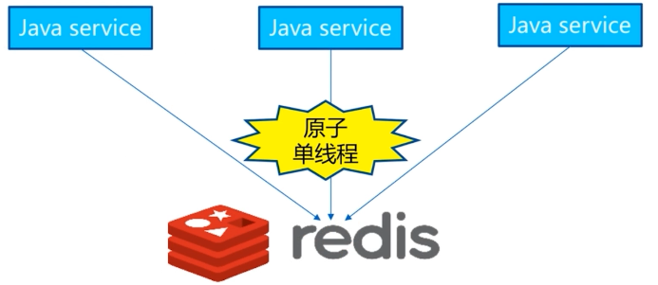

API set setnx setxx

|  |
| --- |
| # 不管key是否存在，都设置O(1)  set key value  # key不存在，才设置O(1)  setnx key value  # key存在，才设置O(1)  set key value xx  # setnx 如果不存在，则add  # set key newValue xx 如果存在，则update  redis>exists php  (integer) 0  redis>set php good  OK  redis>setnx php bad  (integer) 0  redis>set php best xx  OK  redis>get php  “best”  redis>exists java  (integer) 0  redis>setnx java best  (integer) 1  redis>get java  “best”  redis>set java easy xx  OK  redis>get java  “easy”  redis>set lua hehe xx  (integer) 0  redis>get lua  (nil) |

API mget、mset

|  |
| --- |
| # 批量获取key，原子操作O(n)  mget key1 key2 key3 ...  # 批量设置key-value  mset k1 v1 k2 v2 k3 v3 ...  redis> mset hello workd java best php good  OK  redis>mget hello java php   1. ”world” 2. “best” 3. “good” |

·n次get = n次网络时间 + n次命令时间

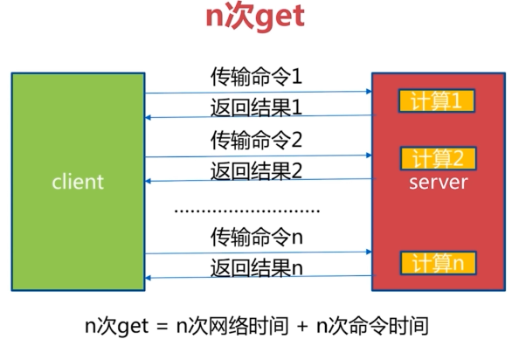

·1次mget = 1次网络时间 + n次命令时间

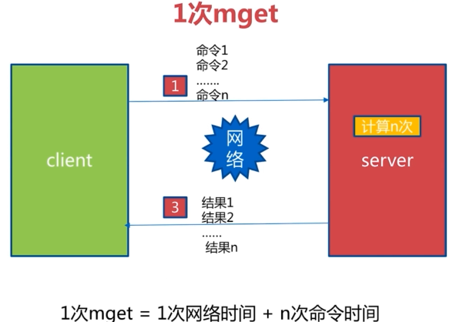

·API getset 、append、strlen

|  |
| --- |
| # set key newvalue 并返回旧的value O(1)  getset key newvalue  # 将value追加到旧的value O(1)  append key value  # 返回字符串的长度（注意中文） O(1)  strlen key |
| redis>set hello world  OK  redis>getset hello php  “world”  redis>append hello “,java”  (integer) 8  redis>get hello  “hello,java  redis>strlen hello  (integer) 8  redis>set hello “足球”  OK  redis>strlen hello  (integer) 4 |

·API incrbyfloat、getrange、setrange

|  |
| --- |
| # 增加key对应的值3.5  incrbyfloat key 3.5  # 获取字符串指定下标所有的值  getrange key start end  # 设置指定下标所有对应的值  setrange key index value  redis>incr counter  (integer) 1  redis>incrbyfloat counter 1.1  “2.1”  redis>get counter  “2.1”  redis>set hello javabest  OK  redis>getrange hello 0 2  “jav”  redis>setrange hello 4 p  (integer) 8  redis>get hello  javapest |

·字符串总结

|  |  |  |
| --- | --- | --- |
| **命令** | **含义** | **复杂度** |
| set key value | 设置key-value | O(1) |
| get key | 获取key-value | O(1) |
| del key | 删除key-value | O(1) |
| setnx | 根据key是否存在设置key-value | O(1) |
| incr decr | 计数 | O(1) |
| mget mset | 批量操作key-value | O(1) |

### 3.5哈希

·特点

·重要API

·hash vs string

·查漏补缺

·哈希键值结构

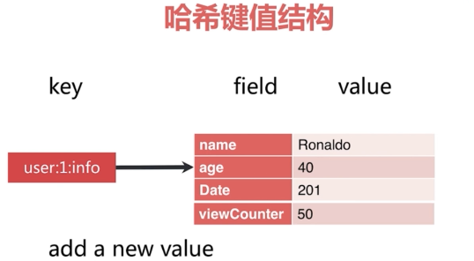

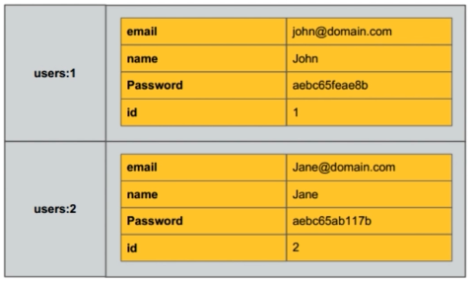

·特点

·MapMap？

·Small redis

·field不能相同，value可以相同

·API hget、hset、hdel

|  |
| --- |
| # 获取hash key对应的field的值  hget key field  # 设置hash key对应field的value  hset key field value  # 删除hash key 对应field的value |
| redis>hset user:1info age 23  (integer) 1  redis>hget user:1info age  “23”  redis>hset user:1:info name ronaldo  (integer) 1  redis>hgetall user:1:info   1. ”age” 2. “23” 3. “name” 4. “ronaldo”   redis>hdel user:1:info age  (integer) 1  redis>hgetall user:1:info  1)”name”  2)”ronaldo” |

·API hexists、hlen

|  |
| --- |
| # 判断hash key是否有field O(1)  hexist key field  # 获取hash key field的数量 O(1)  hlen key |
| redis>hgetall user:1:info   1. ”name” 2. “ronaldo” 3. “age” 4. “23”   redis>hexist user:1:info name  (integer) 1  redis>hlen user:1:info  (integer) 2 |

·API hmget、hmset

|  |
| --- |
| # 批量获取hash key的一批field的值  hmget key field1 field2 .... fieldN  # 批量设置hash key的一批field value  hmset key f1 v1 f2 v2 f3 v3 ... fN vN |
| redis>hmset user:2:info age 30 name kaka page 50  OK  redis>hlen user:2:info  (integer) 3  redis>hmget user:2:info age name   1. ”30” 2. “kaka” |

·使用场景

·记录网站每个用户个人主页的访问量

hincrby user:1:info pageview count

·缓存视频的基本信息（数据源在MySQL中）伪代码

|  |
| --- |
| public VideoInfo get(long id) {  String redisKey = redisPrefix + id;  Map<String, String> hashMap = redis.hgetAll(redisKey);  VideoInfo videoInfo = transferMapToVideo(hashMap );  if( videoInfo == null) {  videoInfo = mysql.get(id);  if( videoInfo != null ) {  // 序列化  redis.hmset(redisKey, transferVideoToMap(videoInfo);  }  }  return videoInfo ;  } |

·API hgetall、hvals、hkeys

|  |
| --- |
| # 返回hash key对应所有的field和value O(n)  hgetall key  # 返回hash key对应所有field的value O(n)  hvals key  # 返回hashkey多有对应的field O(n) |
| redis>hgetall user:2:info   1. ”age” 2. “30” 3. “name” 4. “kaka” 5. “page” 6. “50”   redis>hvals user:2:info  1)”30”  2)”kaka”  3)”50”  redis>hkeys user:2:info  1)”age”  2)”name”  3)”page” |

·相似的API

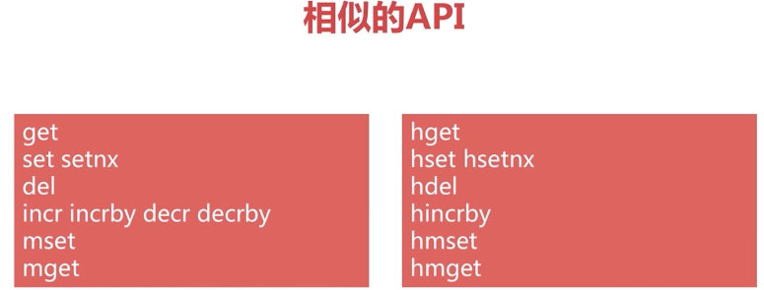

注意：

·小心使用hgetall，牢记单线程

·哈希可以理解small redis

·如何更新用户属性

·string实现，整个对象序列化set更新

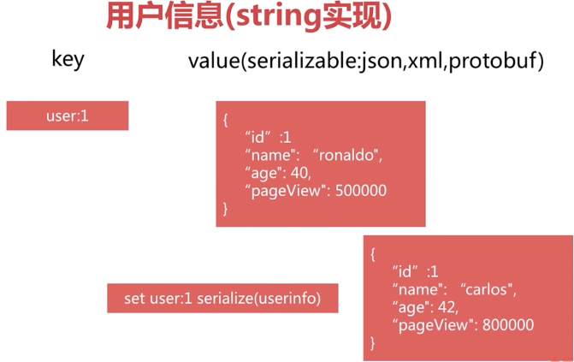

·string实现V2对象差分多个key，set更新

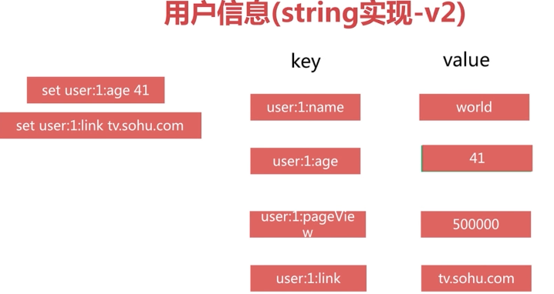

·hash实现

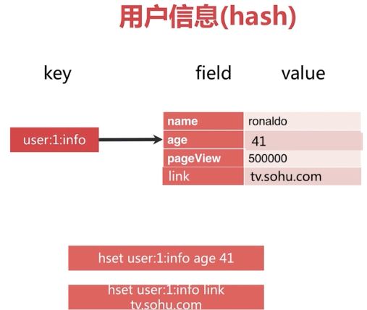

·3种方案比较

|  |  |  |
| --- | --- | --- |
| **命令** | **优点** | **缺点** |
| string V1 | 编程简单；  可能节约内存 | 1.序列化开销；  2.设置属性要操作整属性 |
| string V2 | 直观  更新部分 | 1.内存占用较大；  2.key较为分散 |
| hash | 直观；  节省空间；  可以更新部分 | 1.编程稍微复杂；  2.ttl不好控制 |

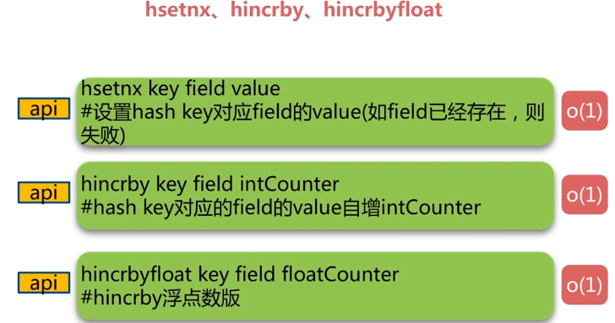

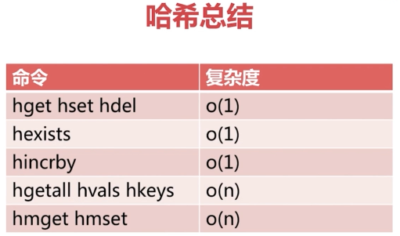

### 3.6列表

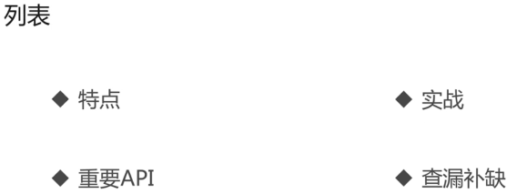

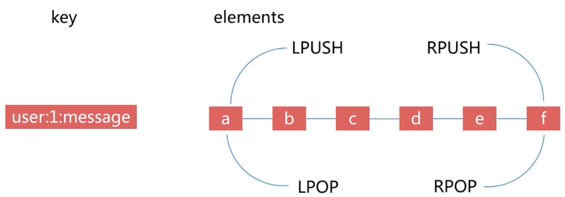

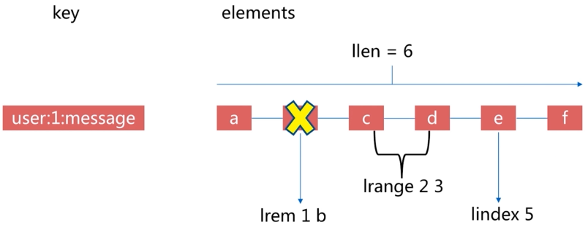

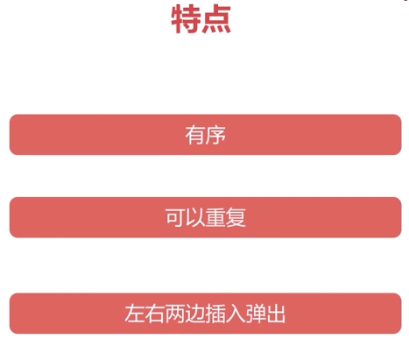

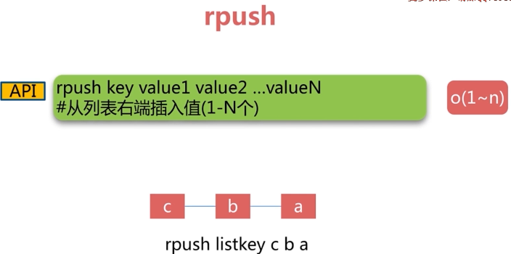

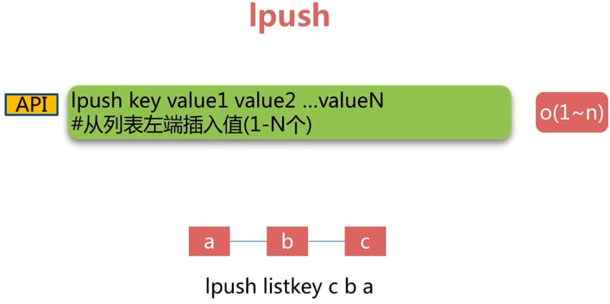

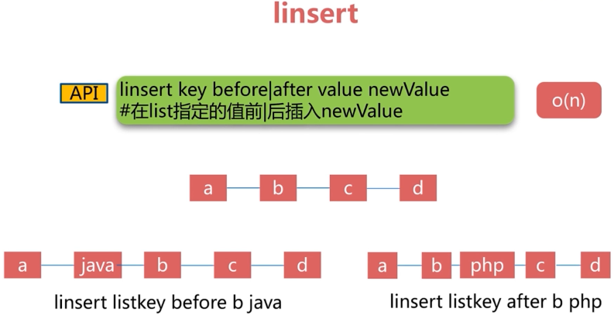

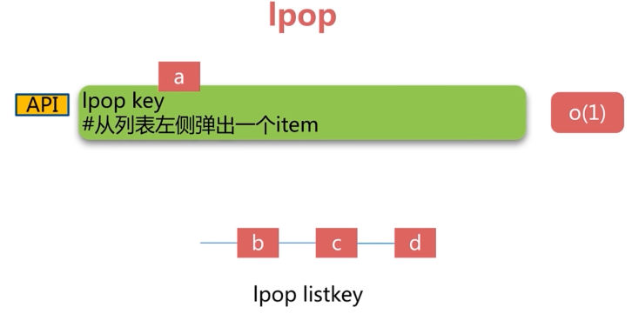

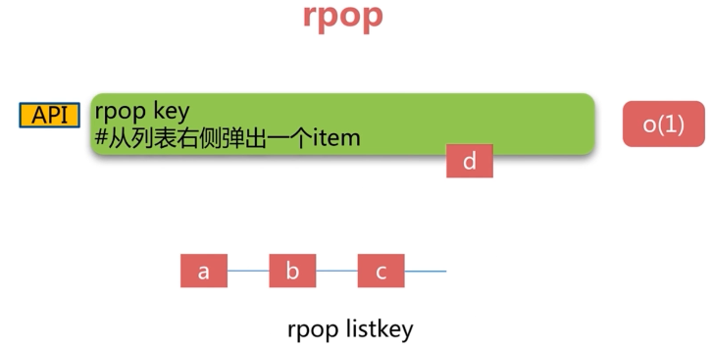

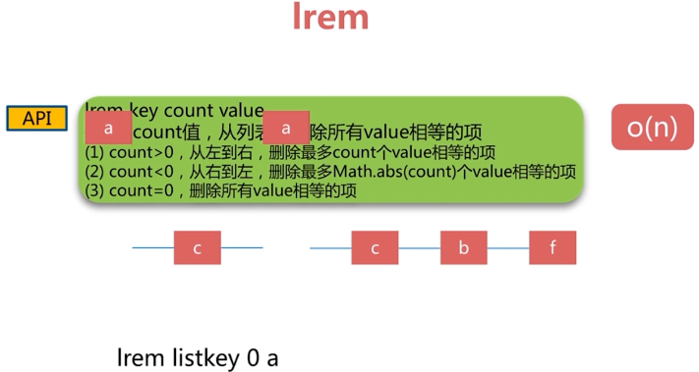

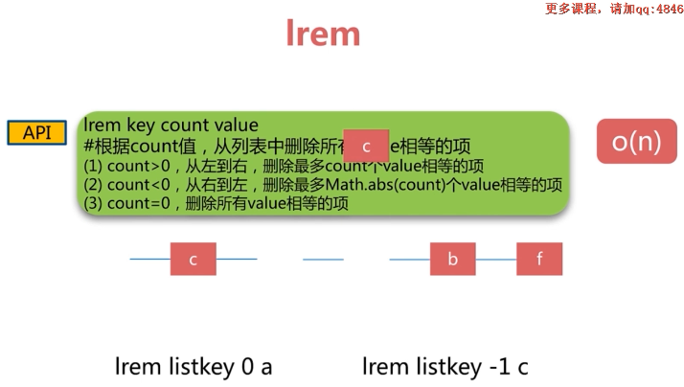

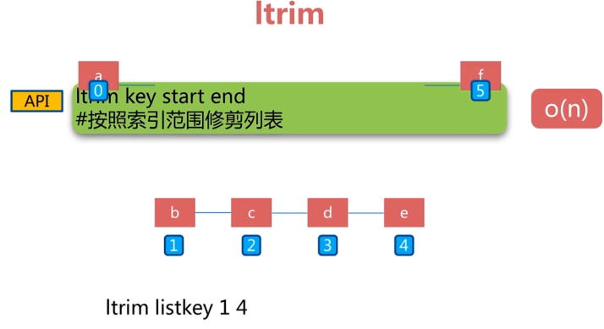

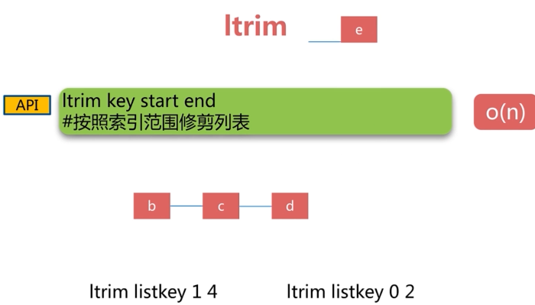

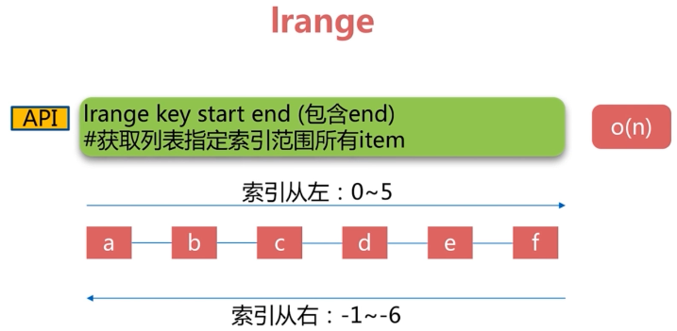

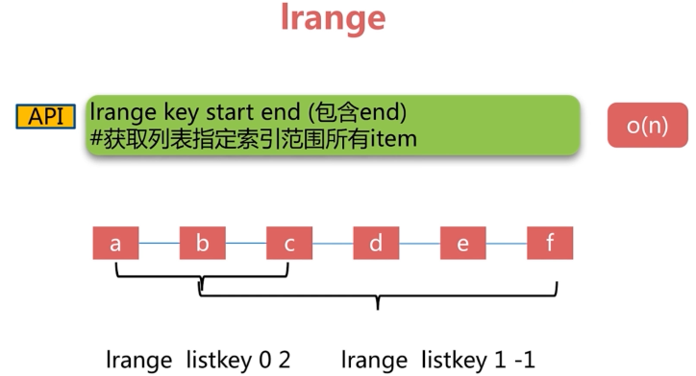

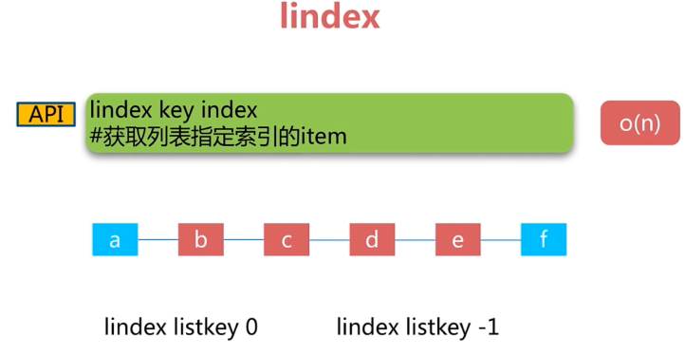

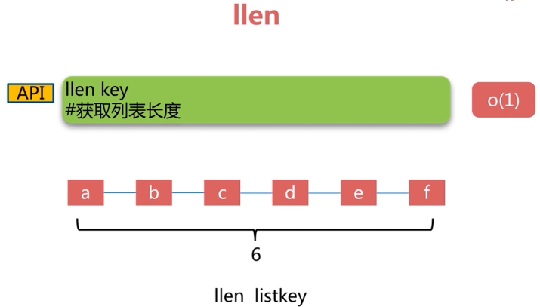

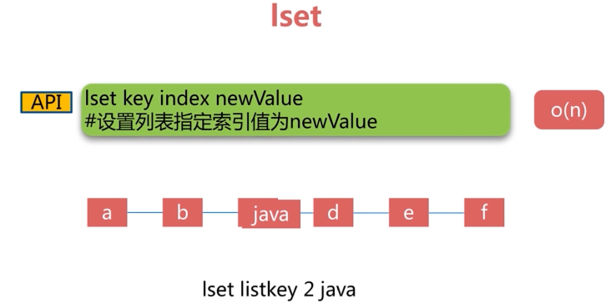

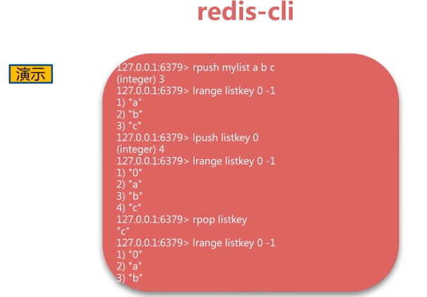



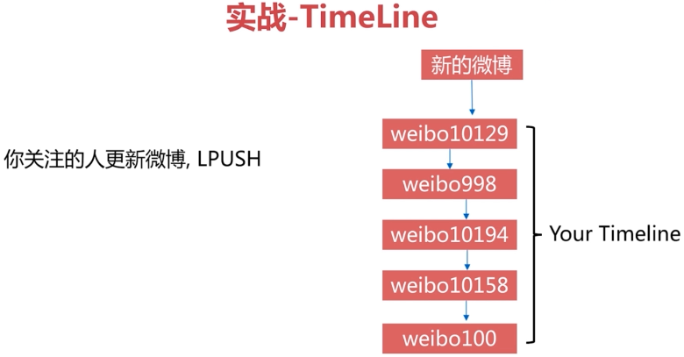

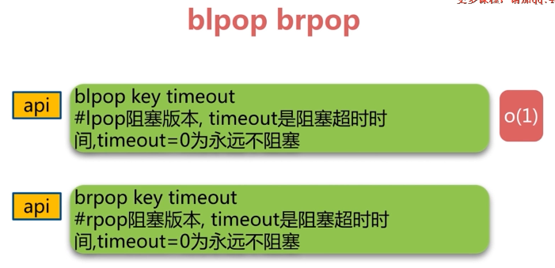

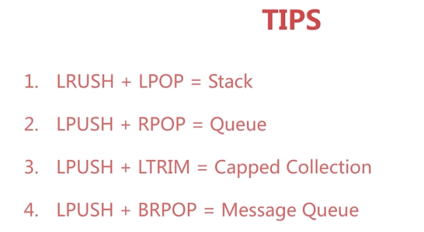

### 3.7集合set

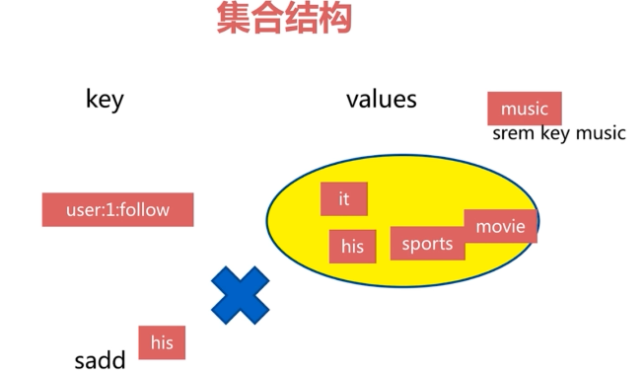

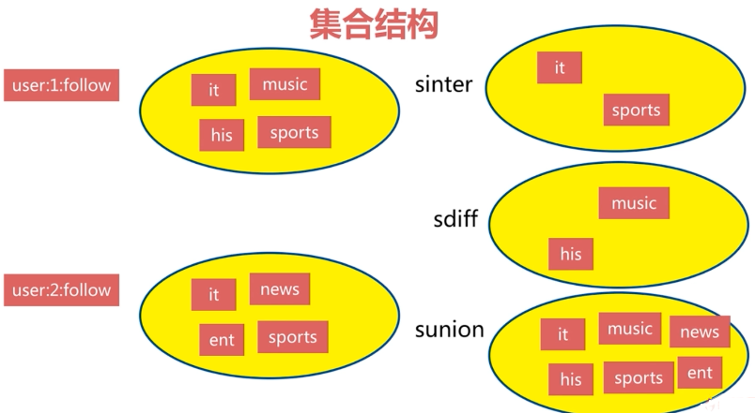

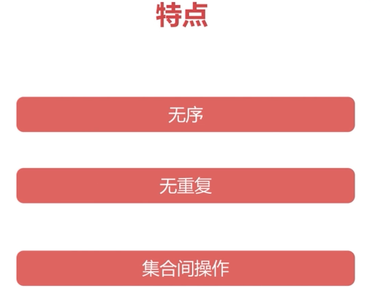

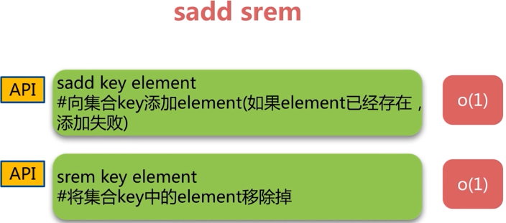

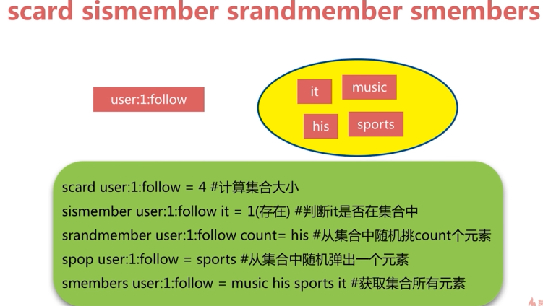

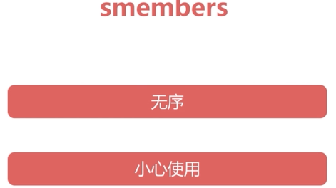

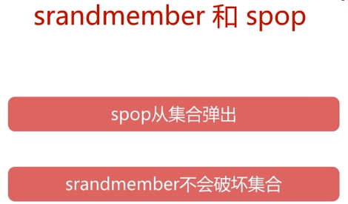

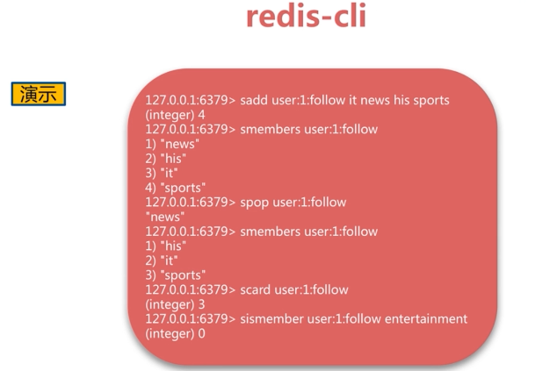



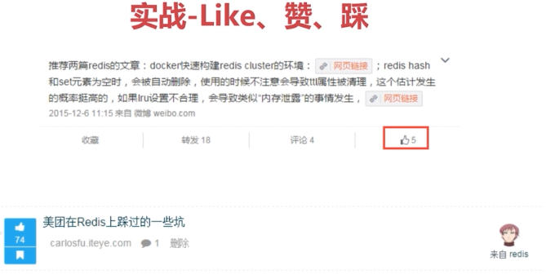

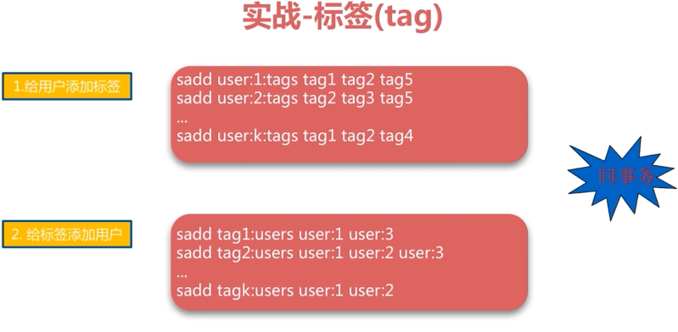



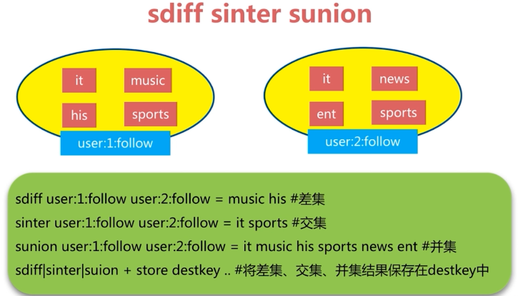



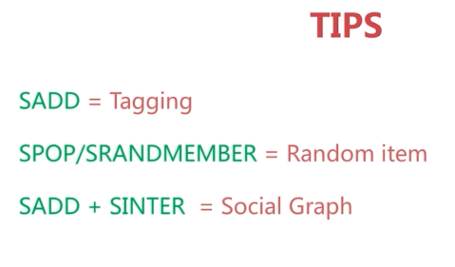

### 3.8有序集合zset

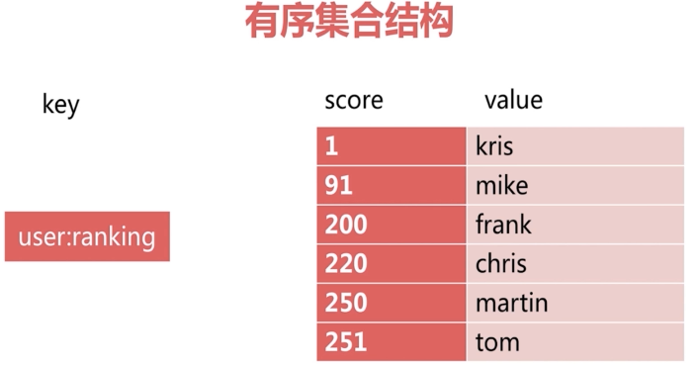

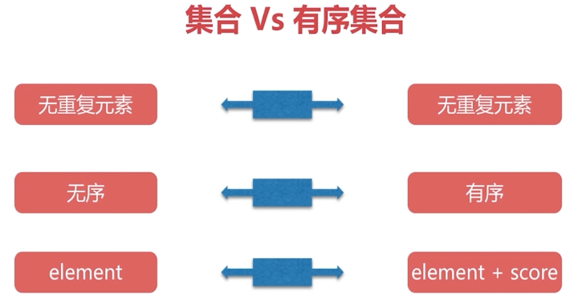

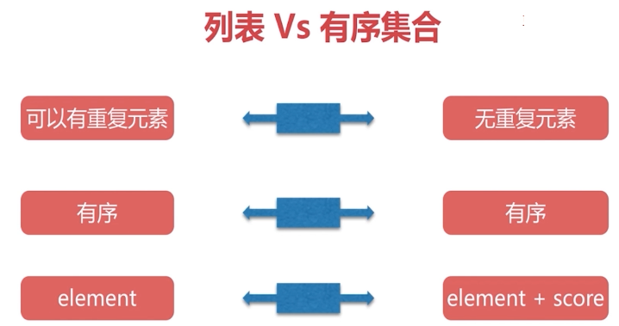

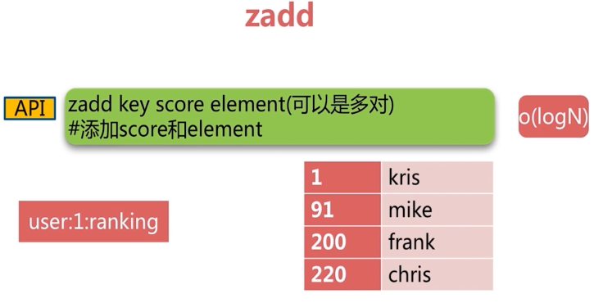

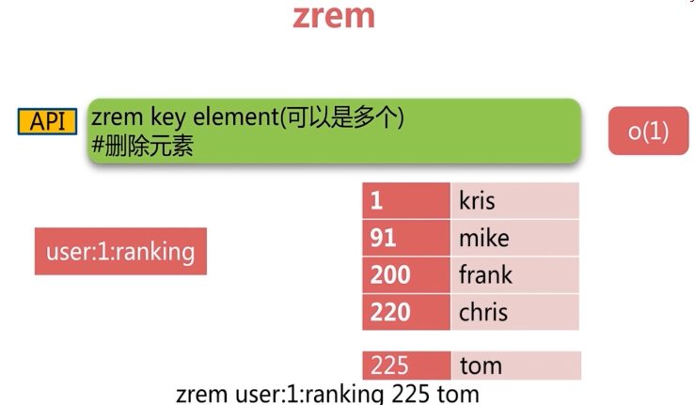

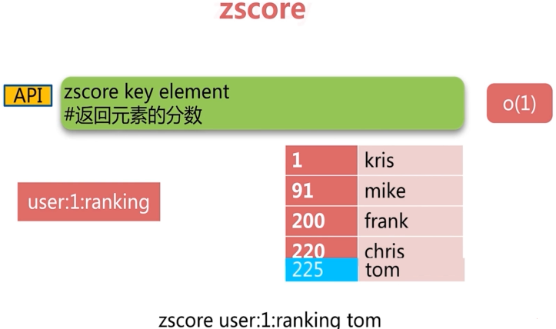

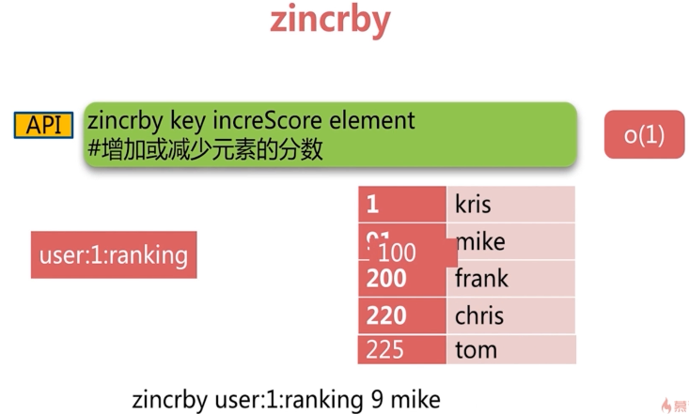

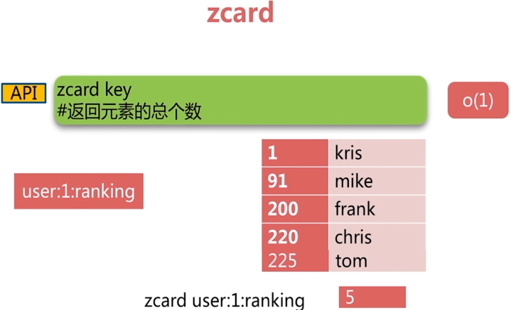

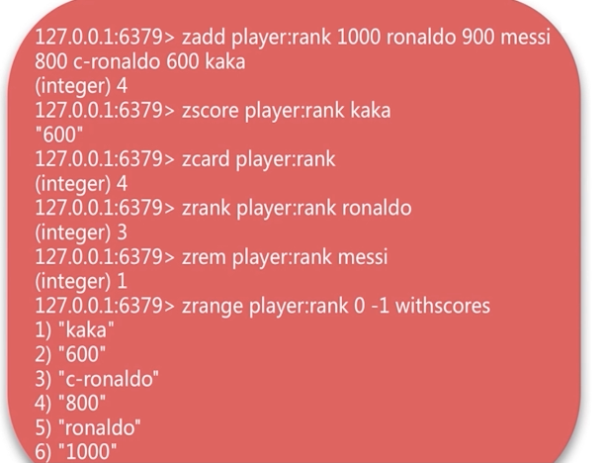

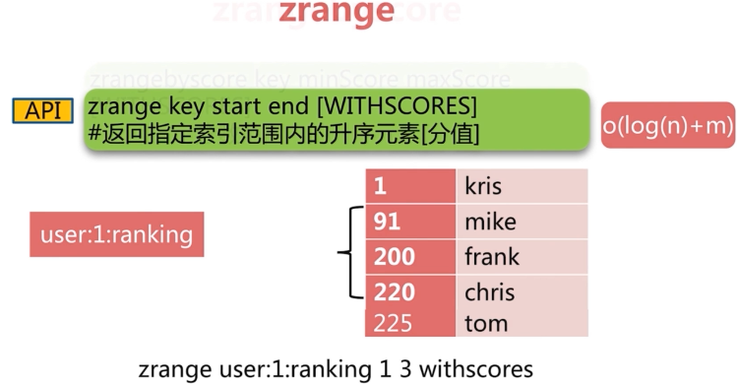

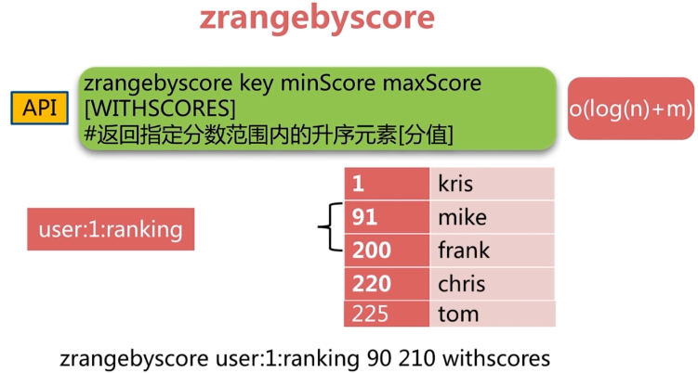

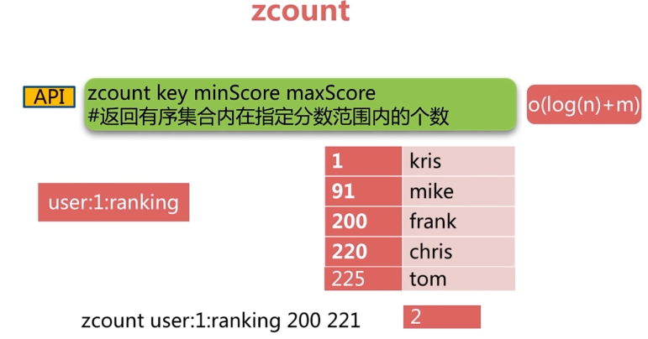

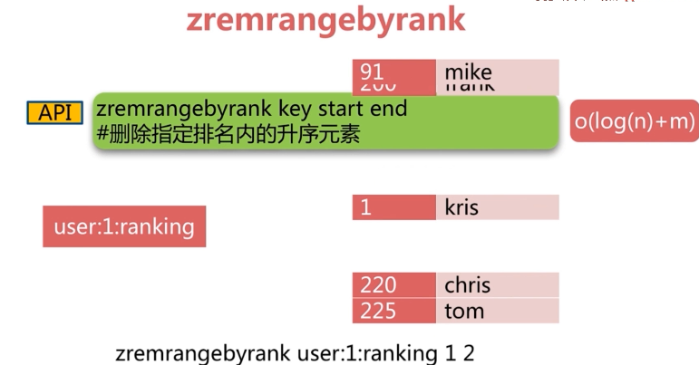

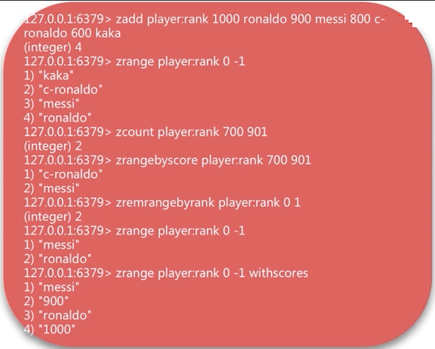



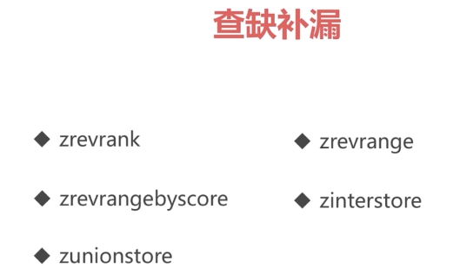

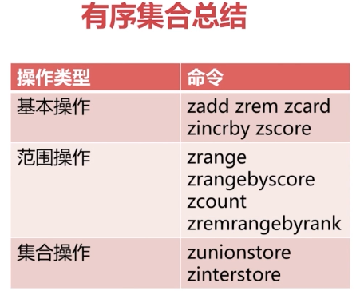

## 第4节Redis客户端使用

### 4.1Java客户端：Jedis





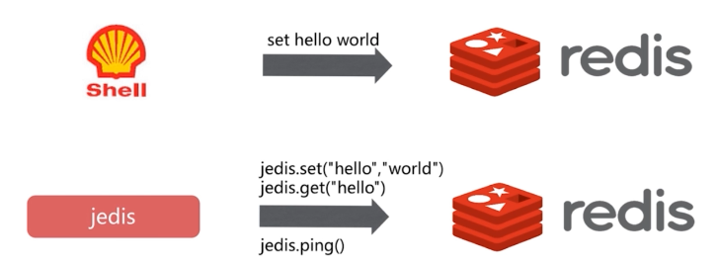

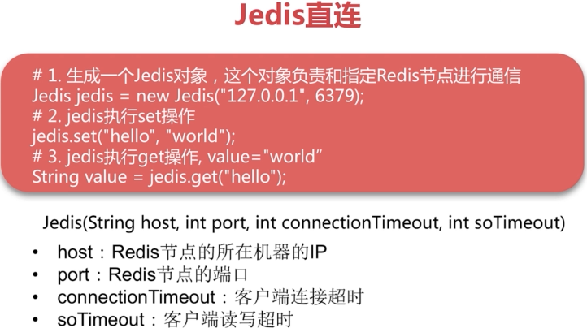

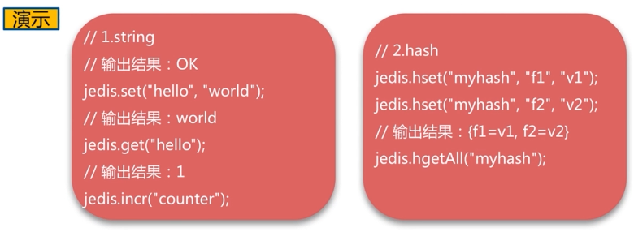

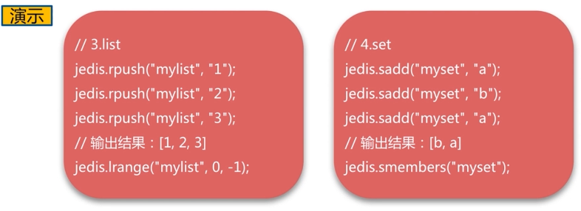

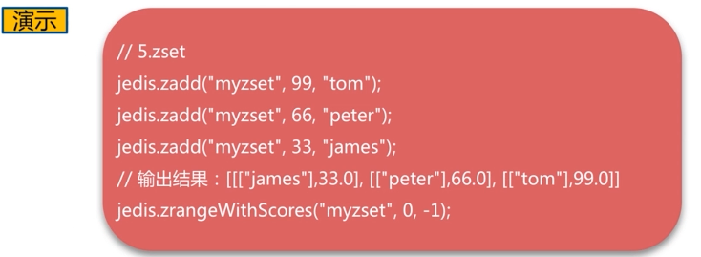

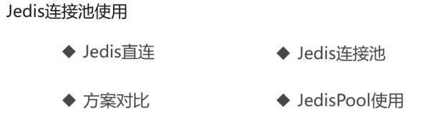

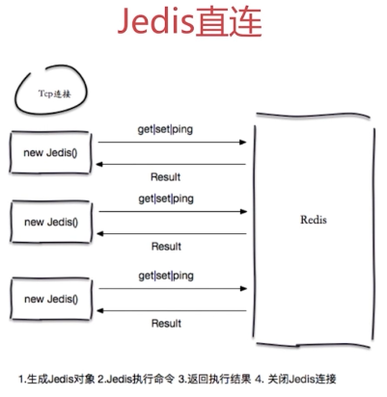

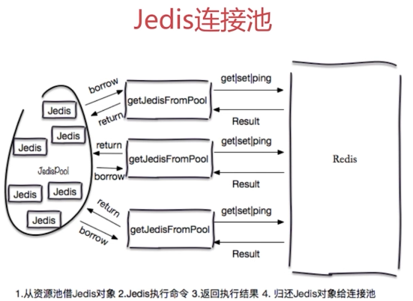

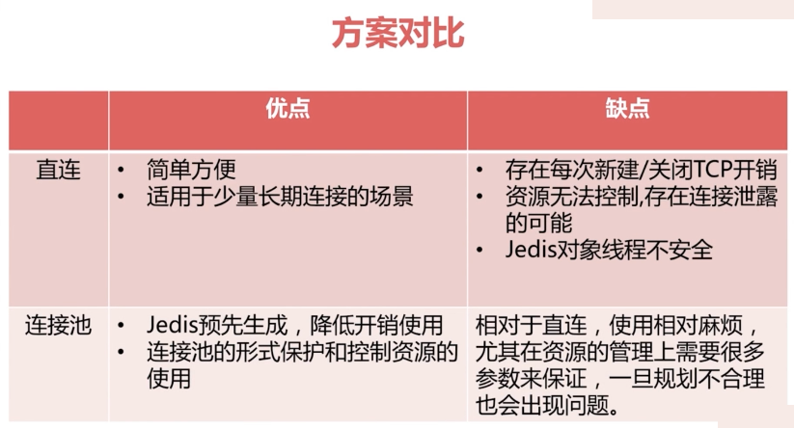

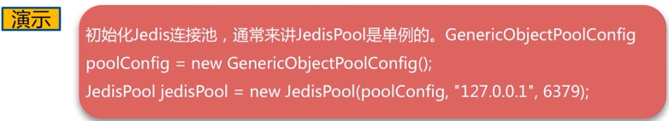

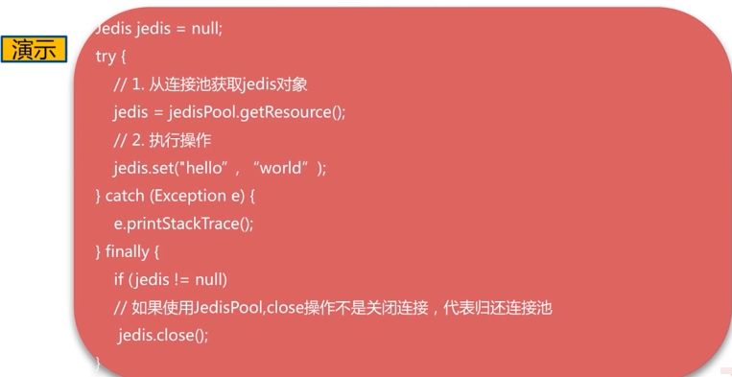

|  |
| --- |
| **package** com.byf.redis;  **import** org.apache.commons.pool2.impl.GenericObjectPoolConfig;  **import** org.junit.Test;  **import** redis.clients.jedis.Jedis;  **import** redis.clients.jedis.JedisPool;  **public** **class** RedisAPITest {  Jedis jedis = **new** Jedis("192.168.0.200", 6379);  @Test  **public** **void** testSetString() {  jedis.set("hello", "world");  // world  System.***out***.println(jedis.get("hello"));  }  @Test  **public** **void** testIncrease() {  jedis.incr("counter");  // 1  System.***out***.println(jedis.get("counter"));  }  @Test  **public** **void** testHash() {  jedis.hset("myHashkey", "f1", "v1");  jedis.hset("myHashkey", "f2", "v2");  // {f2=v2, f1=v1}  System.***out***.println(jedis.hgetAll("myHashkey"));  }  @Test  **public** **void** testList() {  jedis.rpush("mylist", "1");  jedis.rpush("mylist", "2");  jedis.rpush("mylist", "1");  // [1, 2, 1]  System.***out***.println(jedis.lrange("mylist", 0, -1));  }  @Test  **public** **void** testSet() {  jedis.sadd("myset", "a");  jedis.sadd("myset", "b");  jedis.sadd("myset", "a");  // [b, a]  System.***out***.println(jedis.smembers("myset"));  }  @Test  **public** **void** TestZset() {  jedis.zadd("myzset", 99, "tom");  jedis.zadd("myzset", 66, "peter");  jedis.zadd("myzset", 33, "james");  // [[[106, 97, 109, 101, 115],33.0], [[112, 101, 116, 101, 114],66.0],  // [[116, 111, 109],99.0]]  System.***out***.println(jedis.zrangeWithScores("myzset", 0, -1));  }  GenericObjectPoolConfig poolConfig = **new** GenericObjectPoolConfig();  JedisPool jedisPool = **new** JedisPool(poolConfig, "192.168.0.200", 6379);  @Test  **public** **void** testJedisPool(){  Jedis jedis = **null**;  **try** {  jedis = jedisPool.getResource();  jedis.set("jedisPool", "this is one jedis connection");  System.***out***.println(jedis.get("jedisPool"));  } **catch** (Exception e) {  e.printStackTrace();  } **finally** {  **if**(jedis != **null**){  jedis.close();  }  }  }  } |

### 4.2Python客户端：redis-py

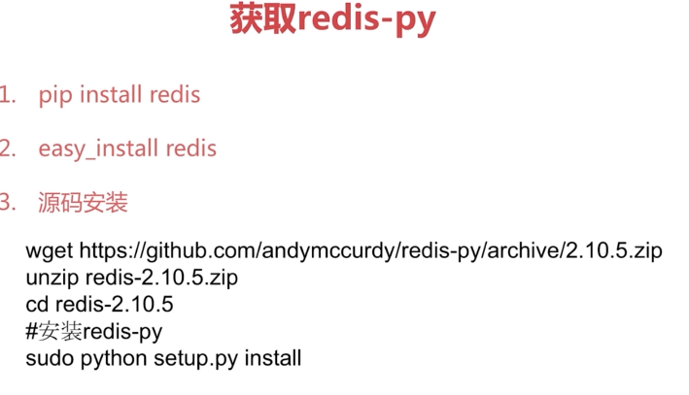

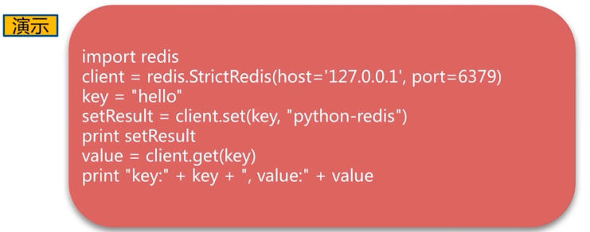

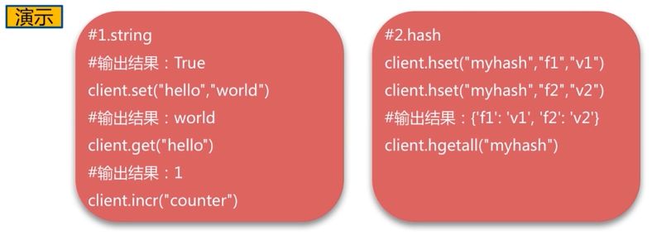

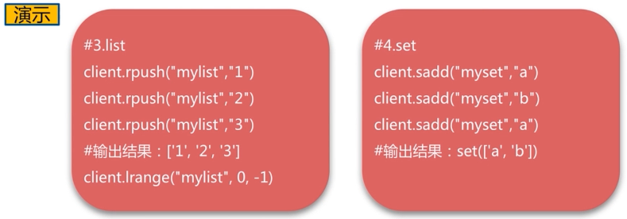

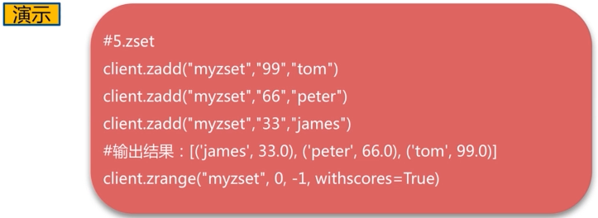

### 4.3Go客户端：redigo

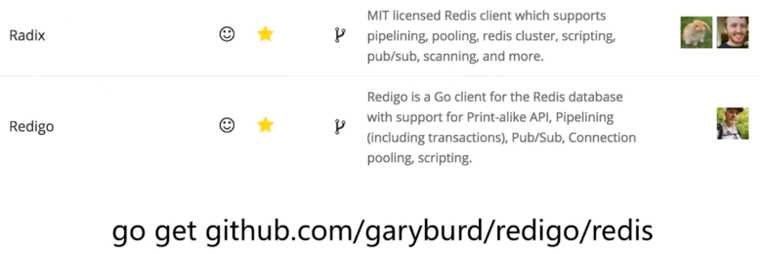

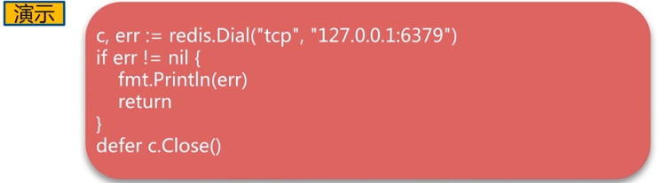

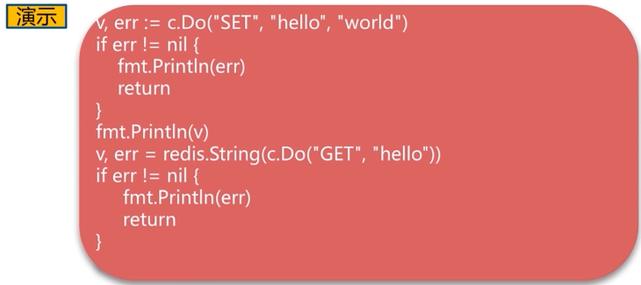

## 第5节瑞士军刀Redis其他功能

### 5.1慢查询

**声明周期**

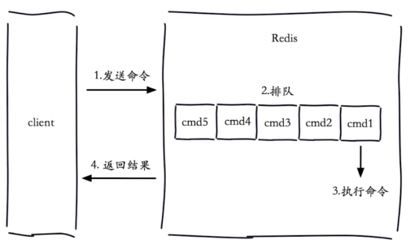

注意：

1. 慢查询发生在第3阶段；命令执行的时间，不包括网络发送，比如keys *的操作，hgetAll执行hline几百万的查询
2. 客户端超时不一定慢查询，但慢查询是客户端超时的一个原因；

慢查询的两个配置：**slowlog-max-len**

1. 先进先出队列
2. 固定长度
3. 保存在内存

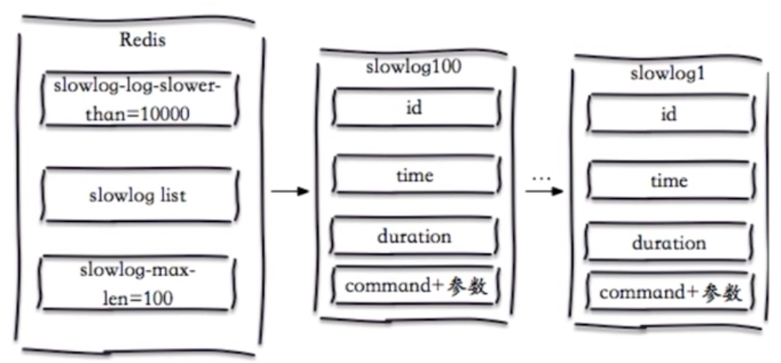

慢查询的两个配置：**slow-log-slower-than**

1. 慢查询阈值（单位：微秒）
2. Slow-log-slower-than = 0，记录所有命令
3. Slow-log-slower-than < 0，不记录任何命令，非常用

**配置方法**

1. 默认值

·config get slowlog-max-len = 128

·config get slowlog-log-slower-than = 10000

1. 修改配置文件重启
2. 动态配置

·config set slowlog-max-len 1000

·config set slowlog-log-slower-than = 1000

**慢查询命令**

1. slowlog get [n]：获取慢查询队列
2. slowlog len：获取慢查询队列长度
3. slowlog reset：清空慢查询队列

**运维经验**

1. slowlog-max-len 不要设置过大，默认10ms，通常设置1ms；通常根据QPS设置
2. slowlog-log-slower-than不要设置过小，通常设置1000左右；默认长度128，设置长一点可以查看更多历史问题；
3. 理解命令生命周期；
4. 定期持久化慢查询；

### 5.2pipeline

**·1次网络命令通信模型**

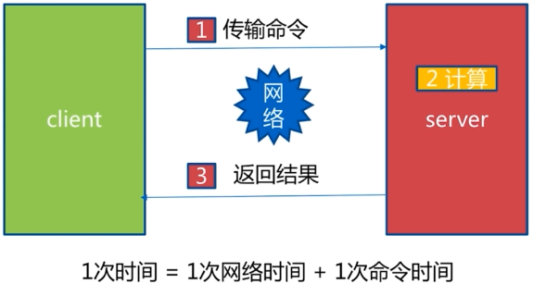

1次网络时间就是1和3，1次命令时间就是2

**·批量网络命令通信模型**

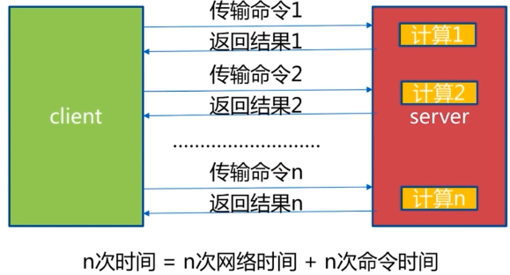

**·什么是流水线**

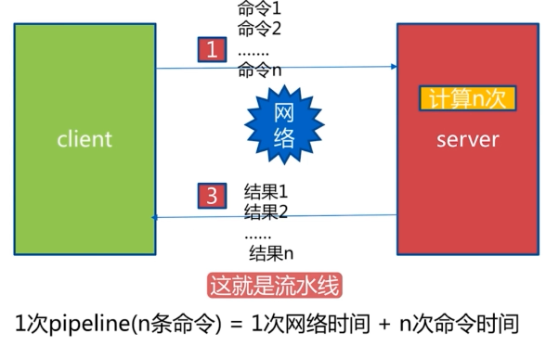

**·流水线的作用**

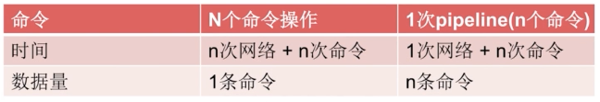

注意：

1. Redis的命令时间是微秒级别；
2. Pipeline每次条数要控制（网络瓶颈）；

**·网络极端例子**



**·Pipeline-Jedis实现**

|  |
| --- |
| **public** **class** PipelineJedisTest {    Jedis jedis = **new** Jedis("127.0.0.1", 6379);    @Test  **public** **void** BatchHsetNoPipeline() {  // jedis.auth("1234");  // redis-server --service-install redis.windows.conf --loglevel verbose  **long** startTime = System.*currentTimeMillis*();  **for**(**int** i=0;i<100000;i++){  jedis.hset("hashkey:"+i, "field:"+i, "value:"+i);  }  **long** endTime = System.*currentTimeMillis*();  System.***out***.println("hset without pipeline, used time : " + (endTime - startTime) + "ms");  }  @Test  **public** **void** BatchHsetUsePipeline() {  // jedis.auth("1234");  // redis-server --service-install redis.windows.conf --loglevel verbose  **long** startTime = System.*currentTimeMillis*();  **for**(**int** i=0;i<1000;i++){  Pipeline pipeline = jedis.pipelined();  **for** (**int** j = i * 100; j < (i + 1)*100; j++) {  pipeline.hset("hashkey:"+i, "field:"+i, "value:"+i);  }  pipeline.syncAndReturnAll();  }  **long** endTime = System.*currentTimeMillis*();  System.***out***.println("hset with pipeline, used time : " + (endTime - startTime) + "ms");  }  } |
| hset without pipeline, used time : 8577ms  hset with pipeline, used time : 464ms |

**·没有使用pipeline**

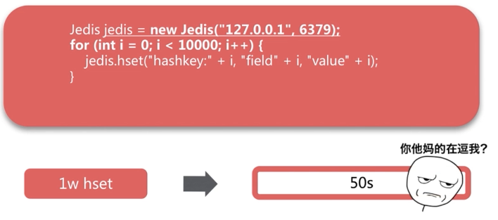

**·使用pipeline**

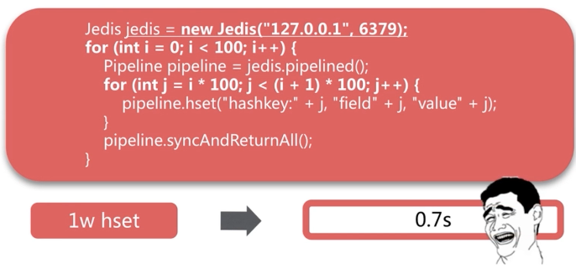

**·与原生M操作对比**

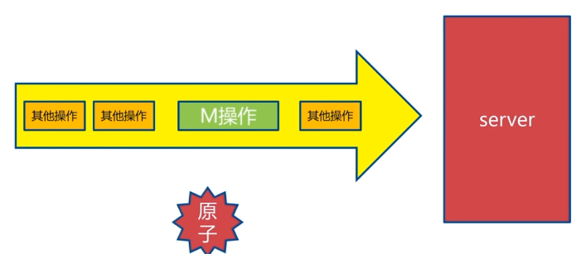

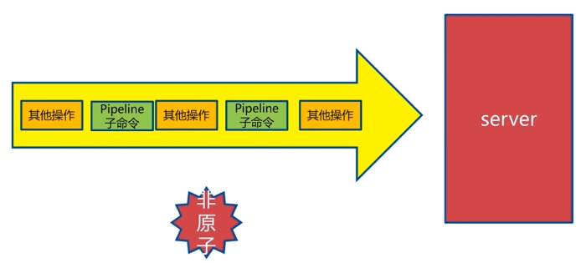

**·使用pipeline注意事项**

1. 注意每次pipeline携带数据量
2. Pipeline每次只能作用在一个Redis接点上；
3. M操作与pipeline区别；

### 5.3发布订阅

**·角色**

1. 发布者（publisher）
2. 订阅者（subscriber）
3. 频道（channel）

**·模型**

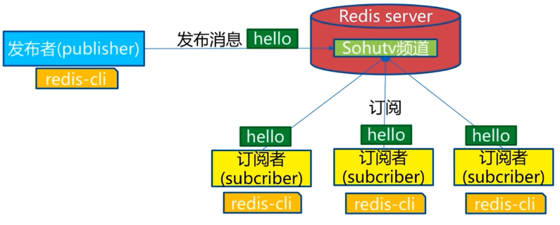

**·发布订阅角色和模型**

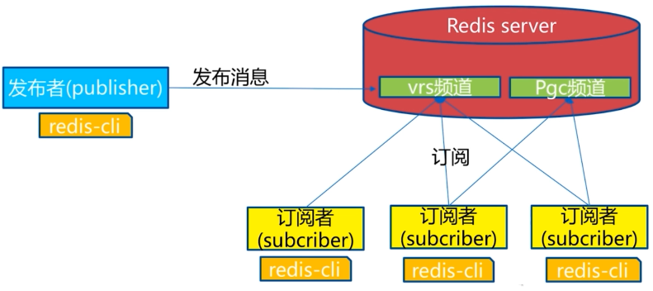

注意：

假如一个发布者发布一个消息到一个频道，新的订阅者订阅该频道，它是收不到之前的消息的，Redis无法做消息堆积，无法做消息队列

**·API**

**发布**

**订阅**

**退订**

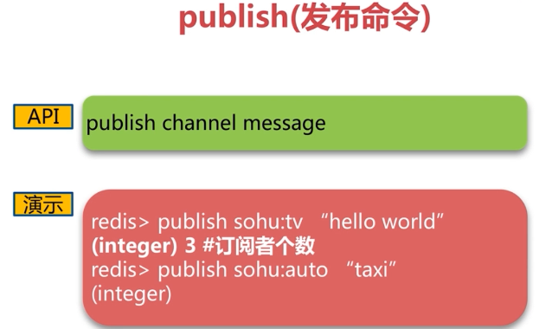

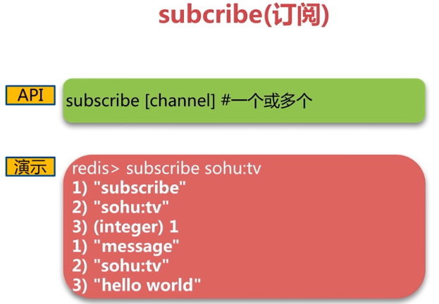

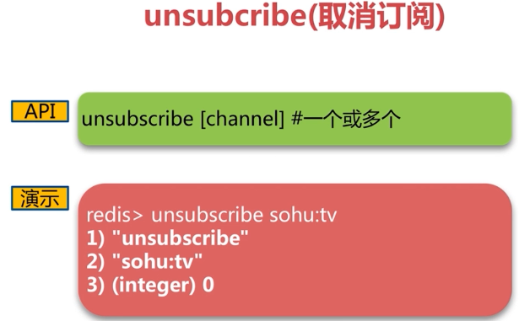

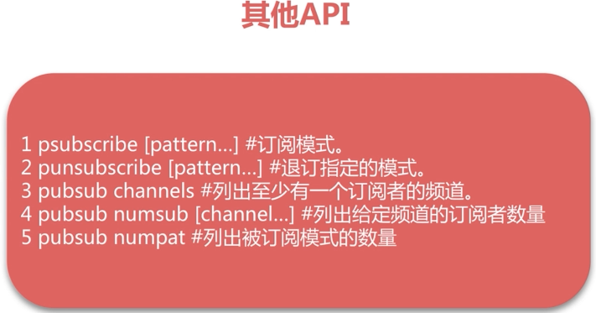

**·消息队列**

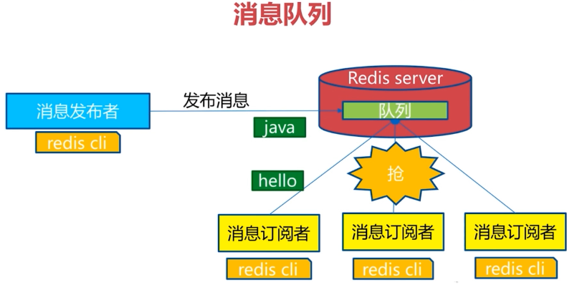

**·发布订阅总结**

### 5.4bitmap

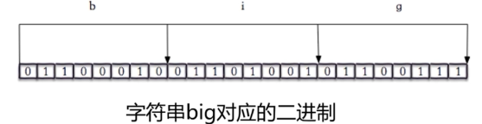

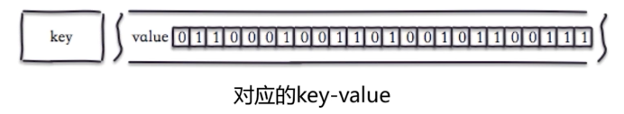

127.0.0.1:6379> getbit hello 0

(integer) 0

127.0.0.1:6379> getbit hello 1

(integer) 1

127.0.0.1:6379> getbit hello 2

(integer) 1

127.0.0.1:6379> getbit hello 3

(integer) 0

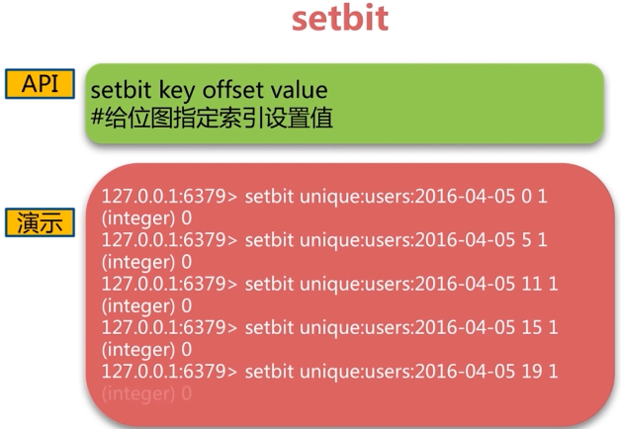

127.0.0.1:6379> setbit hello 7 1

(integer) 0

127.0.0.1:6379> get hello

"cig"

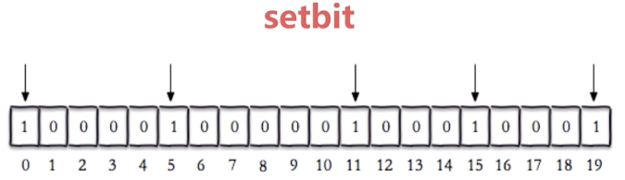

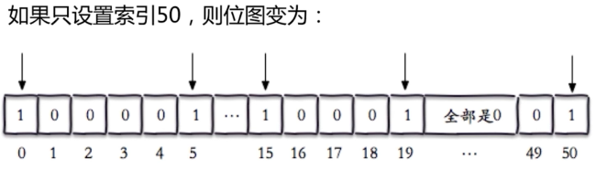

注意：

不要在很短位图的上做很大的偏移，中间补0

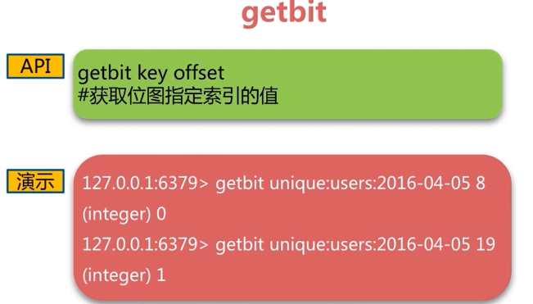

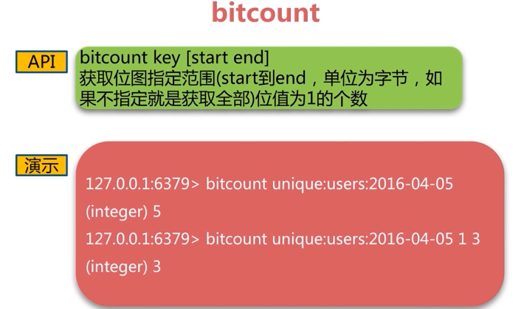

第一个字节到第三个字节之间，位是1的计数

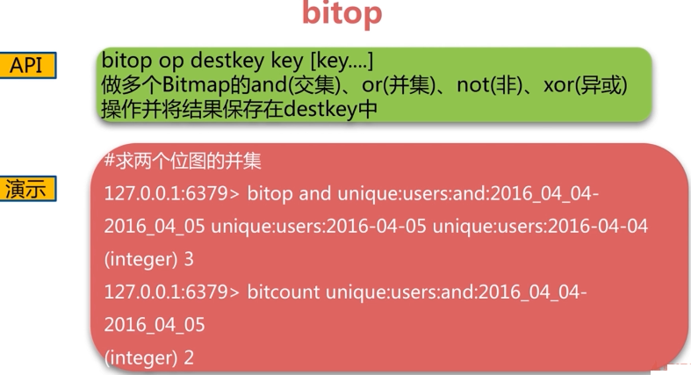

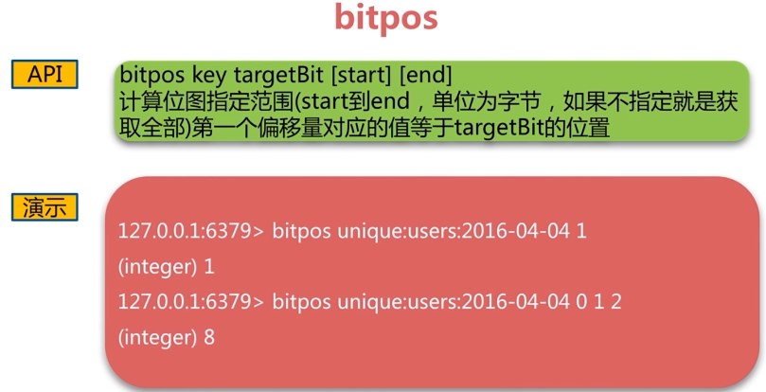

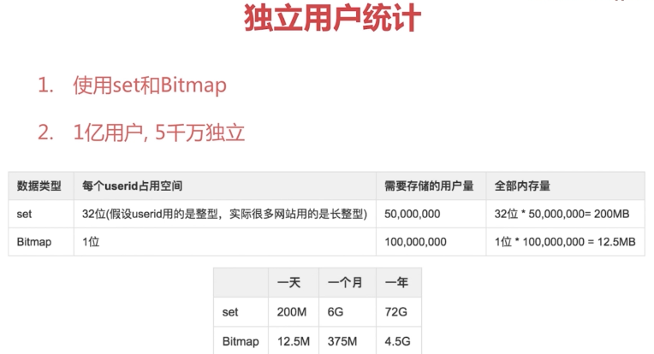

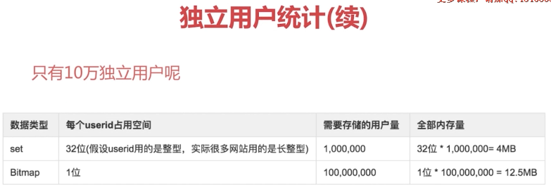

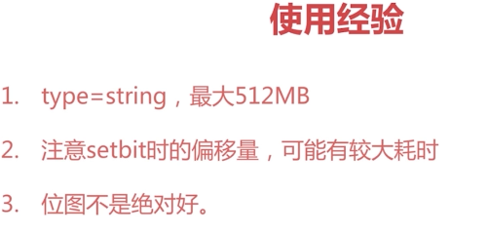

### 5.5hyperloglog

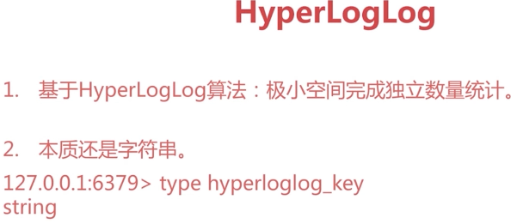

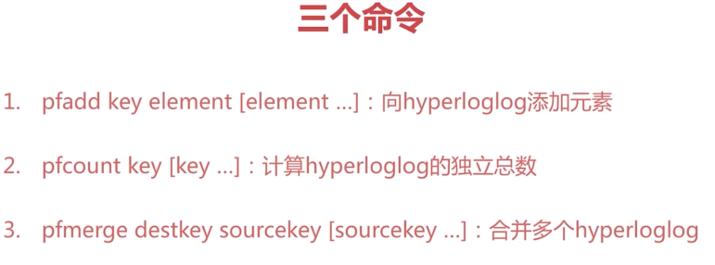

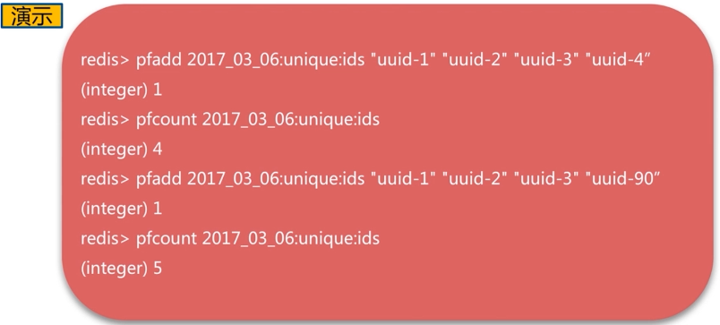

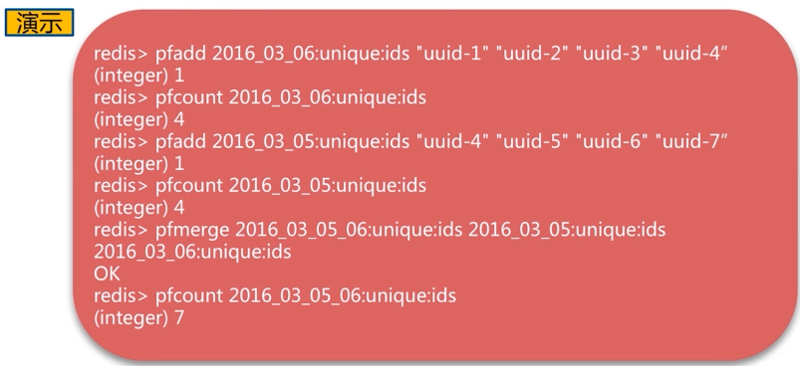

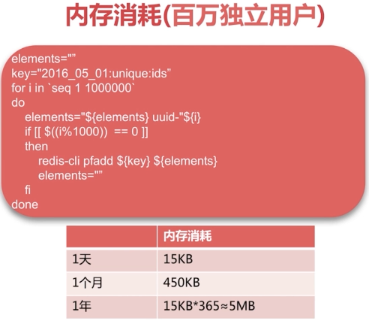

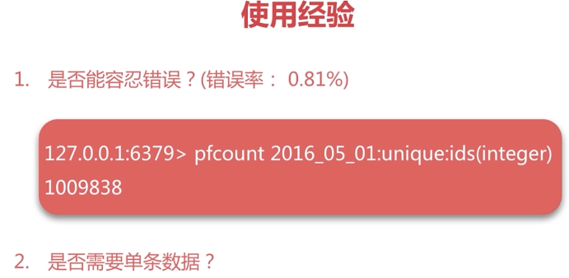

### 5.6geo





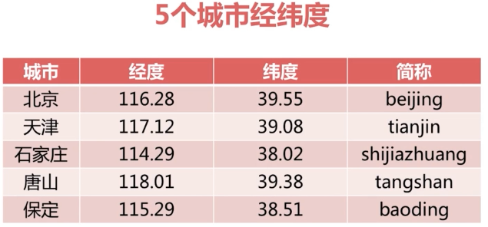

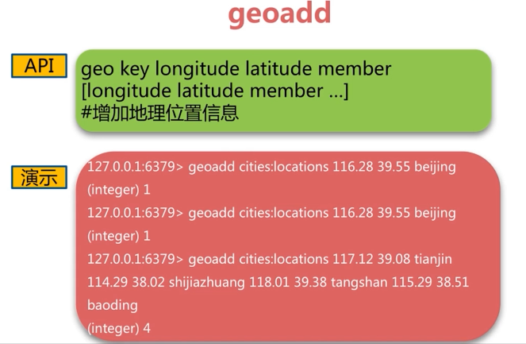

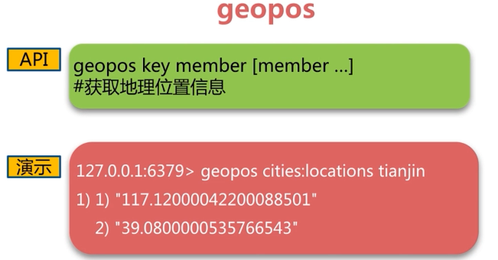

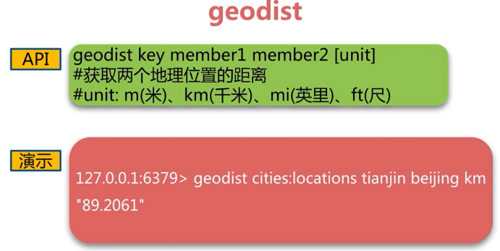

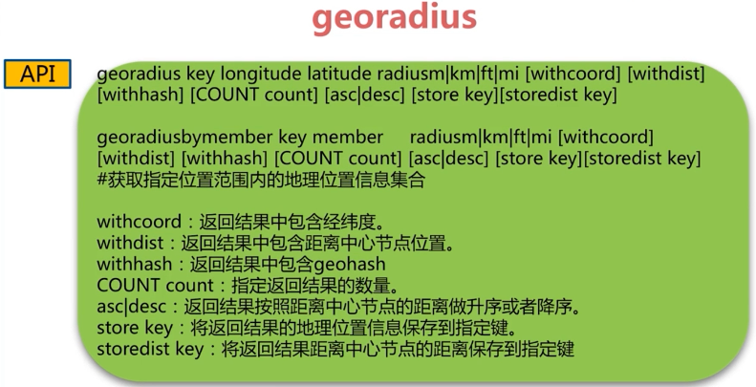

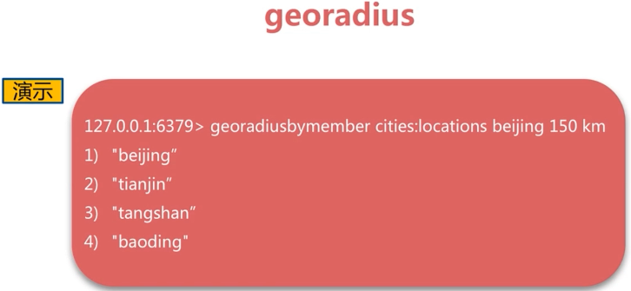

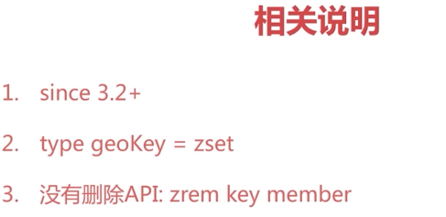

## 第6节Redis持久化的取舍和选择

### 6.1持久化的作用

·什么是持久化

Redis所有数据保持在内存中，对数据的更新将异步地保存到磁盘上



·持久化的实现方式

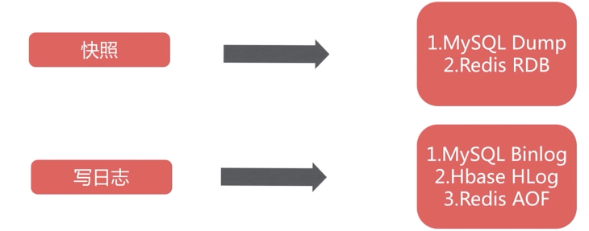

### 6.2RDB

**·什么是RDB**

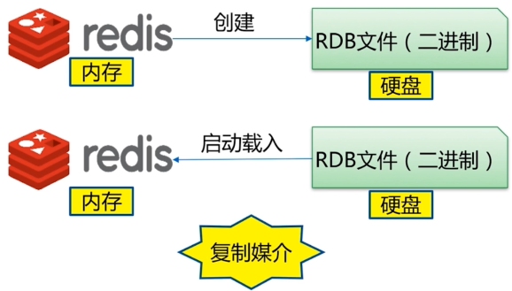

**·触发机制（策略）**

主要有三种方式

·save（同步）

·bgsave（异步）

·自动

**·save命令**

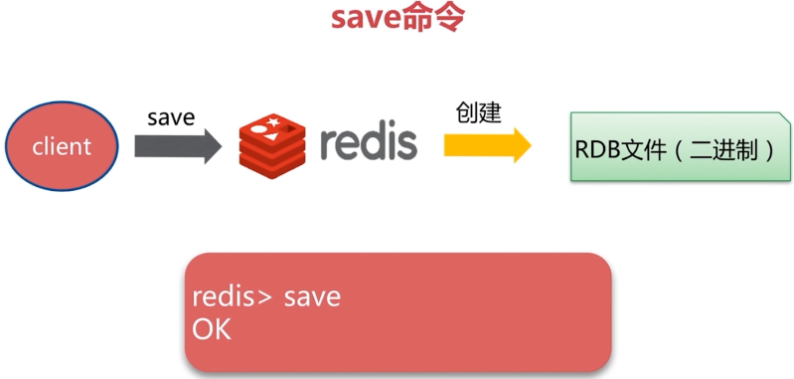

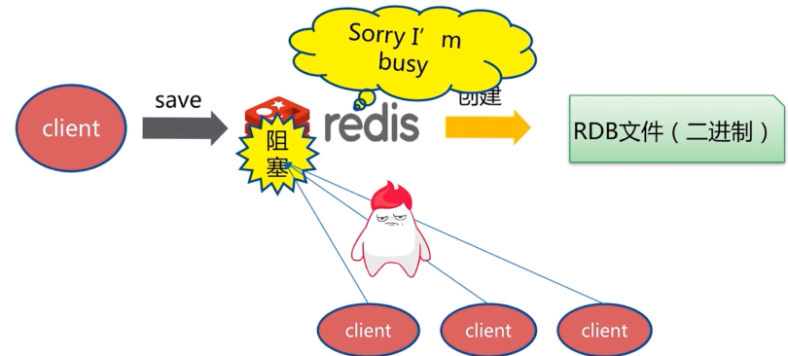

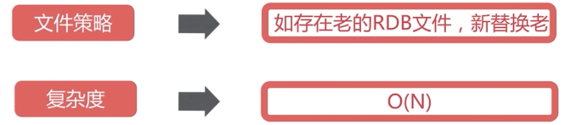

**·bgsave**

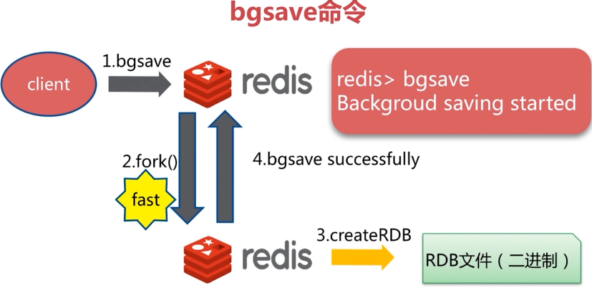

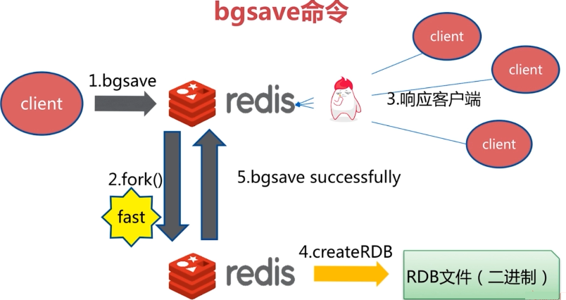

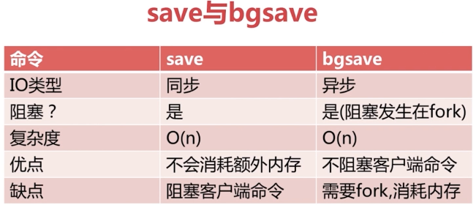

**·自动生成RDB策略**

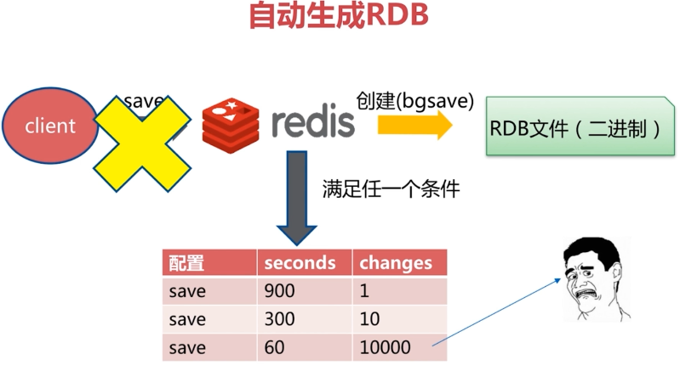

内存频繁的往磁盘写入，磁盘压力比较大

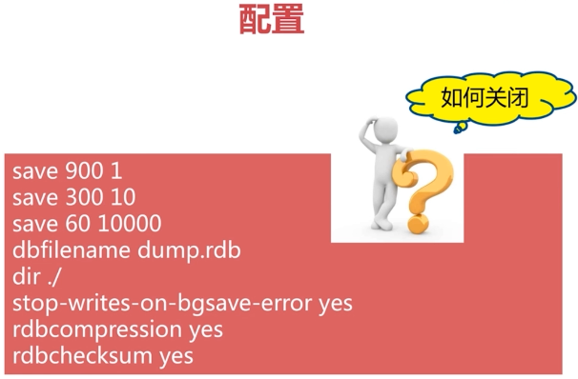

后三条配置：

·Bgsave发生错误停止写入；

·rdb文件是否采用压缩的格式；

·rdb校验和的检验；

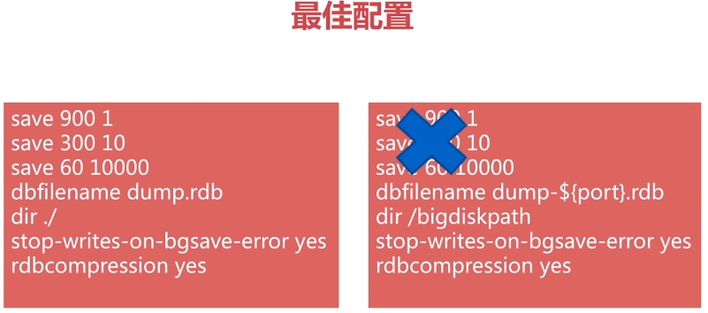

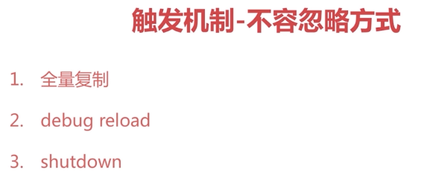

**试验**

**1.配置Redis的conf文件夹**

**$ cp redis.conf rredis-6379.conf**

**$ vi redis-6379.conf**

**#后台守护进程模式开启**

**Daemonize yes**

**Pidfile /var/run/redis-6379.pid**

**Logfile “log-6379.log”**

**# save 900 1**

**# save 300 10**

**# save 60 10000**

**Stop-writes-on-bgsave-error yes**

**Rdbcompression yes**

**Rdbchecksum yes**

**#RDB文件名称**

**Dbfilename dump-6379.rdb**

**Dir /soft/redis/data**

**启动：**

**$ redis-server conf/redis-6379.conf**

**$ redis-cli**

>info memory

**·同步save**

>save

.....同步阻塞快照保存redis中的数据到rdb文件

>get hello

.....等待save完成

**·异步bgsave**

>bgsave

# ps -ef | grep redis- | grep -v redis-cli | grep -v grep

Redis-rdb-bgsave *：6379

# cd data

# less log

......

Background saving started by pid 36910

DB saved on disk

Background saving terminated with success

# ls -al

Log-6379.log

Dump-6379.rdb

Temp-36910.rdb #rdb文件生成策略，dbsave时首先生成临时文件，然后覆盖原有rdb文件

**·自动**

**$ vi redis-6379.conf**

**#60秒更改5条数据，触发rdb备份策略**

**Save 60 5**

**$ redis-cli shutdown**

**$ redis-cli**

**Connection refused**

**$ redis-server conf/redis-6379.conf**

**$ redis-cli**

**>dbsize**

**0**

**>set hello world**

**> set a a**

**>set b b**

**>set c c**

**>set d d**

**>set e e**

**#cd data**

**#less log-6379.log**

**......**

**5 changes in 60 seconds. Saving...**

**Background saving started by pid 37536**

**DB saved on disk**

**Background saving terminated with success**

**生成rdb二进制文件**

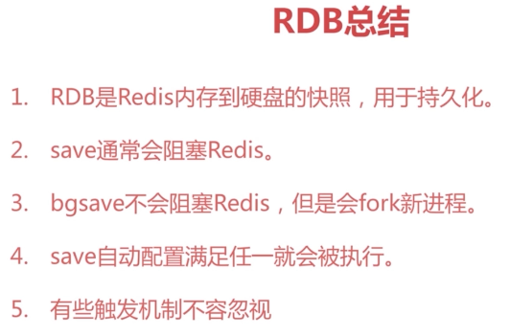

### 6.3AOF

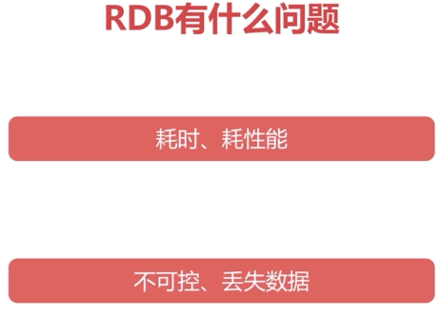

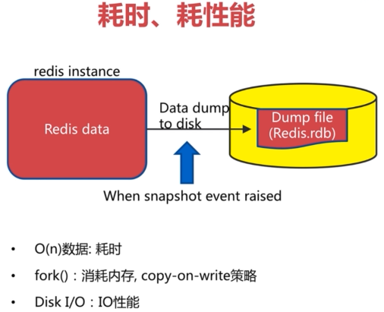

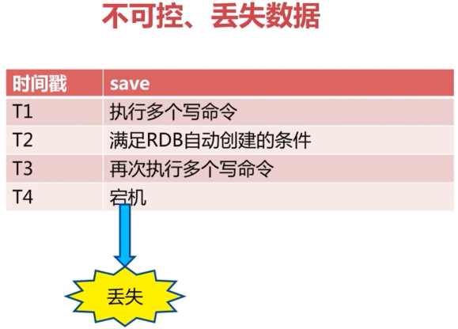

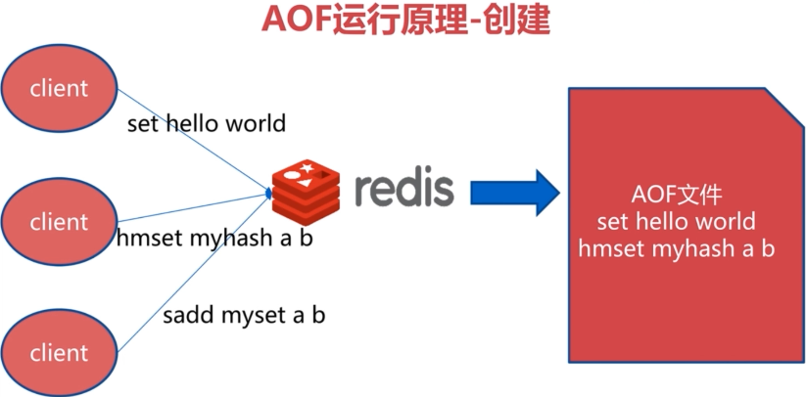

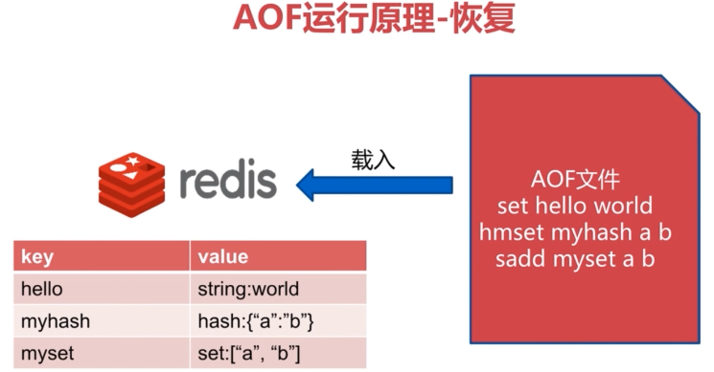

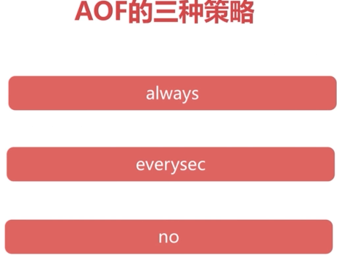

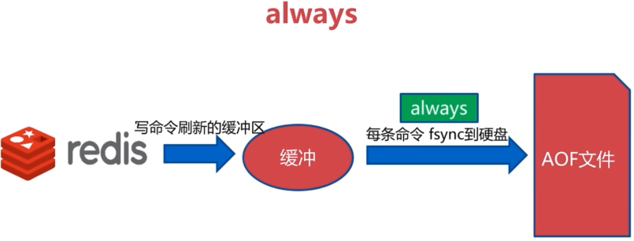

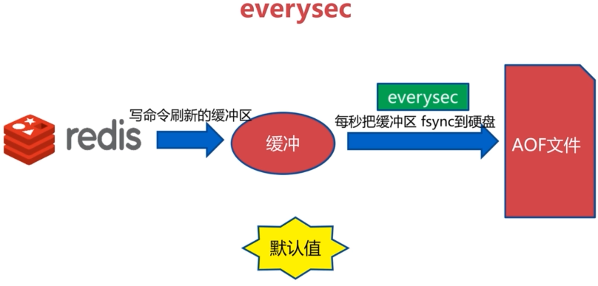

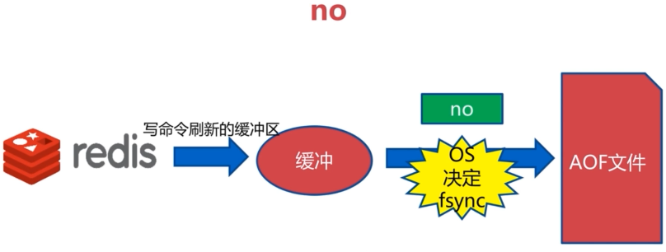

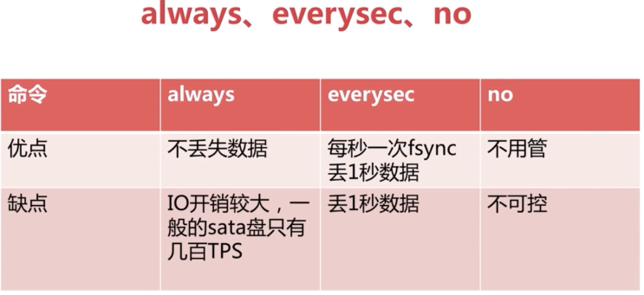

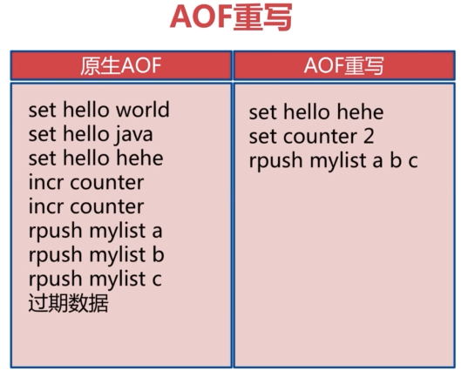



例如，计数器自增1亿，AOF重写后只有一条



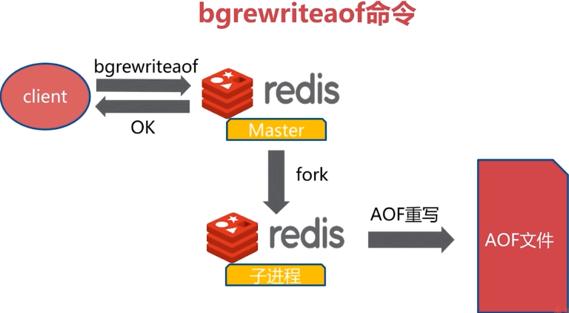

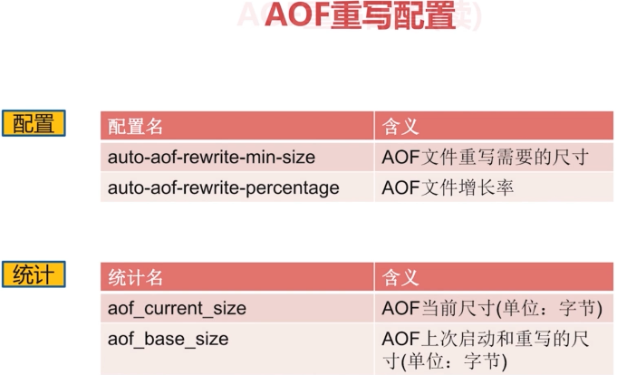



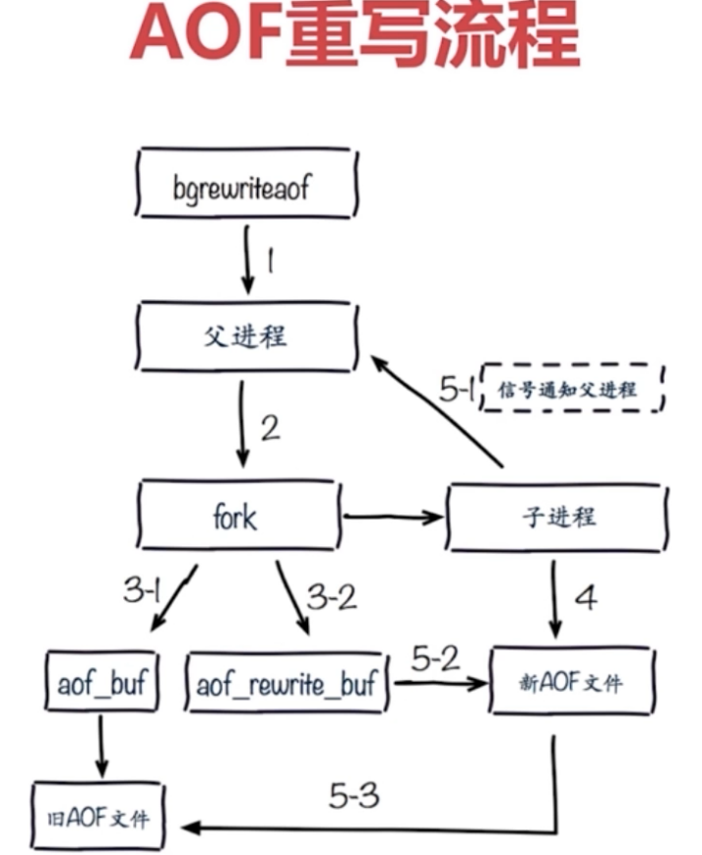

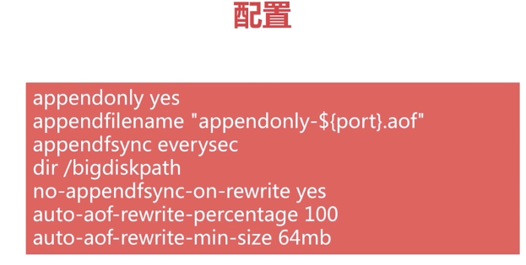

重写的时候关闭正常的append，为了保证性能，将no-appendfsync-on-write 设置yes，在数据量比较大的时候，父进程5-2正常写入AOF，同时子进程4重写AOF，磁盘IO紧张，如果写入失败，存在丢失数据的可能。



**·AOF配置**

**Appendonly no**

**Appendfilename “apendonly.aof”**

**#刷盘策略**

**#appendfsync always**

**Appendfsync everysec**

**#appendfsync no #由操作系统决定，从缓存刷入磁盘**

**#重写时关闭正常的append**

**No-appendfsync-on-rewrite no**

**#AOF自动重写配置的要求，重写尺寸和最小增长率**

**Auto-aof-rewrite-percentage 100**

**Auto-aof-rewrite-min-size 64mb**

**#加入AOF文件不完成，护着有问题，因为宕机时有可能导致AOF写入数据不完整，是否忽略错误，完成恢复**

**Aof-load-truncated yes**

**#appendonly支持动态配置，可以使用config set开启**

**>config set appendonly yes**

**> config rewrite**

**>exit**

**$ redis-cli**

**>set a a**

**>set a b**

**>set a c**

**>incr counter**

**>incr counter**

**>rpush list a**

**>rpush list b**

**>rpush list c**

**>exit**

**$cd data**

**$ more appendonly.aof**

**#简单序列化协议**

**\*2**

**$6 // 下面命令有6个字节**

**SELECT //选择0号数据库**

**$1**

**0**

**\*3**

**$3**

**Set**

**$1**

**a**

**...**

**#重写**

**>bgrewriteaof**

**Background append only file rewriting started**

### 6.4RDB和AOF的抉择

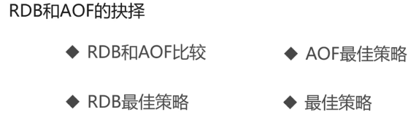

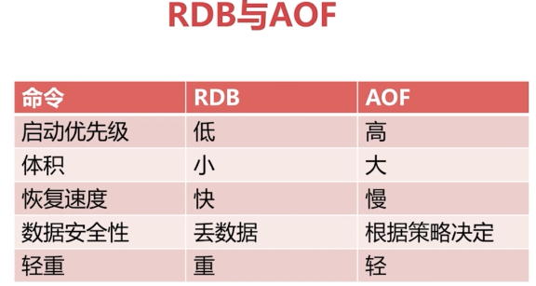

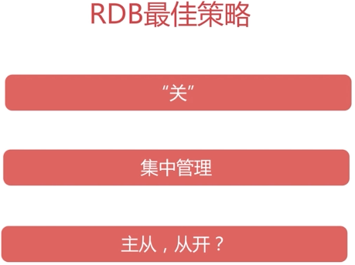

RDB关闭时，主从复制是不生效的

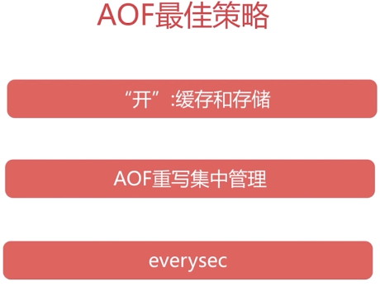

AOF重写集中管理，需要给Redis分配60-70的内存，给fork预留20-30%做操作，也有可能出现集中fork的情况，出现swam的情况，当linux发现内存不足时，会发生OOM killer(OOM=out-of-memory)。它会选择杀死一些进程(用户态进程，不是内核线程)，以便释放内存。

**·出现的问题**

redis运行一段时间后就挂掉了，ps查看进程没啥问题，查看redis的log，发现有warning,如下：

[26145] 07 Dec 19:54:54 # WARNING overcommit_memory is set to 0! Background save may fail under low memory condition. To fix this issue add 'vm.overcommit_memory = 1' to /etc/sysctl.conf and then reboot or run the command 'sysctl vm.overcommit_memory=1' for this to take effect.

telnet到6379，任何操作都会返回not permitted，

[root@localhost redis]# telnet 127.0.0.1 6379

Trying 127.0.0.1...

Connected to 127.0.0.1.

Escape character is '^]'.

keys *

-ERR operation not permitted

redis并没有设置requirepass,不可能是因为权限问题导致not permitted。

**·解决办法**

1，修改内核参数，3种方法，任选其一：

（1）编辑/etc/sysctl.conf ，改vm.overcommit_memory=1，然后sysctl -p 使配置文件生效

（2）sysctl vm.overcommit_memory=1

（3）echo 1 > /proc/sys/vm/overcommit_memory

2，修改redis.conf,然后重启redis

maxmemory 5368709120

maxmemory-policy allkeys-lru

maxmemory-samples 3

设置一下maxmemory，建议设置为物理内存的1/2到3/4，大小不要超过最大物理内存。

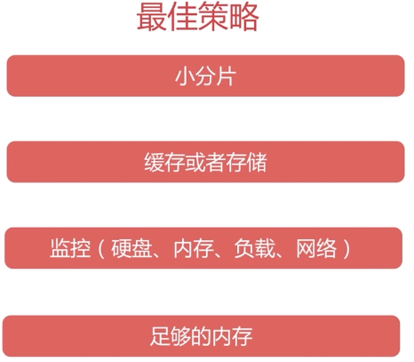

1. 使用max-memory对Redis进行规划，设置最大内存为4G，这样fork，rdb都会产出较小的开销（缺点：分布式会产生更多的进程，CPU占用更多）
2. 客户端缓存区，不受max-memory的限制，由于内存使用突然暴涨，或者fork产生额外内存消耗，导致swap，OOM killer(OOM=out-of-memory)

## 常见的持久化开发运维问题

### 7.1开发运维常见问题

1. fork操作
2. 进程外开销
3. AOF追加阻塞
4. 单机多实例部署

### 7.2fork操作

1. 同步操作
2. 与内存相关：内存越大，耗时越长（与机器类型有关）
3. Info：latest_fork_usec

·改善fork

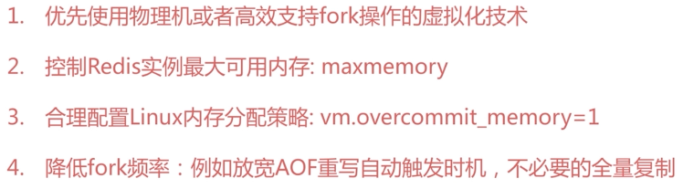

Bgsave和bgwriteaof产生子进程，写入磁盘

### 7.3子进程开销和优化

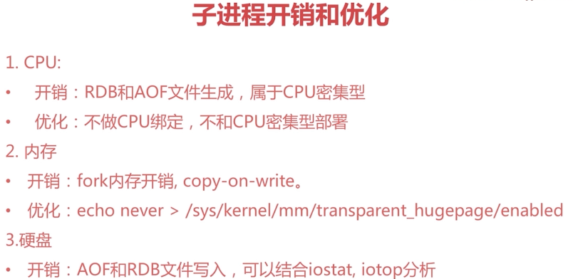

Copy-on-write：父子进程共享物理内存页，但是当父进程有写请求时，会创建一个副本，相当于这个时候消耗一个内存。而整个期间子进程共享fork时父进程的内存快照。如果bgsave或bgwriteaof过程中，父进程有大量的写入，子进程的内存开销会比较大。

Linux内核2.6.38，支持大的内存页的分配，echo never..增加fork的速度，但不利于Redis的使用，因此关闭此参数。

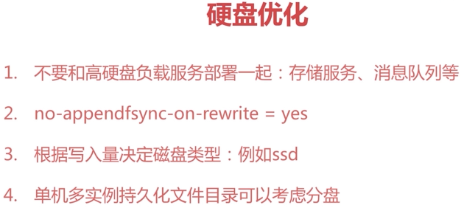

### 7.4AOF追加阻塞

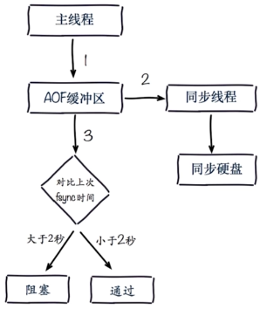

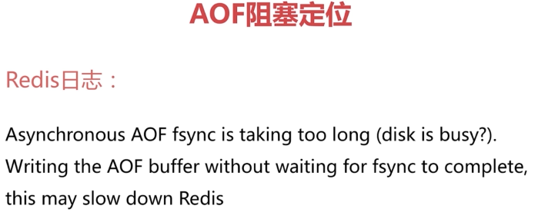

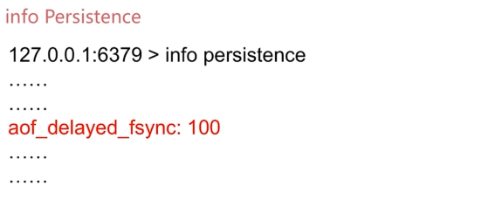

Top

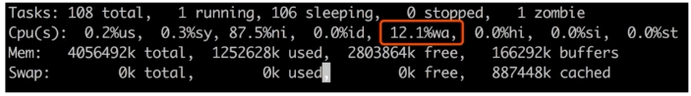

## Redis复制的原理与优化

### 8.1什么是主从复制



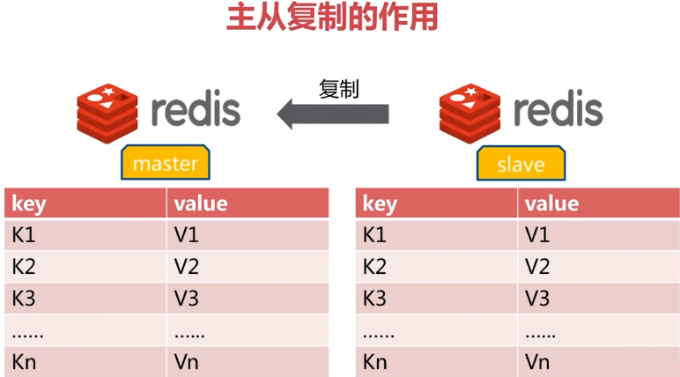

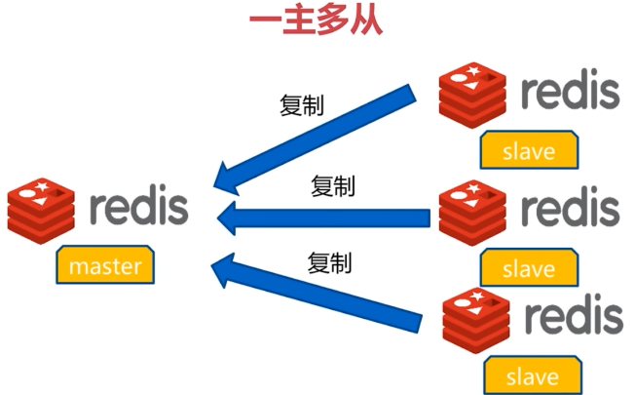

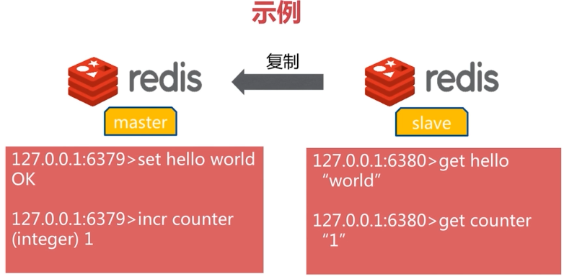

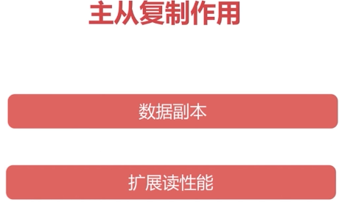

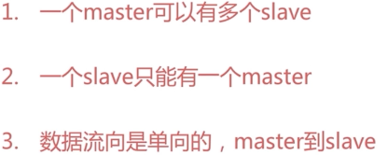

### 8.2主从复制配置-介绍

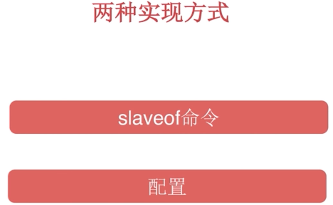

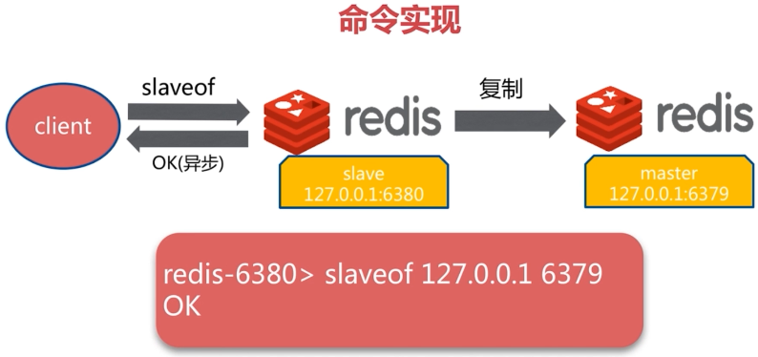

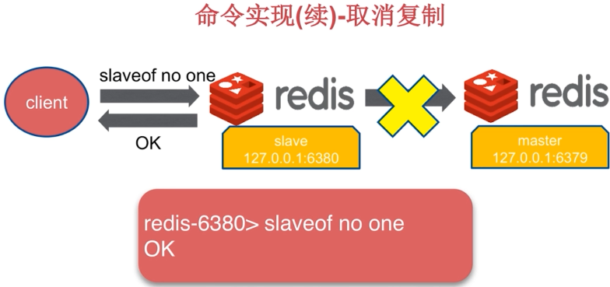

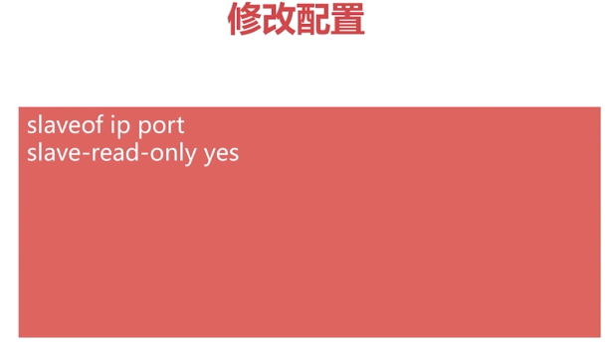

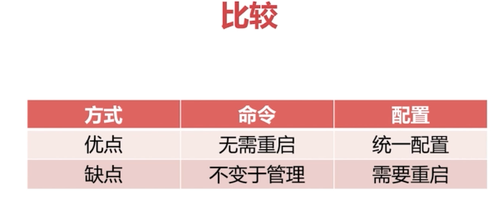

### 8.3主从复制配置-操作



修改配置

Slaveof ip port

>Info replication

#清除数据库

>flushall

#成为其他节点的slave节点时，首先清空自己

> set hello world

>slaveof 127.0.0.1 3679

>get hello

nil

### 8.4runid和复制偏移量

$ redis-cli -p 6379 info server |grep run_id

#查看偏移量

$redis-cli -p 6379 info replication

Slave_repl_offset:1992 / master_repl_offset:1992

>set hello java

$redis-cli -p 6379 info replication

Slave_repl_offset:2048

### 8.5全量复制

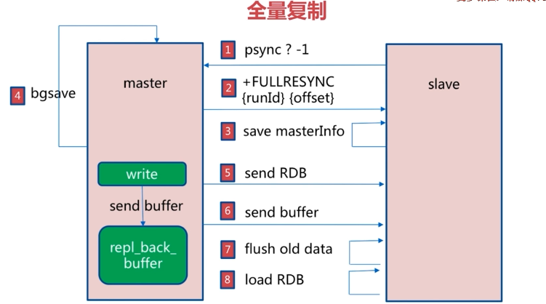

### 8.6全量复制开销 + 部分复制

1. bgsave 产生子进程，对CPU、内存、磁盘都会有一定的开销



出现网络抖动，从节点需要重新进行全量复制，Redis2.8版本之前

之后

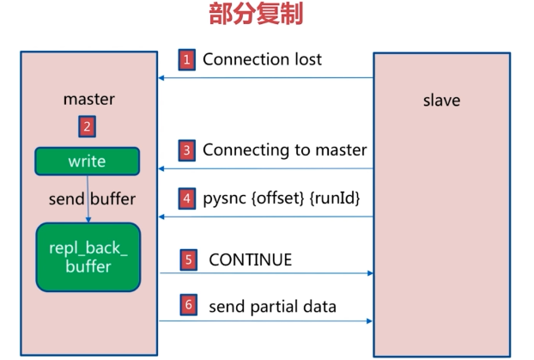

### 8.7故障处理

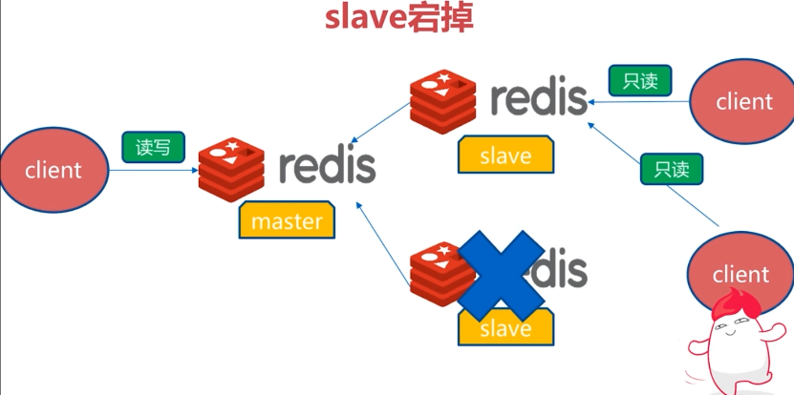

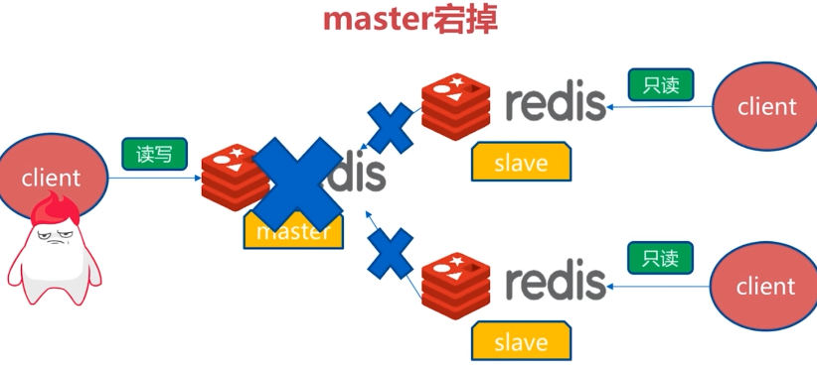

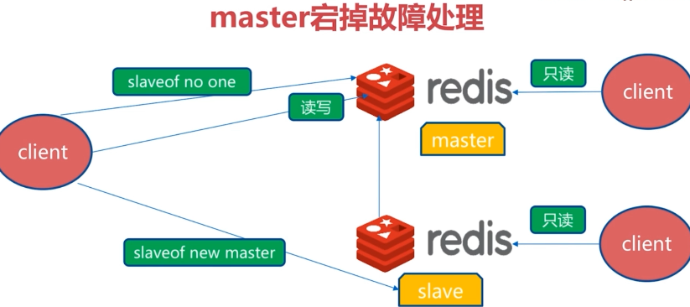

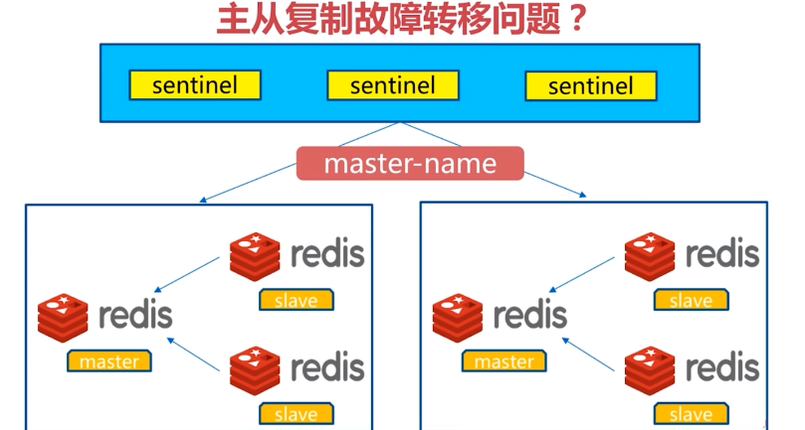

### 8.8主从复制常见问题



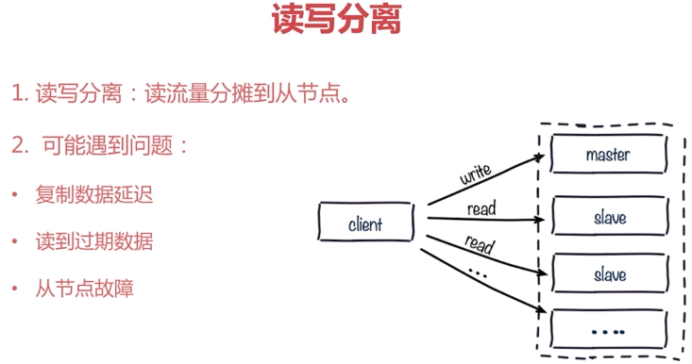

Slave是不能删除数据的，因此可能读到脏数据

Redis3.2已经解决了这个故障





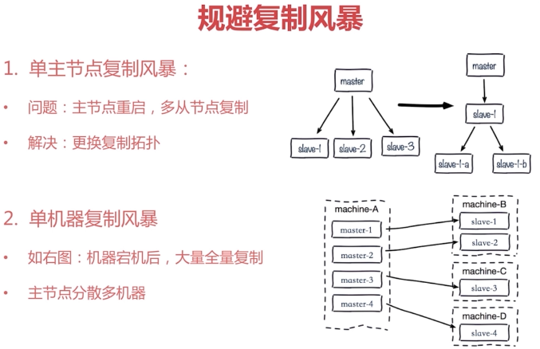

## 第9节 Redis Sentinel

### 9.1redis sentinel架构

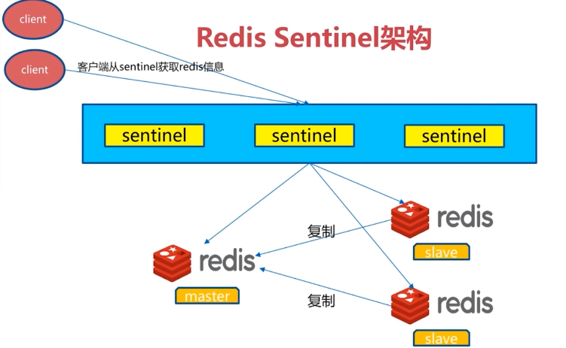

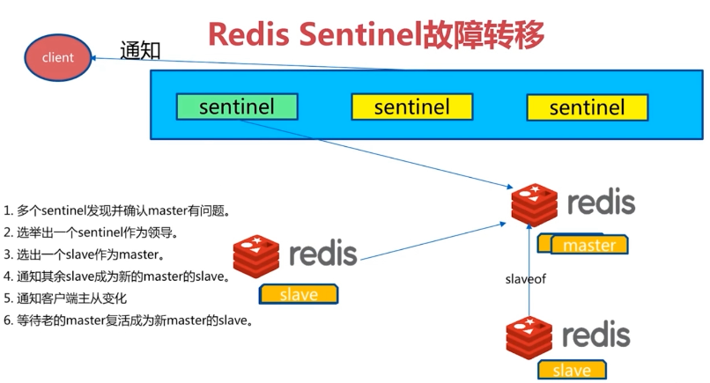

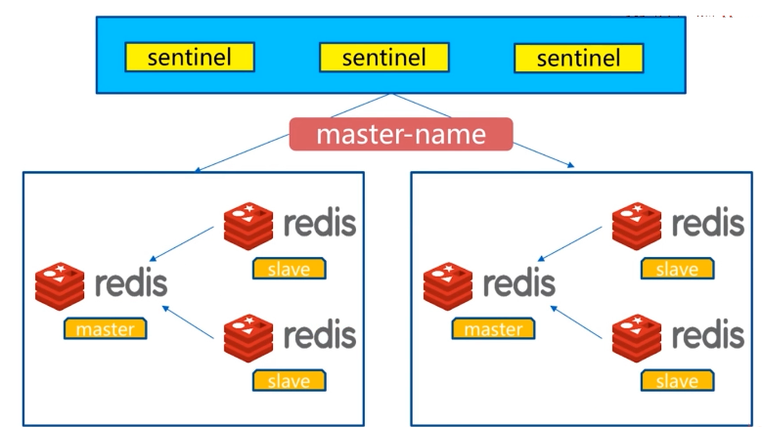

### 9.2redis sentinel安装与配置

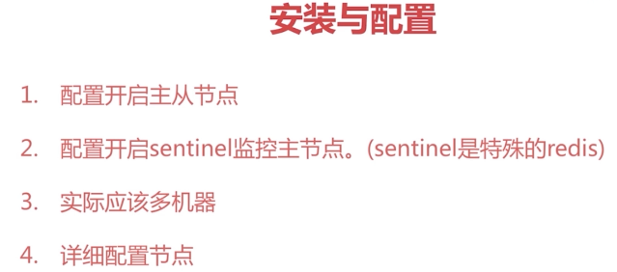

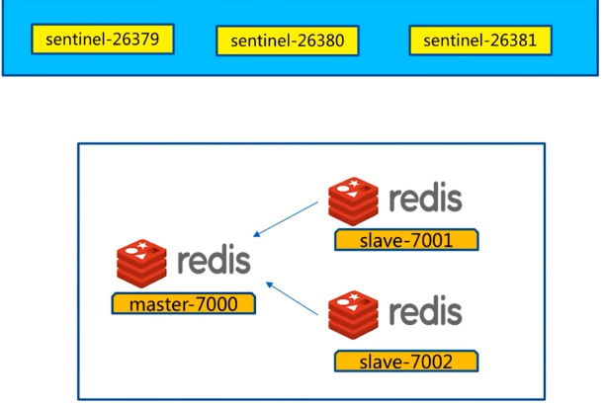

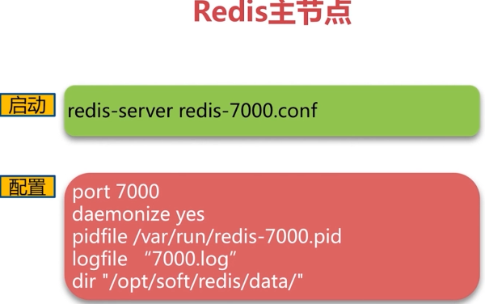

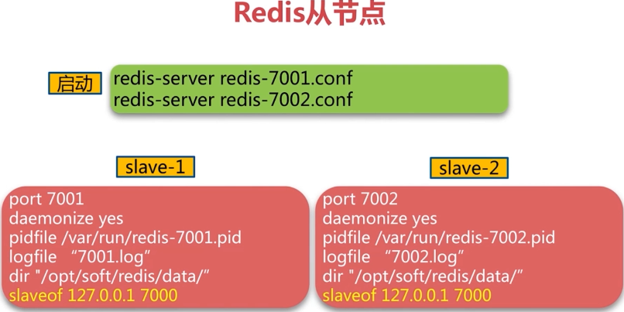

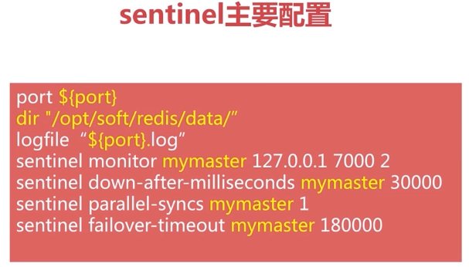

### 9.3redis-sentinel安装演示——redis主从复制安装

1）1主2从配置

$ vi redis-7000.conf

|  |
| --- |
| port 7000  daemonize yes  pidfile /var/run/redis-7000.pid  logfile "7000.log"  dir "/soft/redis/data" |

$ sed "s/7000/7001/g" redis-7000.conf > redis-7001.conf

$ echo "slaveof 127.0.0.1 7000" >> redis-7001.conf

|  |
| --- |
| port 7001  daemonize yes  pidfile /var/run/redis-7001.pid  logfile "7001.log"  dir "/soft/redis/data"  slaveof 127.0.0.1 7000 |

$ sed "s/7000/7002/g" redis-7000.conf > redis-7002.conf

$ echo "slaveof 127.0.0.1 7000" >> redis-7002.conf

|  |
| --- |
| port 7002  daemonize yes  pidfile /var/run/redis-7002.pid  logfile "7002.log"  dir "/soft/redis/data"  slaveof 127.0.0.1 7000 |

2）启动

$ redis-server redis-7000.conf

$ redis-cli -p 7000 ping

PONG

$ ps -ef | grep redis-server| grep 700

centos 1390 1 0 20:31 ? 00:00:00 redis-server *:7000

centos 1398 1 0 20:31 ? 00:00:00 redis-server *:7001

centos 1404 1 0 20:31 ? 00:00:00 redis-server *:7002

$ redis-cli -p 7000 info replication

# Replication

role:master

connected_slaves:2

slave0:ip=127.0.0.1,port=7001,state=online,offset=589,lag=0

slave1:ip=127.0.0.1,port=7002,state=online,offset=589,lag=1

master_repl_offset:589

repl_backlog_active:1

repl_backlog_size:1048576

repl_backlog_first_byte_offset:2

repl_backlog_histlen:588

### 9.4redis-sentinel安装演示——redis sentinel安装

1）配置3个sentinel

$ cp sentinel.conf ./conf/

$ cat sentinel.conf | grep -v "#" | grep -v "^$" > sentinel-26379.conf

$ vi sentinel-26379.conf

|  |
| --- |
| port 26379  daemonize yes  dir "/soft/redis-3.0.7/data"  logfile "26379.log"  sentinel monitor mymaster 127.0.0.1 7000 2  sentinel config-epoch mymaster 0  sentinel leader-epoch mymaster 0  sentinel known-slave mymaster 127.0.0.1 7002  # Generated by CONFIG REWRITE  maxclients 4064  sentinel known-slave mymaster 127.0.0.1 7001  sentinel known-sentinel mymaster 127.0.0.1 26380 b2bc83eaa10193faaf4f39d905f2a28777af0627  sentinel known-sentinel mymaster 127.0.0.1 26381 77b33eb673c7aee06dc3ca73b3ffc51b22cf1990  sentinel current-epoch 0 |

对比原始sentinel.conf

|  |
| --- |
| port 26379  dir /tmp  sentinel monitor mymaster 127.0.0.1 6379 2  sentinel down-after-milliseconds mymaster 30000  sentinel parallel-syncs mymaster 1  sentinel failover-timeout mymaster 180000 |

$ sed "s/26379/26380/g" sentinel-26379.conf > sentinel-26380.conf

$ sed "s/26379/26381/g" sentinel-26379.conf > sentinel-26381.conf

2）启动redis sentinel

$ redis-sentinel sentinel-26379.conf

$ redis-sentinel sentinel-26380.conf

$ redis-sentinel sentinel-26381.conf

$ ps -ef | grep redis-sentinel | grep 263

centos 1457 1 0 20:45 ? 00:00:02 redis-sentinel *:26379 [sentinel]

centos 1478 1 0 20:50 ? 00:00:01 redis-sentinel *:26380 [sentinel]

centos 1483 1 0 20:50 ? 00:00:01 redis-sentinel *:26381 [sentinel]

3）查看redis sentinel信息

$ redis-cli -p 26379 info sentinel

# Sentinel

sentinel_masters:1

sentinel_tilt:0

sentinel_running_scripts:0

sentinel_scripts_queue_length:0

master0:name=mymaster,status=ok,address=127.0.0.1:7000,slaves=2,sentinels=3

### 9.5使用Java客户端请求

1）客户端实现基本原理

·直连？

·redis-sentinel是服务端高可用

·客户端本身

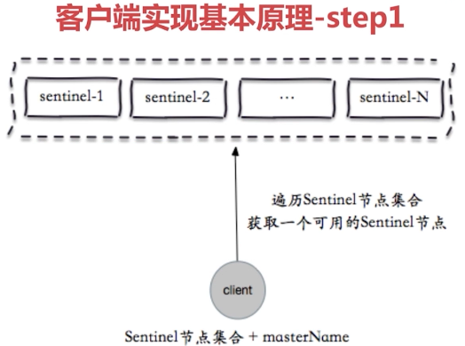

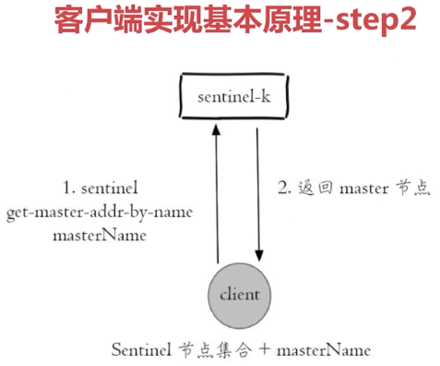

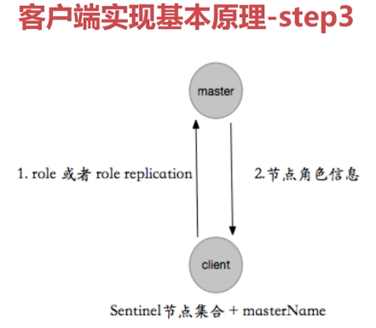

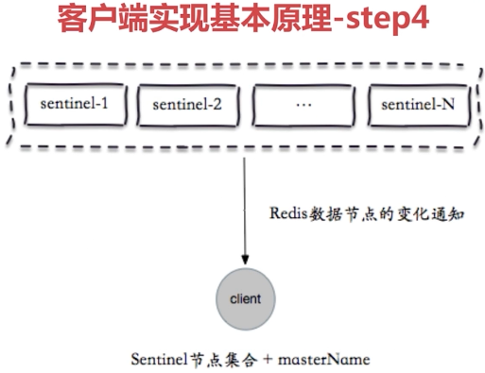

客户端订阅sentinel的一个获取mastername的频道

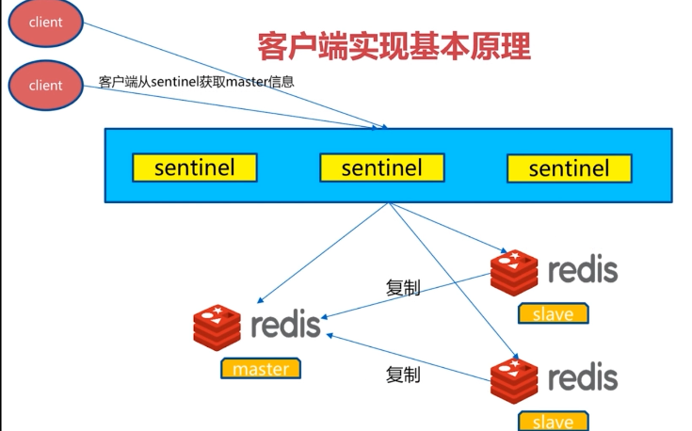

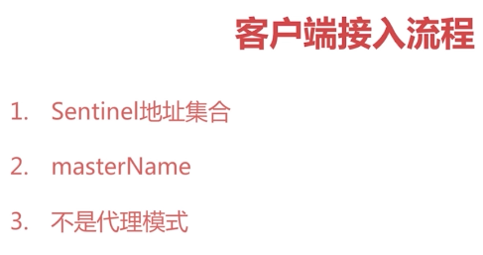

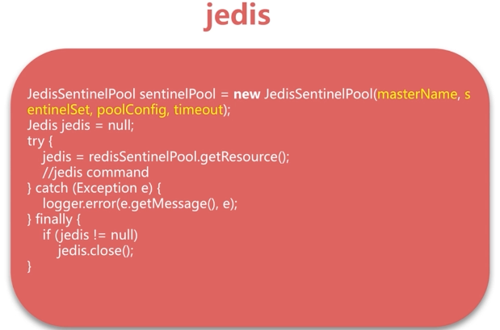

### 9.6实现原理--故障转移演练

1）故障转移演练

·客户端高可用观察（故障转移、客户端通知）

·服务端日志分析：数据节点和sentinel节点

|  |
| --- |
| **public** **class** RedisSentinelFailoverTest {  **private** **static** **final** Logger ***logger*** = LoggerFactory.*getLogger*(RedisSentinelFailoverTest.**class**);  **public** **static** **void** main(String[] args) {  String masterName = "mymaster";  Set<String> sentinels = **new** HashSet<String>();  sentinels.add("192.168.0.111:26379");  sentinels.add("192.168.0.111:26380");  sentinels.add("192.168.0.111:26381");  JedisSentinelPool jedisSentinelPool = **new** JedisSentinelPool(masterName,sentinels);    **while**(**true**) {  Jedis jedis = **null**;  **try** {  jedis = jedisSentinelPool.getResource();  **int** index = **new** Random().nextInt(100000);  String key = "k-" + index;  String value = "v-" + index;  jedis.set(key, value);  ***logger***.info("{} value is {}", key, jedis.get(key));  TimeUnit.***MILLISECONDS***.sleep(10);  } **catch** (Exception e) {  ***logger***.error(e.getMessage(),e);  } **finally** {  **if**(jedis != **null**) {  jedis.close();  }  }  }  }  } |

### 9.7实现原理--故障转移演练（客户端）

|  |
| --- |
| **public** **class** RedisSentinelFailoverTest {  **private** **static** **final** Logger ***logger*** = LoggerFactory.*getLogger*(RedisSentinelFailoverTest.**class**);  **public** **static** **void** main(String[] args) {  String masterName = "mymaster";  Set<String> sentinels = **new** HashSet<String>();  sentinels.add("192.168.0.111:26379");  sentinels.add("192.168.0.111:26380");  sentinels.add("192.168.0.111:26381");  JedisSentinelPool jedisSentinelPool = **new** JedisSentinelPool(masterName,sentinels);    **int** counter = 0;  **while**(**true**) {  Jedis jedis = **null**;  **try** {  jedis = jedisSentinelPool.getResource();  **int** index = **new** Random().nextInt(100000);  String key = "k-" + index;  String value = "v-" + index;  jedis.set(key, value);  **if**(counter % 100 == 0) {  ***logger***.info("{} value is {}", key, jedis.get(key));  }  TimeUnit.***MILLISECONDS***.sleep(10);  } **catch** (Exception e) {  ***logger***.error(e.getMessage(),e);  } **finally** {  **if**(jedis != **null**) {  jedis.close();  }  }  }  }  } |

$ kill -9 ${master pid}

默认30s故障转移；

### 9.7实现原理--故障演练（服务端日志分析）

### 执行kill -9 redis-master-pid后，的日志分析

7001.log

|  |
| --- |
| 1398:S 07 Jan 22:57:35.892 * MASTER <-> SLAVE sync started  1398:S 07 Jan 22:57:35.892 # Error condition on socket for SYNC: Connection refused  1398:S 07 Jan 22:57:36.452 * Discarding previously cached master state.  1398:S 07 Jan 22:57:36.452 * SLAVE OF 127.0.0.1:7002 enabled (user request from 'id=3 addr=127.0.0.1:33612 fd=7 name=sentinel-bd06cf6b-cmd age=7941 idle=0 flags=x db=0 sub=0 psub=0 multi=3 qbuf=133 qbuf-free=32635 obl=36 oll=0 omem=0 events=rw cmd=exec')  1398:S 07 Jan 22:57:36.452 # CONFIG REWRITE executed with success.  1398:S 07 Jan 22:57:36.898 * Connecting to MASTER 127.0.0.1:7002  1398:S 07 Jan 22:57:36.899 * MASTER <-> SLAVE sync started  1398:S 07 Jan 22:57:36.899 * Non blocking connect for SYNC fired the event.  1398:S 07 Jan 22:57:36.899 * Master replied to PING, replication can continue...  1398:S 07 Jan 22:57:36.900 * Partial resynchronization not possible (no cached master)  1398:S 07 Jan 22:57:36.901 * Full resync from master: 1aec4205255d354600dfc7b42deb7936078a50d0:1  1398:S 07 Jan 22:57:37.000 * MASTER <-> SLAVE sync: receiving 18 bytes from master  1398:S 07 Jan 22:57:37.001 * MASTER <-> SLAVE sync: Flushing old data  1398:S 07 Jan 22:57:37.001 * MASTER <-> SLAVE sync: Loading DB in memory  1398:S 07 Jan 22:57:37.001 * MASTER <-> SLAVE sync: Finished with success |

7002.log

|  |
| --- |
| 1404:S 07 Jan 22:57:34.692 * MASTER <-> SLAVE sync started  1404:S 07 Jan 22:57:34.692 # Error condition on socket for SYNC: Connection refused  1404:M 07 Jan 22:57:35.501 * Discarding previously cached master state.  1404:M 07 Jan 22:57:35.501 * MASTER MODE enabled (user request from 'id=3 addr=127.0.0.1:33518 fd=7 name=sentinel-bd06cf6b-cmd age=7940 idle=0 flags=x db=0 sub=0 psub=0 multi=3 qbuf=0 qbuf-free=32768 obl=36 oll=0 omem=0 events=rw cmd=exec')  1404:M 07 Jan 22:57:35.501 # CONFIG REWRITE executed with success.  1404:M 07 Jan 22:57:36.900 * Slave 127.0.0.1:7001 asks for synchronization  1404:M 07 Jan 22:57:36.900 * Full resync requested by slave 127.0.0.1:7001  1404:M 07 Jan 22:57:36.900 * Starting BGSAVE for SYNC with target: disk  1404:M 07 Jan 22:57:36.901 * Background saving started by pid 1702  1702:C 07 Jan 22:57:36.903 * DB saved on disk  1702:C 07 Jan 22:57:36.904 * RDB: 0 MB of memory used by copy-on-write  1404:M 07 Jan 22:57:37.000 * Background saving terminated with success  1404:M 07 Jan 22:57:37.000 * Synchronization with slave 127.0.0.1:7001 succeeded |

Redis-sentinel的信息

$ redis-cli -p 26379 info Sentinel

sentinel_masters:1

sentinel_tilt:0

sentinel_running_scripts:0

sentinel_scripts_queue_length:0

master0:name=mymaster,status=ok,address=127.0.0.1:7002,slaves=2,sentinels=3

Sentinel投票选举

26379.log

|  |
| --- |
| 1457:X 07 Jan 22:57:35.206 # +sdown master mymaster 127.0.0.1 7000  1457:X 07 Jan 22:57:35.308 # +odown master mymaster 127.0.0.1 7000 #quorum 2/2  1457:X 07 Jan 22:57:35.308 # +new-epoch 1  1457:X 07 Jan 22:57:35.308 # +try-failover master mymaster 127.0.0.1 7000  1457:X 07 Jan 22:57:35.311 # +vote-for-leader bd06cf6b780e28f7ec4e6180e5c99882315a7549 1  1457:X 07 Jan 22:57:35.316 # 127.0.0.1:26381 voted for bd06cf6b780e28f7ec4e6180e5c99882315a7549 1  1457:X 07 Jan 22:57:35.317 # 127.0.0.1:26380 voted for bd06cf6b780e28f7ec4e6180e5c99882315a7549 1  1457:X 07 Jan 22:57:35.374 # +elected-leader master mymaster 127.0.0.1 7000  1457:X 07 Jan 22:57:35.374 # +failover-state-select-slave master mymaster 127.0.0.1 7000  1457:X 07 Jan 22:57:35.446 # +selected-slave slave 127.0.0.1:7002 127.0.0.1 7002 @ mymaster 127.0.0.1 7000  1457:X 07 Jan 22:57:35.447 * +failover-state-send-slaveof-noone slave 127.0.0.1:7002 127.0.0.1 7002 @ mymaster 127.0.0.1 7000  1457:X 07 Jan 22:57:35.500 * +failover-state-wait-promotion slave 127.0.0.1:7002 127.0.0.1 7002 @ mymaster 127.0.0.1 7000  1457:X 07 Jan 22:57:36.379 # +promoted-slave slave 127.0.0.1:7002 127.0.0.1 7002 @ mymaster 127.0.0.1 7000  1457:X 07 Jan 22:57:36.379 # +failover-state-reconf-slaves master mymaster 127.0.0.1 7000  1457:X 07 Jan 22:57:36.452 * +slave-reconf-sent slave 127.0.0.1:7001 127.0.0.1 7001 @ mymaster 127.0.0.1 7000  1457:X 07 Jan 22:57:37.390 * +slave-reconf-inprog slave 127.0.0.1:7001 127.0.0.1 7001 @ mymaster 127.0.0.1 7000  1457:X 07 Jan 22:57:37.391 * +slave-reconf-done slave 127.0.0.1:7001 127.0.0.1 7001 @ mymaster 127.0.0.1 7000  1457:X 07 Jan 22:57:37.443 # -odown master mymaster 127.0.0.1 7000  1457:X 07 Jan 22:57:37.443 # +failover-end master mymaster 127.0.0.1 7000  1457:X 07 Jan 22:57:37.443 # +switch-master mymaster 127.0.0.1 7000 127.0.0.1 7002  1457:X 07 Jan 22:57:37.444 * +slave slave 127.0.0.1:7001 127.0.0.1 7001 @ mymaster 127.0.0.1 7002  1457:X 07 Jan 22:57:37.444 * +slave slave 127.0.0.1:7000 127.0.0.1 7000 @ mymaster 127.0.0.1 7002  1457:X 07 Jan 22:58:07.518 # +sdown slave 127.0.0.1:7000 127.0.0.1 7000 @ mymaster 127.0.0.1 7002 |

### 9.8三个定时任务

Redis Sentinel对失败判定、故障转移，通过三个定时任务实现这些过程。

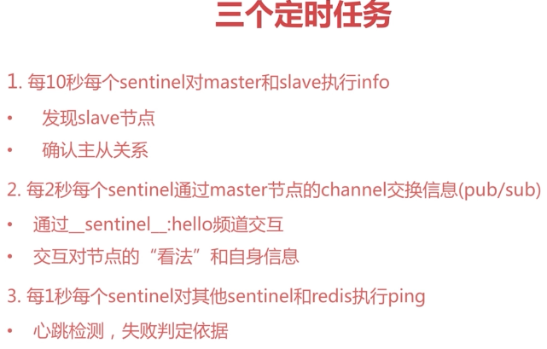

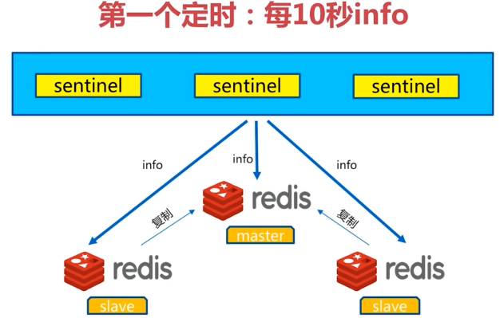

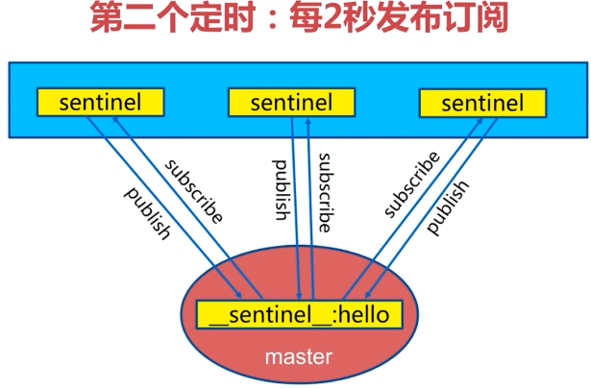

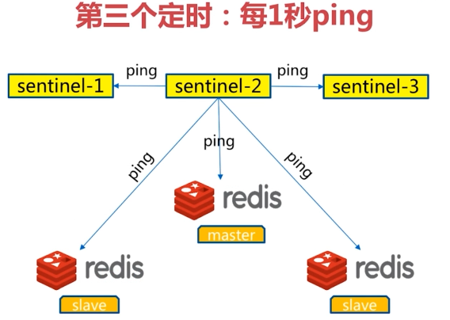

### 9.9主观下线和客观下线

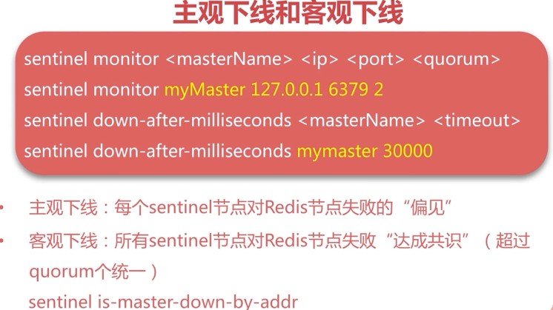

第二个定时任务实现

Quorum ~= n/2 +1（n通常为奇数）；

### 9.10领导者选举

故障转移之前，需要做领导者选举

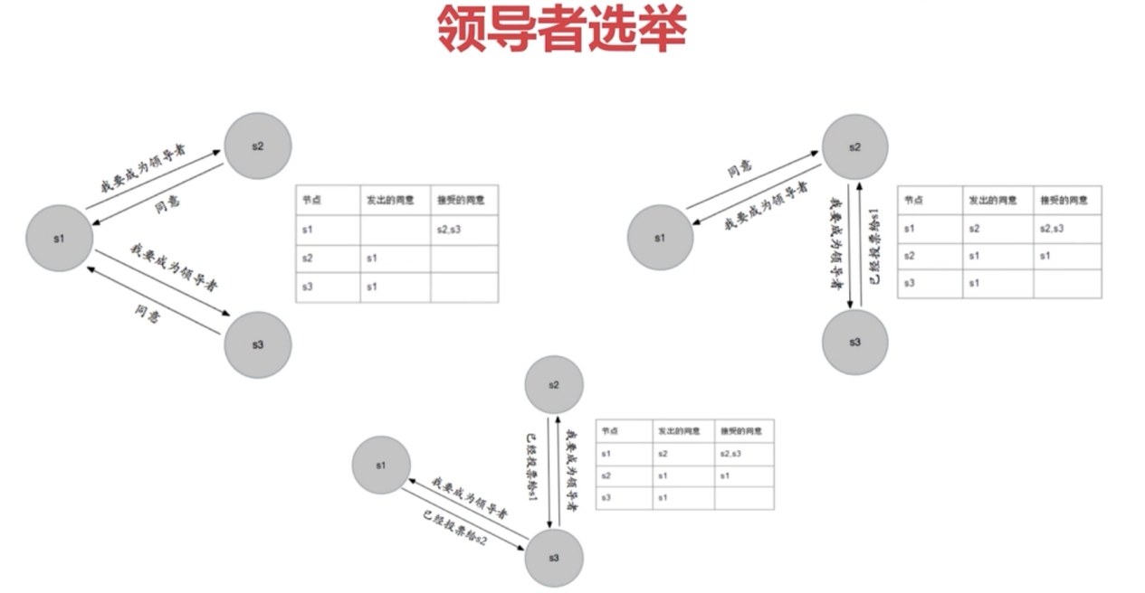

### 9.11故障转移（Sentinel领导者节点完成）

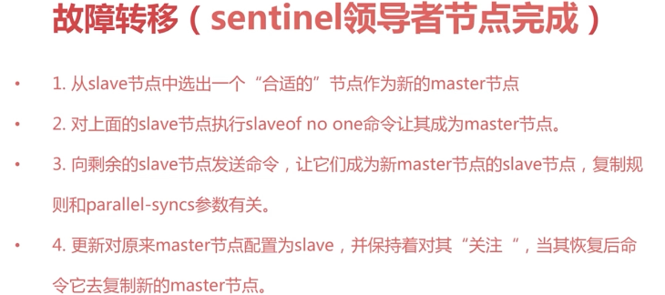

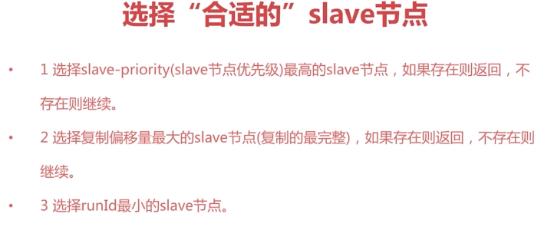

3.启动最早的节点

### 9.12常见开发运维问题



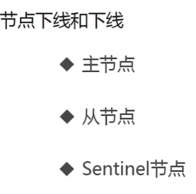



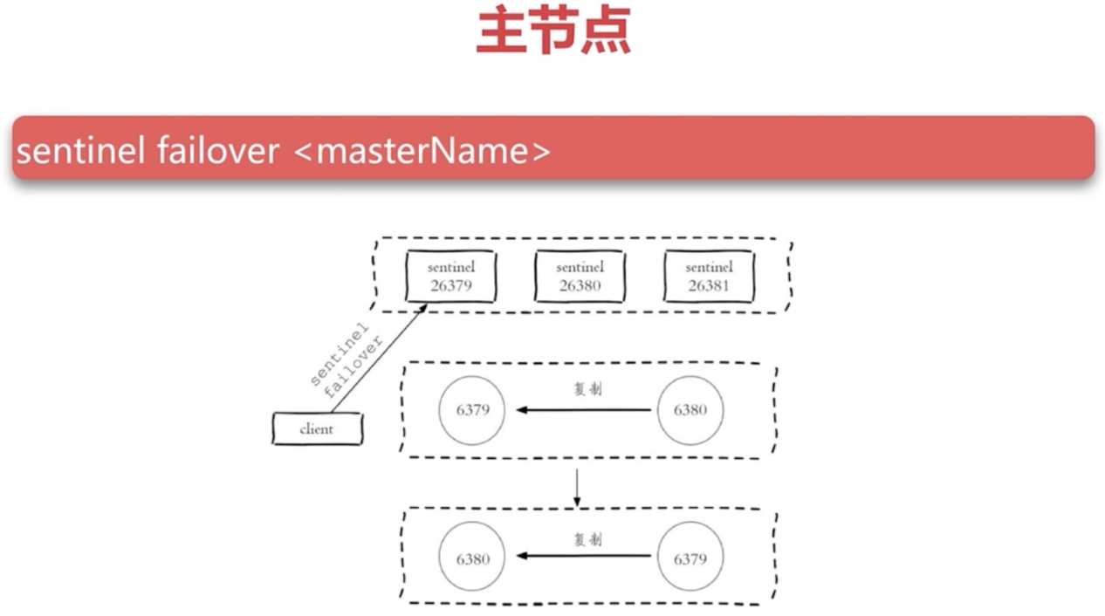



Slave节点正在被许多客户端读的场景；

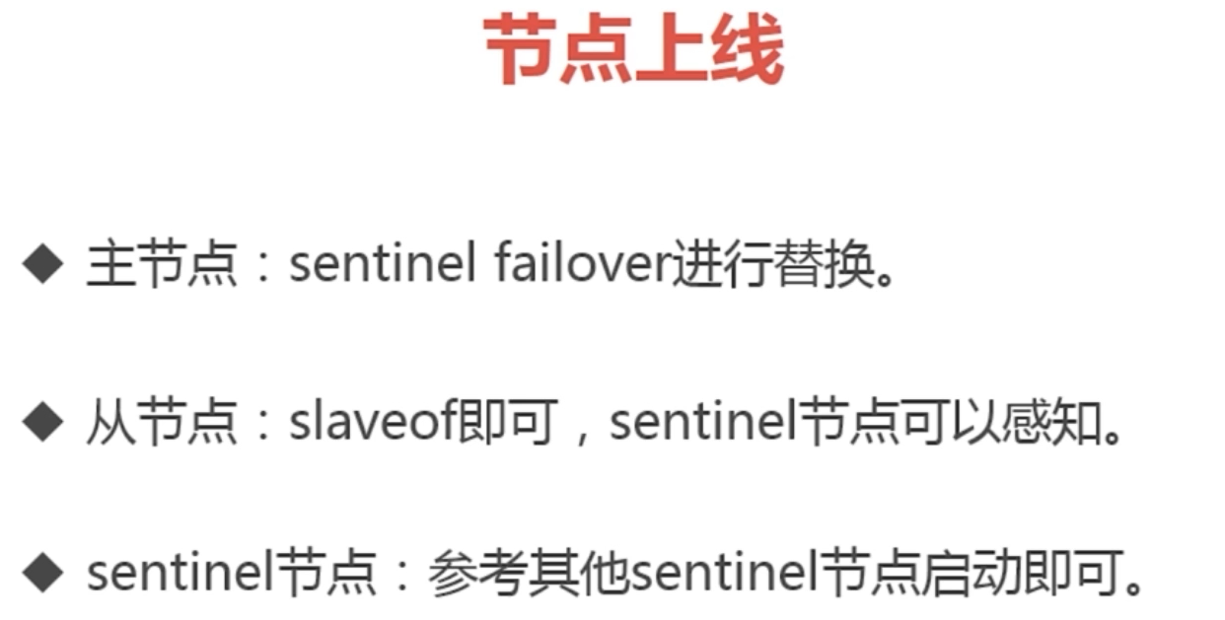

总结

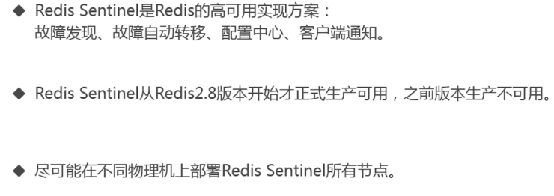

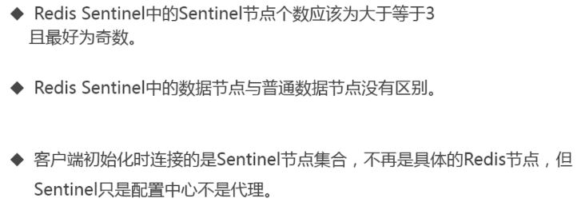

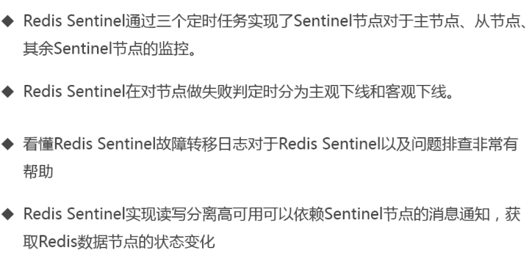

## 第10节初识Redis Cluster

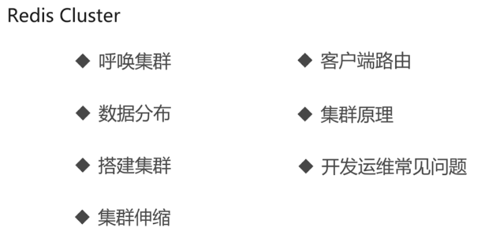

### 10.1呼唤集群

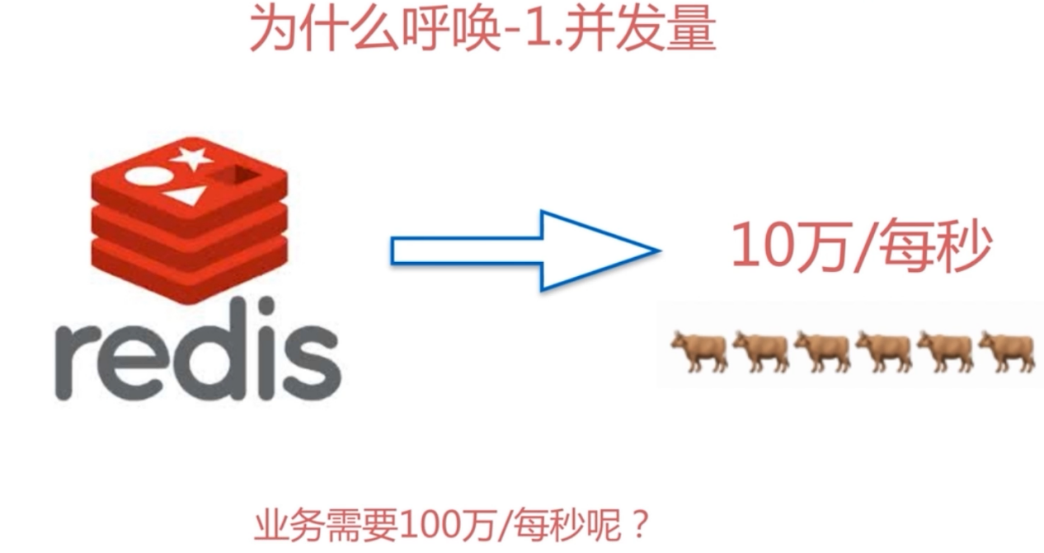

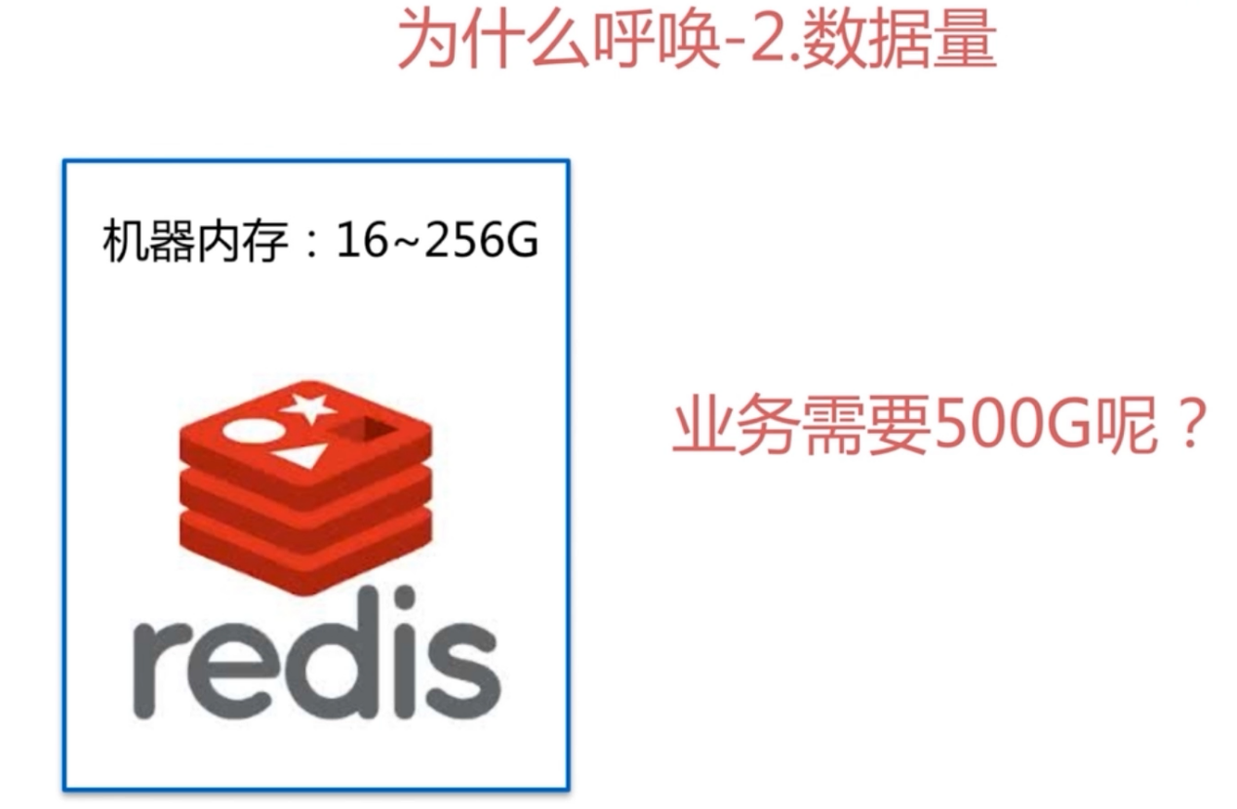

流量、网卡瓶颈，千兆网卡流量过万







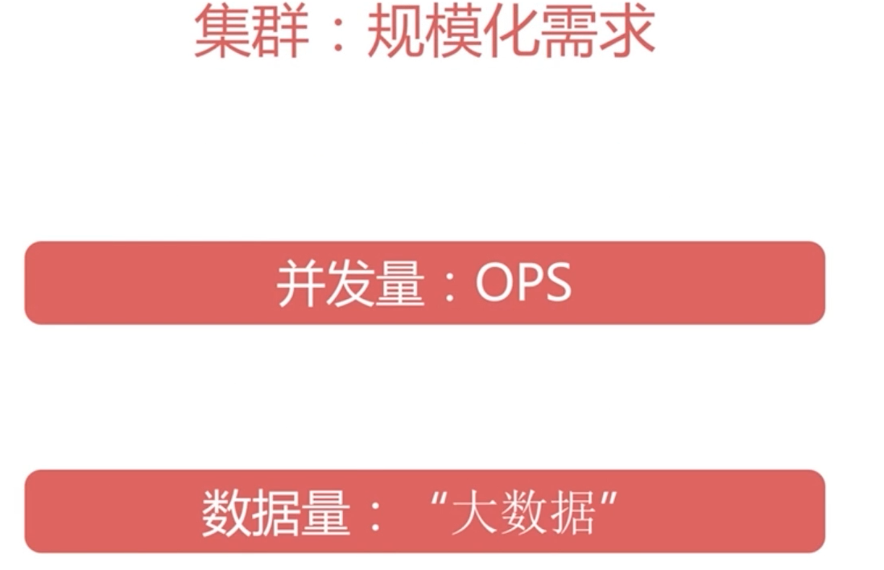

网络流量

### 10.2数据分布

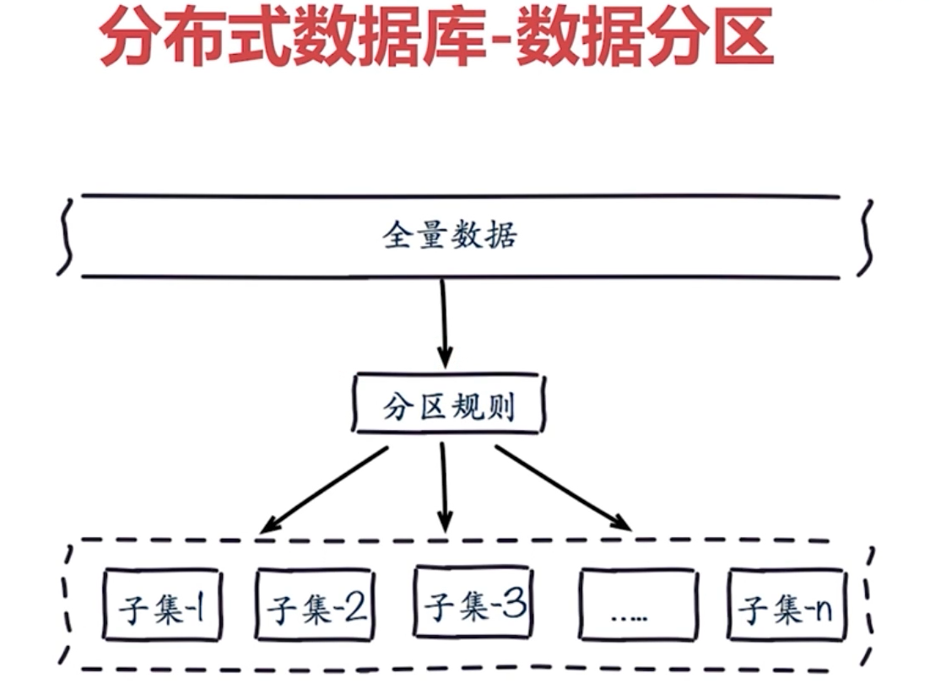

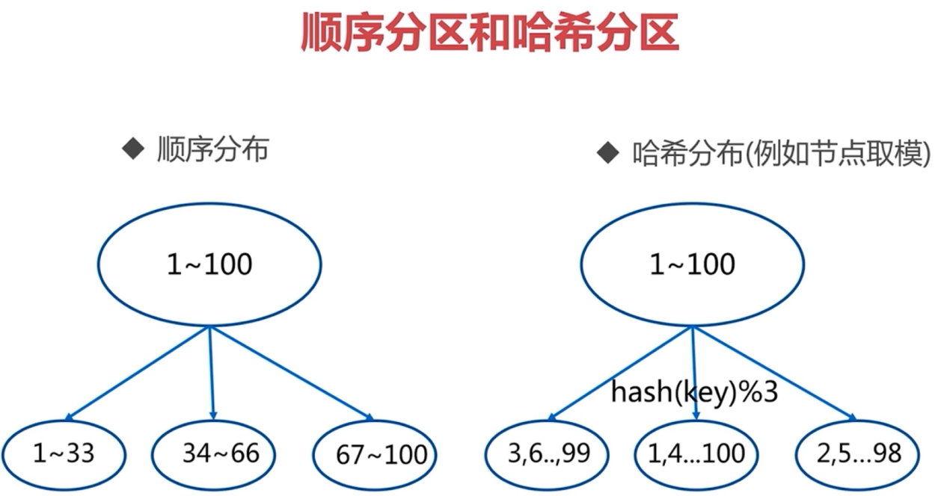

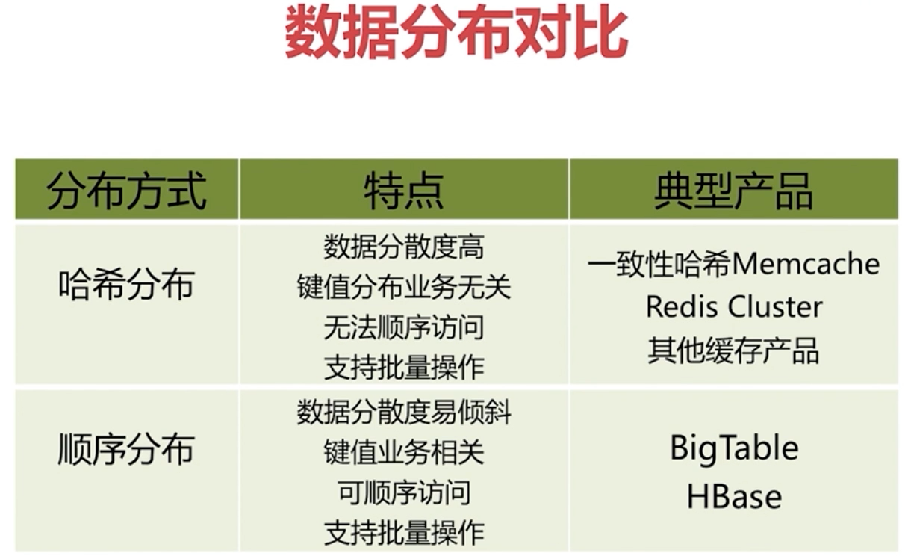



### 10.3节点分区取余

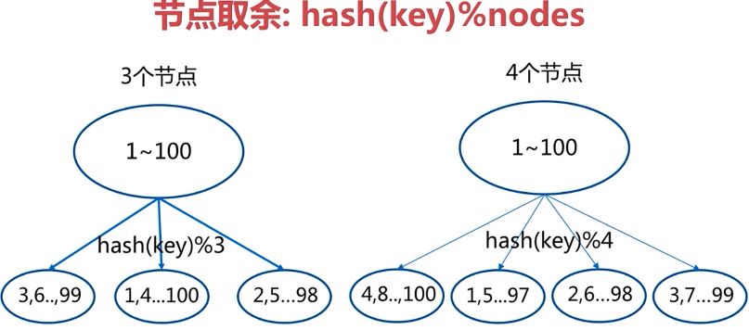

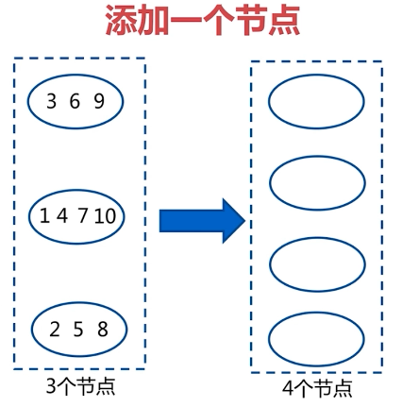

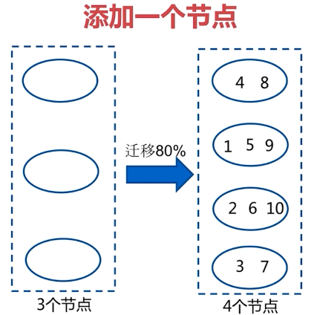

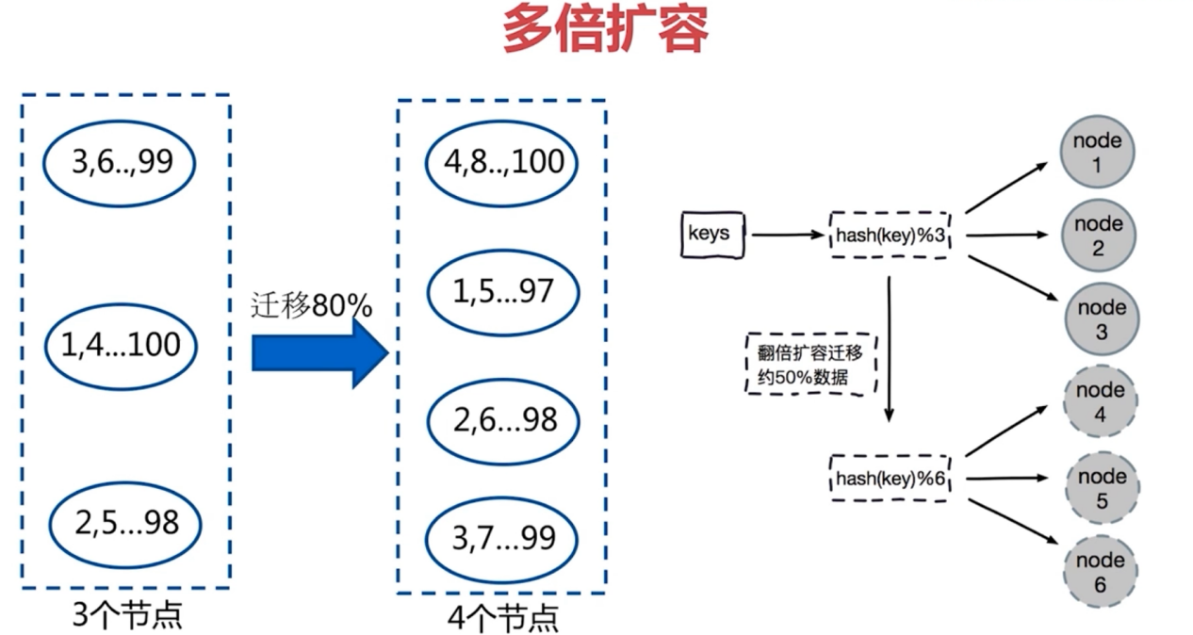

需要从数据库回写到Redis，还是有压力的；



### 10.4 一致性哈希分区

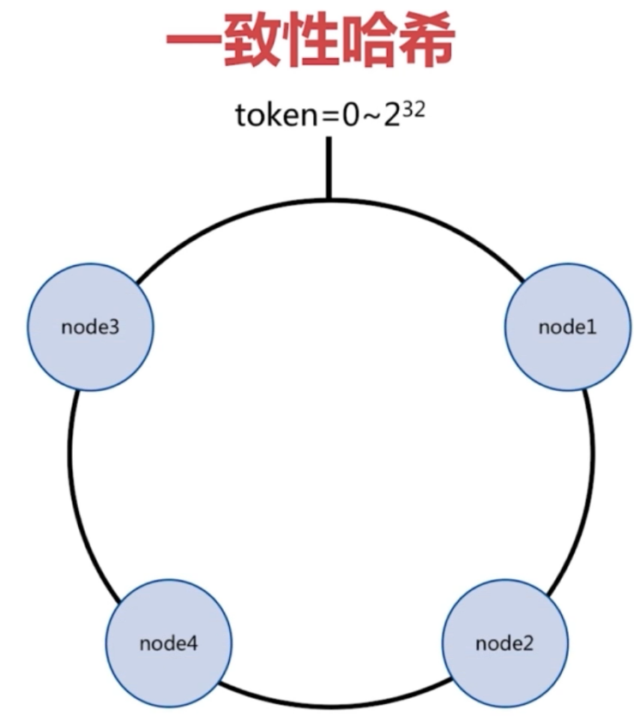

顺时针存储

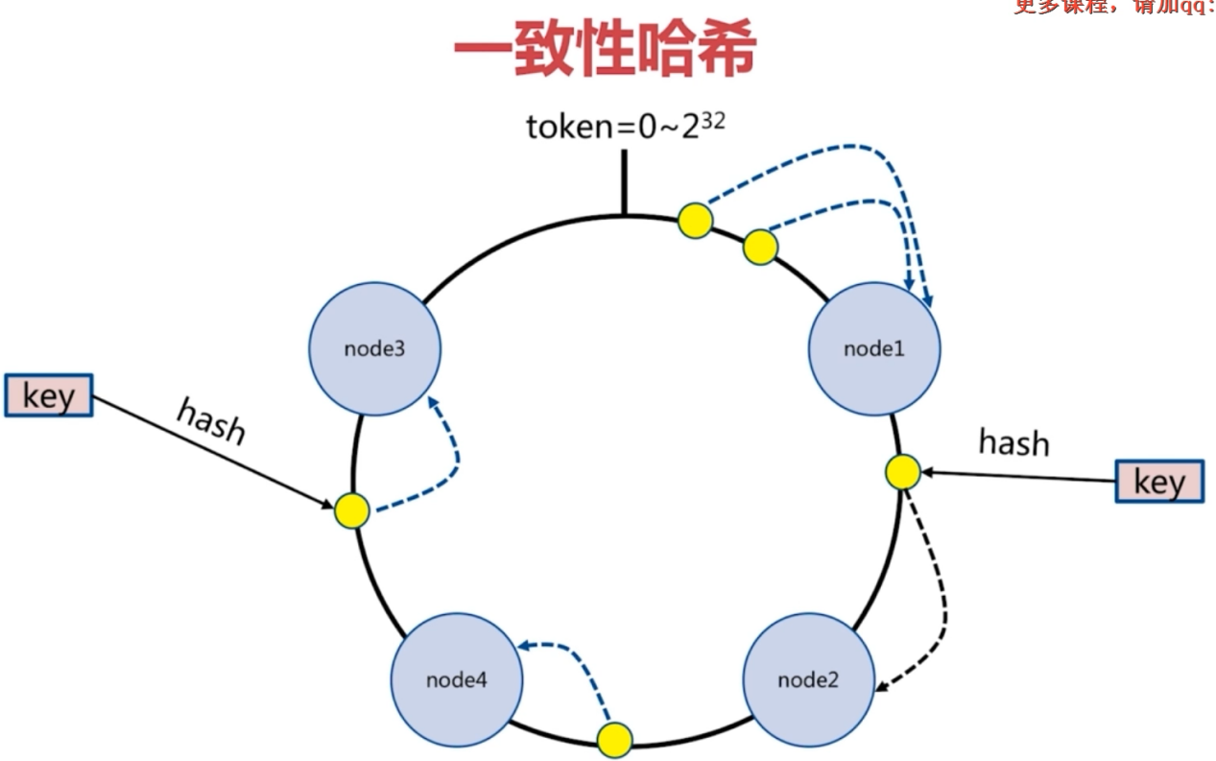

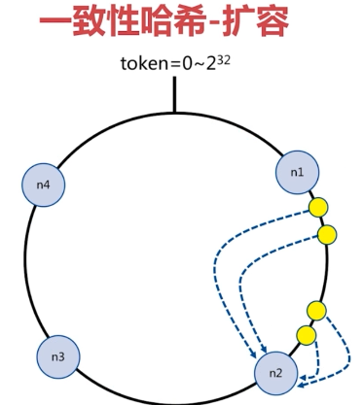

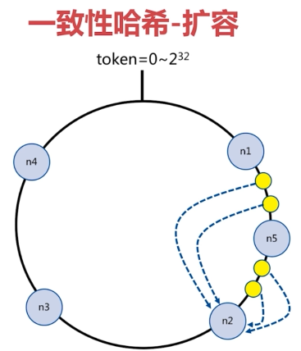

N1和n5之间本来存放在n2上的数据，下次访问，n1和n5之间的数据需要从数据库读，回写



### 10.5虚拟槽分区



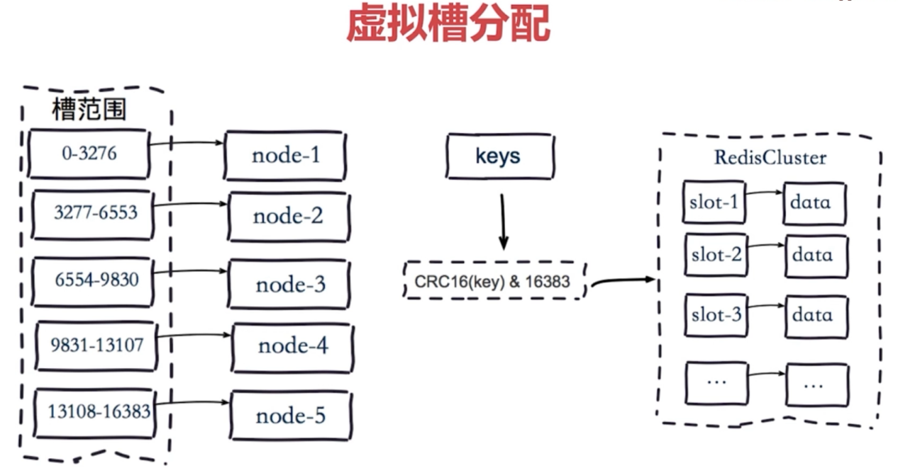

### 10.6Redis Cluster基本架构

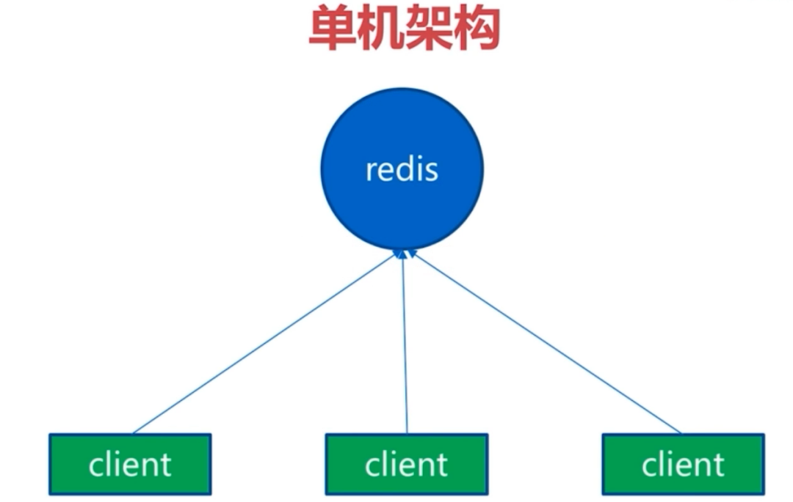



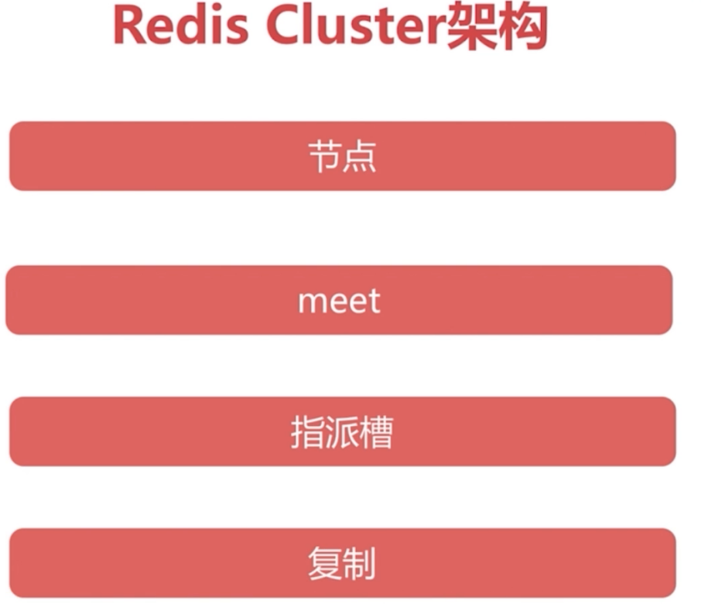

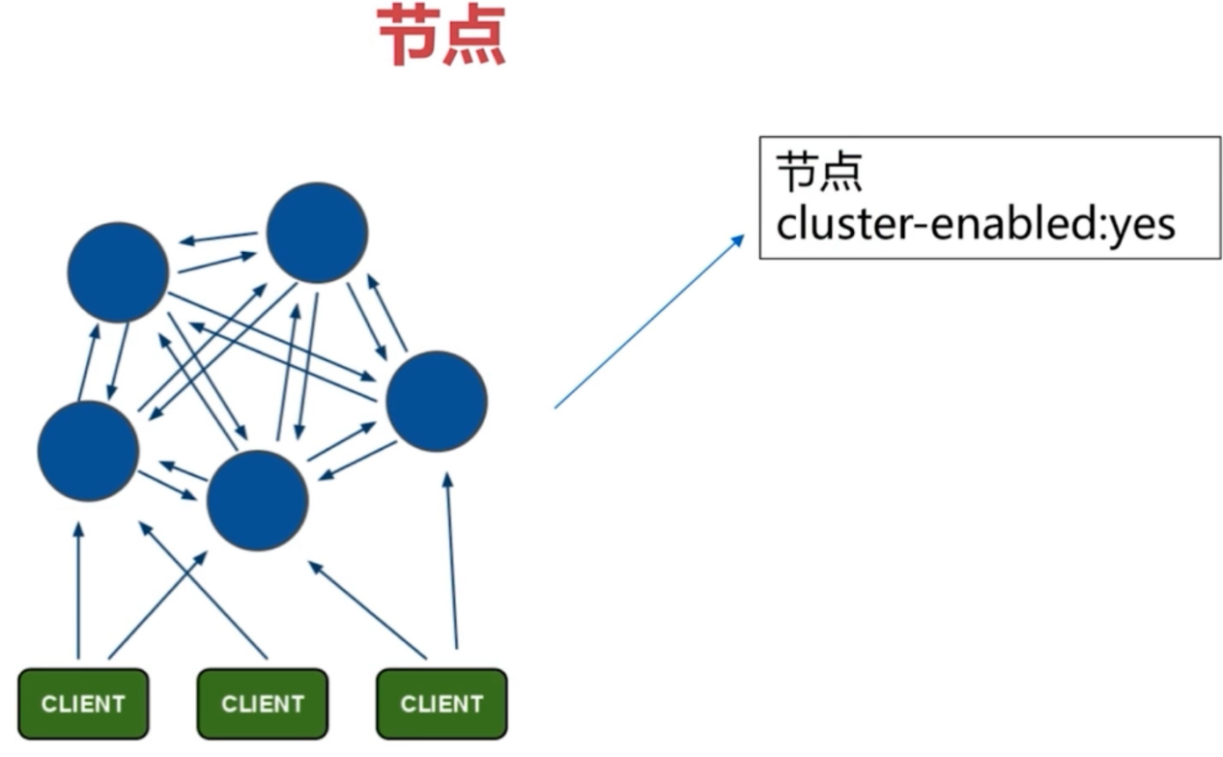

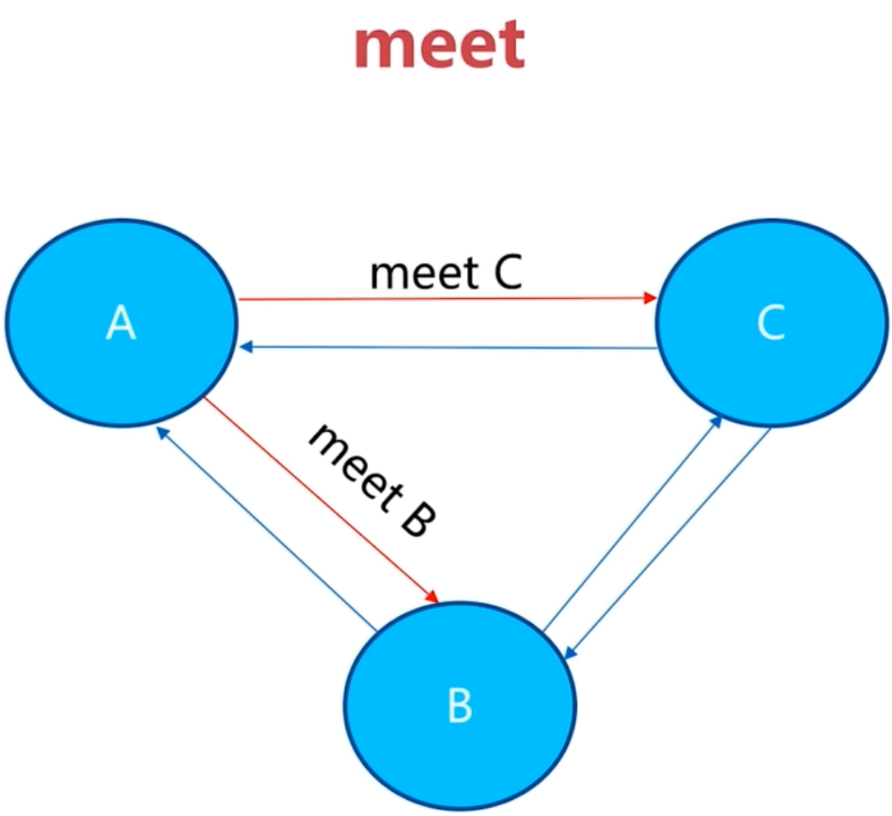

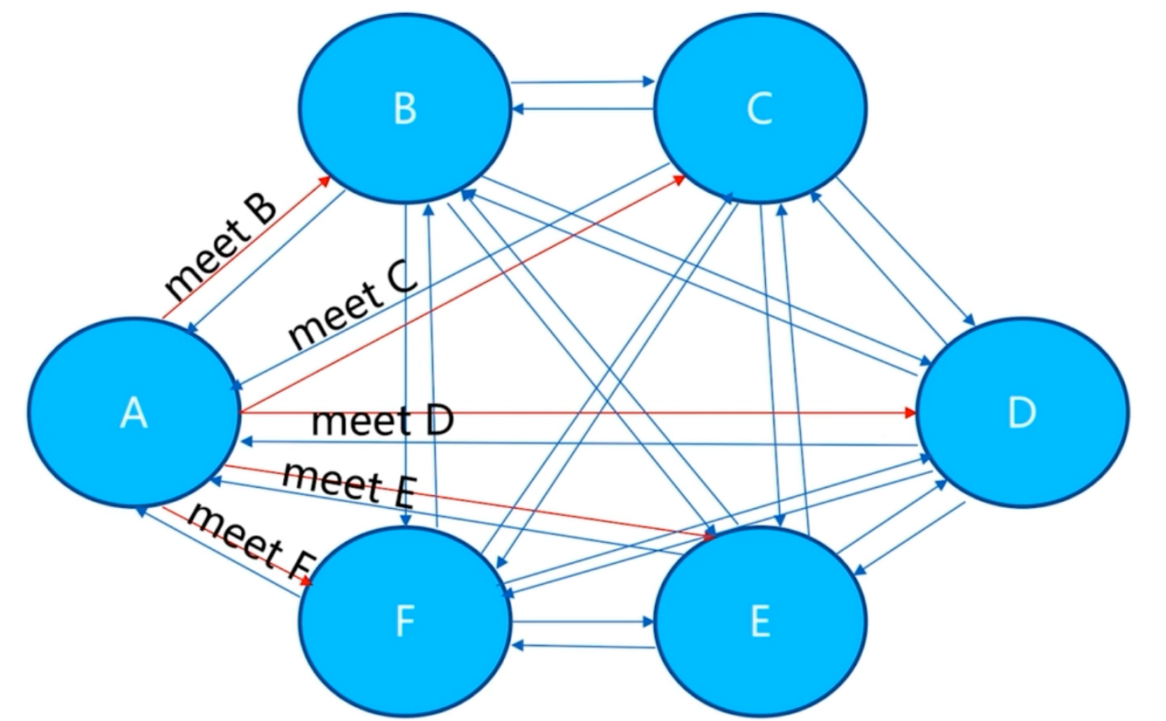

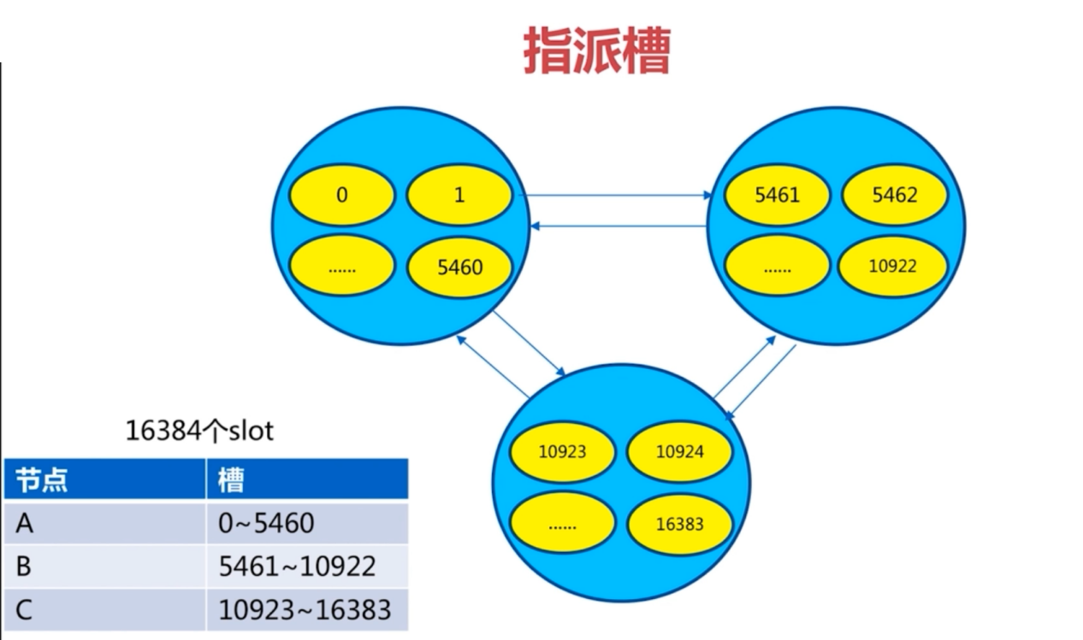

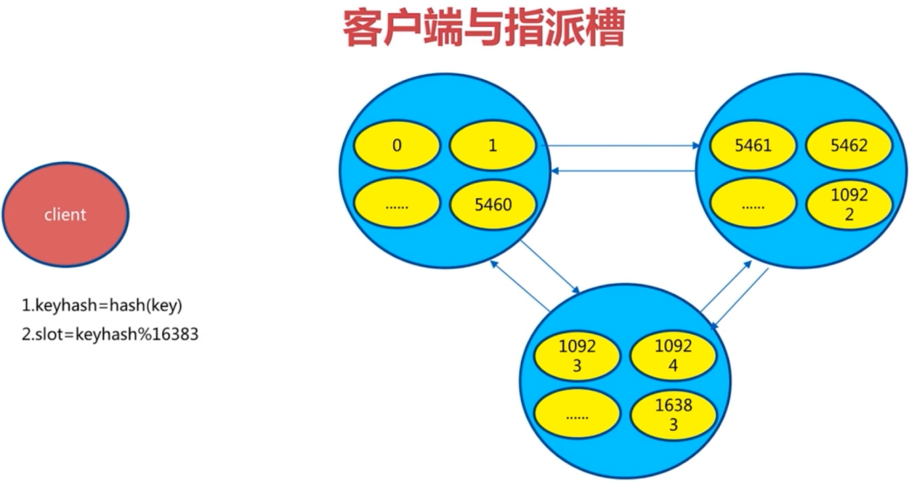

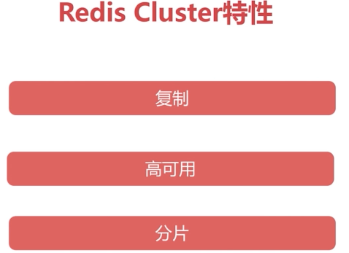

### 10.7原生命令安装



Ruby工具，一键安装



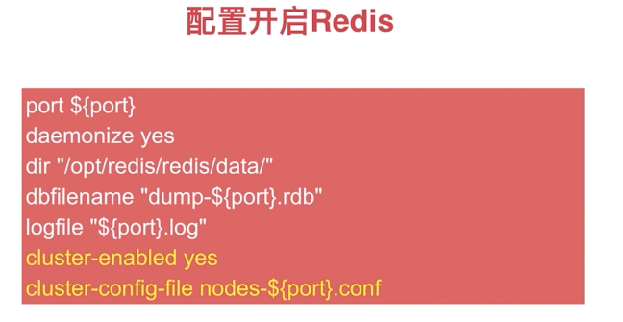

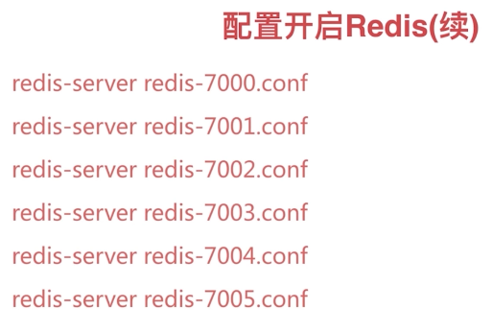

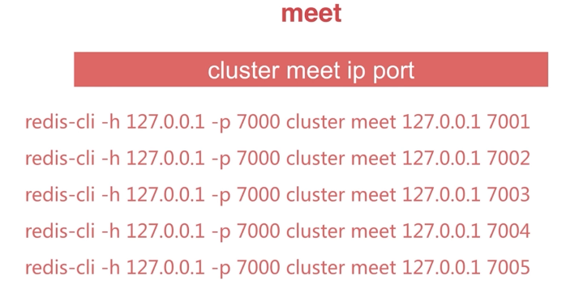

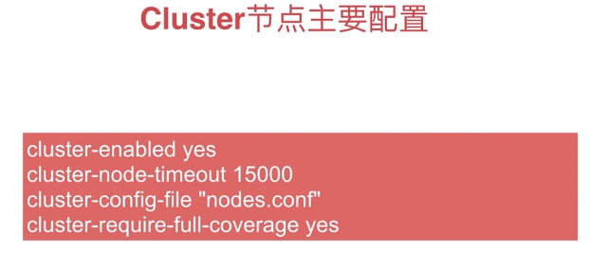

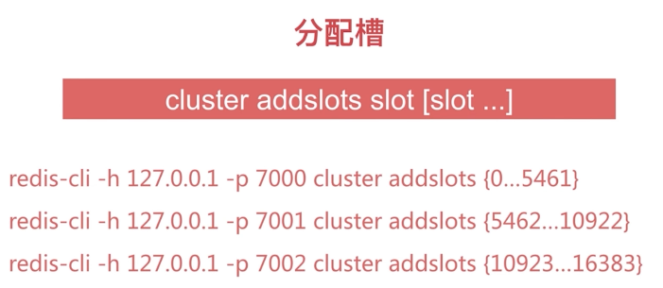

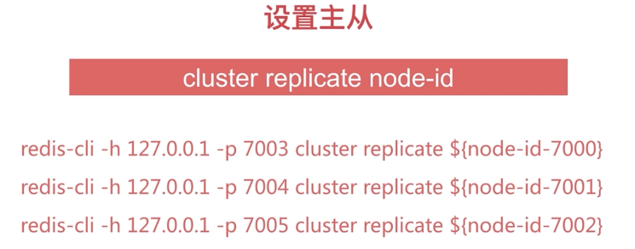

10.8原生安装--准备节点

|  |
| --- |
| [centos@s200 /soft/redis/conf]$vi redis-8000.conf  [centos@s200 /soft/redis/conf]$cat redis-8000.conf  port 8000  daemonize yes  pidfile /var/run/redis-8000.pid  logfile "8000.log"  dir "/soft/redis/data"  dbfilename "dump-8000.rdb"  cluster-enabled yes  cluster-config-file nodes-8000.conf  cluster-require-full-coverage no  [centos@s200 /soft/redis/conf]$sed 's/8000/8001/g' redis-8000.conf > redis-8001.conf  [centos@s200 /soft/redis/conf]$sed 's/8000/8002/g' redis-8000.conf > redis-8002.conf  [centos@s200 /soft/redis/conf]$sed 's/8000/8003/g' redis-8000.conf > redis-8003.conf  [centos@s200 /soft/redis/conf]$sed 's/8000/8004/g' redis-8000.conf > redis-8004.conf  [centos@s200 /soft/redis/conf]$sed 's/8000/8005/g' redis-8000.conf > redis-8005.conf  start-redis-all.sh  [centos@s200 /soft/redis/conf]$echo "redis-server redis-8000.conf" >> start-redis-all.sh  [centos@s200 /soft/redis/conf]$cat start-redis-all.sh  #! /bin/bash  redis-server redis-8000.conf  [centos@s200 /soft/redis/conf]$echo "redis-server redis-8001.conf" >> start-redis-all.sh  [centos@s200 /soft/redis/conf]$echo "redis-server redis-8002.conf" >> start-redis-all.sh  [centos@s200 /soft/redis/conf]$echo "redis-server redis-8003.conf" >> start-redis-all.sh  [centos@s200 /soft/redis/conf]$echo "redis-server redis-8004.conf" >> start-redis-all.sh  [centos@s200 /soft/redis/conf]$echo "redis-server redis-8005.conf" >> start-redis-all.sh  [centos@s200 /soft/redis/conf]$chmod 755 start-redis-all.sh  [centos@s200 /soft/redis/conf]$./start-redis-all.sh  [centos@s200 /soft/redis/conf]$ps -ef | grep redis-server | grep -v grep  centos 1447 1 0 22:01 ? 00:00:00 redis-server *:8000 [cluster]  centos 1476 1 0 22:04 ? 00:00:00 redis-server *:8001 [cluster]  centos 1478 1 0 22:04 ? 00:00:00 redis-server *:8002 [cluster]  centos 1480 1 0 22:04 ? 00:00:00 redis-server *:8003 [cluster]  centos 1482 1 0 22:04 ? 00:00:00 redis-server *:8004 [cluster]  centos 1488 1 0 22:04 ? 00:00:00 redis-server *:8005 [cluster]  [centos@s200 /soft/redis/conf]$redis-cli -p 8000  127.0.0.1:8000> set hello world  (error) CLUSTERDOWN The cluster is down  127.0.0.1:8000> exit  [centos@s200 /soft/redis/conf]$cd ../data/  [centos@s200 /soft/redis/data]$cat nodes-8000.conf  9a8e34d40bc97c47ebb9c24c68d0efaa1d6d7c9e :0 myself,master - 0 0 0 connected  vars currentEpoch 0 lastVoteEpoch 0  [centos@s200 /soft/redis/data]$redis-cli -p 8000 cluster nodes  9a8e34d40bc97c47ebb9c24c68d0efaa1d6d7c9e :8000 myself,master - 0 0 0 connected  [centos@s200 /soft/redis/data]$redis-cli -p 8000 cluster info  cluster_state:fail  cluster_slots_assigned:0  cluster_slots_ok:0  cluster_slots_pfail:0  cluster_slots_fail:0  cluster_known_nodes:1  cluster_size:0  cluster_current_epoch:0  cluster_my_epoch:0  cluster_stats_messages_sent:0  cluster_stats_messages_received:0 |

### 10.8原生命令安装--节点握手

|  |
| --- |
| [centos@s200 /soft/redis/conf]$vi meet-all.sh  [centos@s200 /soft/redis/conf]$cat meet-all.sh  #! /bin/bash  redis-cli -p 8000 cluster meet 192.168.0.111 8001  redis-cli -p 8000 cluster meet 192.168.0.111 8002  redis-cli -p 8000 cluster meet 192.168.0.111 8003  redis-cli -p 8000 cluster meet 192.168.0.111 8004  redis-cli -p 8000 cluster meet 192.168.0.111 8005  [centos@s200 /soft/redis/conf]$chmod 755 meet-all.sh  [centos@s200 /soft/redis/conf]$./meet-all.sh  OK  OK  OK  OK  OK  [centos@s200 /soft/redis/conf]$redis-cli -p 8000 cluster nodes  e1a4126a01a03a732d8030f76fcd8233066389ed 192.168.0.111:8002 master - 0 1547129623727 0 connected  5d258f75a61fb8a67e8f07d2e013d37ef9dcbb2c 192.168.0.111:8004 master - 0 1547129626241 5 connected  c67f0c063009f7177ae17716e767eacc91183e9e 192.168.0.111:8001 master - 0 1547129625236 4 connected  9a8e34d40bc97c47ebb9c24c68d0efaa1d6d7c9e 192.168.0.111:8000 myself,master - 0 0 1 connected  817d458606d41b98986a16e05065310f7e142d9a 192.168.0.111:8005 master - 0 1547129623225 3 connected  664b95cf9a2ad6fa7c2fa368934285a9bfbd32a3 192.168.0.111:8003 master - 0 1547129624230 2 connected  [centos@s200 /soft/redis/conf]$redis-cli -p 8001 cluster nodes  c67f0c063009f7177ae17716e767eacc91183e9e 192.168.0.111:8001 myself,master - 0 0 4 connected  664b95cf9a2ad6fa7c2fa368934285a9bfbd32a3 192.168.0.111:8003 master - 0 1547129633134 2 connected  9a8e34d40bc97c47ebb9c24c68d0efaa1d6d7c9e 192.168.0.111:8000 master - 0 1547129635144 1 connected  5d258f75a61fb8a67e8f07d2e013d37ef9dcbb2c 192.168.0.111:8004 master - 0 1547129630119 5 connected  e1a4126a01a03a732d8030f76fcd8233066389ed 192.168.0.111:8002 master - 0 1547129631124 0 connected  817d458606d41b98986a16e05065310f7e142d9a 192.168.0.111:8005 master - 0 1547129634139 3 connected  [centos@s200 /soft/redis/conf]$redis-cli -p 8002 cluster nodes  9a8e34d40bc97c47ebb9c24c68d0efaa1d6d7c9e 192.168.0.111:8000 master - 0 1547129646198 1 connected  817d458606d41b98986a16e05065310f7e142d9a 192.168.0.111:8005 master - 0 1547129645190 3 connected  664b95cf9a2ad6fa7c2fa368934285a9bfbd32a3 192.168.0.111:8003 master - 0 1547129644184 2 connected  e1a4126a01a03a732d8030f76fcd8233066389ed 192.168.0.111:8002 myself,master - 0 0 0 connected  c67f0c063009f7177ae17716e767eacc91183e9e 192.168.0.111:8001 master - 0 1547129641166 4 connected  5d258f75a61fb8a67e8f07d2e013d37ef9dcbb2c 192.168.0.111:8004 master - 0 1547129643178 5 connected  [centos@s200 /soft/redis/conf]$redis-cli -p 8002 cluster info  cluster_state:fail  cluster_slots_assigned:0  cluster_slots_ok:0  cluster_slots_pfail:0  cluster_slots_fail:0  cluster_known_nodes:6  cluster_size:0  cluster_current_epoch:5  cluster_my_epoch:0  cluster_stats_messages_sent:136  cluster_stats_messages_received:136  [centos@s200 /soft/redis/conf]$redis-cli -p 8000  127.0.0.1:8000> set hello world  (error) CLUSTERDOWN The cluster is down  127.0.0.1:8000> exit |

### 10.9原生命令--分配槽

|  |
| --- |
| vi add-slots-all.sh  [centos@s200 /soft/redis/sbin]$cat add-slots-all.sh  #! /bin/bash  start=$1  end=$2  port=$3  # 16384/3 0~5461 => 8000 | 5462~10922 => 8001 | 10923~16383 => 8002  for slot in `seq ${start} ${end}`  do  echo "slot:${slot}"  redis-cli -p ${port} cluster addslots ${slot}  Done  ./add-slots-all.sh 0 5461 8000  ./add-slots-all.sh 5462 10922 8001  ./add-slots-all.sh 10923 16383 8002  [centos@s200 /soft/redis/sbin]$redis-cli -p 8000 cluster info  cluster_state:ok  cluster_slots_assigned:16384  cluster_slots_ok:16384  cluster_slots_pfail:0  cluster_slots_fail:0  cluster_known_nodes:6  cluster_size:3  cluster_current_epoch:5  cluster_my_epoch:1  cluster_stats_messages_sent:2932  cluster_stats_messages_received:2932  [centos@s200 /soft/redis/sbin]$redis-cli -p 8005 cluster nodes  5d258f75a61fb8a67e8f07d2e013d37ef9dcbb2c 192.168.0.111:8004 master - 0 1547130986618 5 connected  e1a4126a01a03a732d8030f76fcd8233066389ed 192.168.0.111:8002 master - 0 1547130987121 0 connected 10923-16383  c67f0c063009f7177ae17716e767eacc91183e9e 192.168.0.111:8001 master - 0 1547130985612 4 connected 5462-10922  817d458606d41b98986a16e05065310f7e142d9a 192.168.0.111:8005 myself,master - 0 0 3 connected  664b95cf9a2ad6fa7c2fa368934285a9bfbd32a3 192.168.0.111:8003 master - 0 1547130984605 2 connected  9a8e34d40bc97c47ebb9c24c68d0efaa1d6d7c9e 192.168.0.111:8000 master - 0 1547130987625 1 connected 0-5461 |

### 10.10原生命令安装--分配主从

|  |
| --- |
| [centos@s200 /soft/redis/sbin]$redis-cli -p 8005 cluster nodes  5d258f75a61fb8a67e8f07d2e013d37ef9dcbb2c 192.168.0.111:8004 master - 0 1547130986618 5 connected  e1a4126a01a03a732d8030f76fcd8233066389ed 192.168.0.111:8002 master - 0 1547130987121 0 connected 10923-16383  c67f0c063009f7177ae17716e767eacc91183e9e 192.168.0.111:8001 master - 0 1547130985612 4 connected 5462-10922  817d458606d41b98986a16e05065310f7e142d9a 192.168.0.111:8005 myself,master - 0 0 3 connected  664b95cf9a2ad6fa7c2fa368934285a9bfbd32a3 192.168.0.111:8003 master - 0 1547130984605 2 connected  9a8e34d40bc97c47ebb9c24c68d0efaa1d6d7c9e 192.168.0.111:8000 master - 0 1547130987625 1 connected 0-5461  [centos@s200 /soft/redis/sbin]$redis-cli -p 8003 cluster replicate 9a8e34d40bc97c47ebb9c24c68d0efaa1d6d7c9e  OK  [centos@s200 /soft/redis/sbin]$redis-cli -p 8004 cluster replicate c67f0c063009f7177ae17716e767eacc91183e9e  OK  [centos@s200 /soft/redis/sbin]$redis-cli -p 8005 cluster replicate e1a4126a01a03a732d8030f76fcd8233066389ed  OK  [centos@s200 /soft/redis/sbin]$redis-cli -p 8000 cluster slots  1) 1) (integer) 10923  2) (integer) 16383  3) 1) "192.168.0.111"  2) (integer) 8002  4) 1) "192.168.0.111"  2) (integer) 8005  2) 1) (integer) 5462  2) (integer) 10922  3) 1) "192.168.0.111"  2) (integer) 8001  4) 1) "192.168.0.111"  2) (integer) 8004  3) 1) (integer) 0  2) (integer) 5461  3) 1) "192.168.0.111"  2) (integer) 8000  4) 1) "192.168.0.111"  2) (integer) 8003 |

高可用设置，可以充分利用三台机器

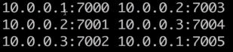

### 10.11Ruby环境准备

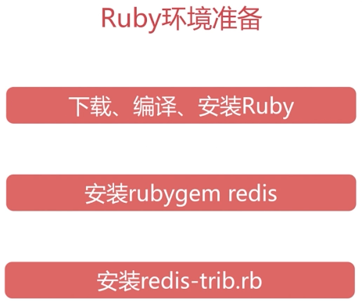

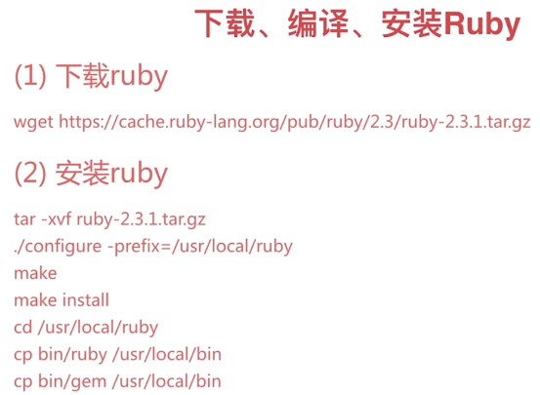

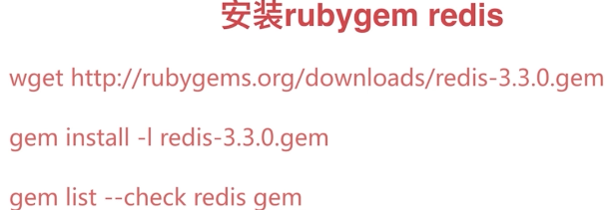

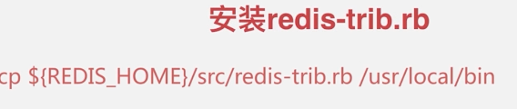

#安装ruby

|  |
| --- |
| 1101 wget https://cache.ruby-china.com/pub/ruby/ruby-2.3.1.tar.gz  1102 tar -zxvf ruby-2.3.1.tar.gz  1121 cd ruby-2.3.1  1122 ./configure --prefix=/usr/local/ruby  1123 make && make install |

# 安装ruby-redis客户端

|  |
| --- |
| wget <https://rubygems.global.ssl.fastly.net/gems/redis-3.3.0.gem>  sudo yum -y install zlib-devel  /usr/local/ruby/bin/gem install -l redis-3.3.0.gem  cd /soft/ruby-2.3.1/ext/zlib/  1029 ruby ./extconf.rb  1030 sudo make  1031 sudo make install  1036 sudo /usr/local/ruby/bin/gem install -l redis-3.3.0.gem  1037 sudo /usr/local/ruby/bin/gem list -- check redis gem  1038 cd redis/src/  1039 ./redis-trib.rb |

### 10.12Redis-trib构建集群



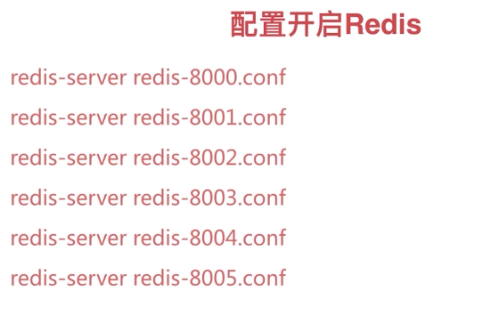

|  |
| --- |
| $ ps -ef | grep -v grep | grep redis-server | grep 800 | awk '{print $2}' | xargs kill  ./start-redis-all.sh  ps -ef | grep -v grep | grep redis-server  redis-cli -p 8000 cluster nodes  sudo cp /soft/redis-3.0.7/src/redis-trib.rb /usr/local/bin/  export PATH=/usr/local/ruby/bin/:$PATH  redis-trib.rb create --replicas 1 192.168.0.111:8000 192.168.0.111:8001 192.168.0.111:8002 192.168.0.111:8003 192.168.0.111:8004 192.168.0.111:8005  >>> Creating cluster  >>> Performing hash slots allocation on 6 nodes...  Using 3 masters:  192.168.0.111:8000  192.168.0.111:8001  192.168.0.111:8002  Adding replica 192.168.0.111:8003 to 192.168.0.111:8000  Adding replica 192.168.0.111:8004 to 192.168.0.111:8001  Adding replica 192.168.0.111:8005 to 192.168.0.111:8002  M: ea8a80e648f4ac7cabe30a53c566bc6e194e2582 192.168.0.111:8000  slots:0-5460 (5461 slots) master  M: 2f9b9e098e35f0df4f4a5da5140953a0f9a750b2 192.168.0.111:8001  slots:5461-10922 (5462 slots) master  M: 86ed2a76a98daedf3f2eedda27b8f3079874b536 192.168.0.111:8002  slots:10923-16383 (5461 slots) master  S: 9ebfb9f40c7eb98da485f918eb830e9329b1a3cf 192.168.0.111:8003  replicates ea8a80e648f4ac7cabe30a53c566bc6e194e2582  S: 59e7bd192c26e0153f025dededace973a01130ac 192.168.0.111:8004  replicates 2f9b9e098e35f0df4f4a5da5140953a0f9a750b2  S: f10c1d9a69cc53d15d76e3fcd68066026475e76b 192.168.0.111:8005  replicates 86ed2a76a98daedf3f2eedda27b8f3079874b536  Can I set the above configuration? (type 'yes' to accept): yes  >>> Nodes configuration updated  >>> Assign a different config epoch to each node  >>> Sending CLUSTER MEET messages to join the cluster  Waiting for the cluster to join......  >>> Performing Cluster Check (using node 192.168.0.111:8000)  M: ea8a80e648f4ac7cabe30a53c566bc6e194e2582 192.168.0.111:8000  slots:0-5460 (5461 slots) master  M: 2f9b9e098e35f0df4f4a5da5140953a0f9a750b2 192.168.0.111:8001  slots:5461-10922 (5462 slots) master  M: 86ed2a76a98daedf3f2eedda27b8f3079874b536 192.168.0.111:8002  slots:10923-16383 (5461 slots) master  M: 9ebfb9f40c7eb98da485f918eb830e9329b1a3cf 192.168.0.111:8003  slots: (0 slots) master  replicates ea8a80e648f4ac7cabe30a53c566bc6e194e2582  M: 59e7bd192c26e0153f025dededace973a01130ac 192.168.0.111:8004  slots: (0 slots) master  replicates 2f9b9e098e35f0df4f4a5da5140953a0f9a750b2  M: f10c1d9a69cc53d15d76e3fcd68066026475e76b 192.168.0.111:8005  slots: (0 slots) master  replicates 86ed2a76a98daedf3f2eedda27b8f3079874b536  [OK] All nodes agree about slots configuration.  >>> Check for open slots...  >>> Check slots coverage...  [OK] All 16384 slots covered. |

### 10.13原生命令和redis-trib.rb对比

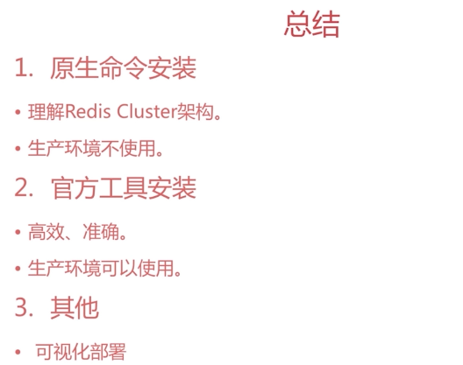

## 深入Redis Cluster.

### 11.1集群伸缩原理

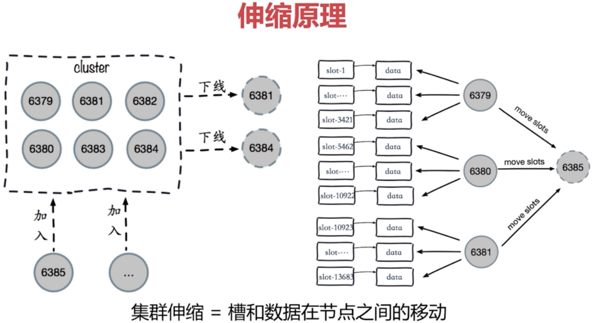

### 11.2扩展集群

1）加入节点



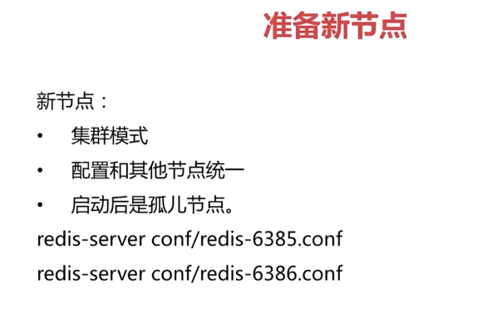

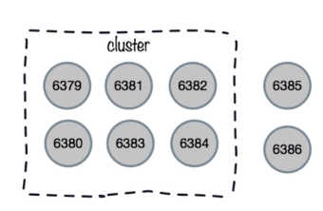

2）加入集群

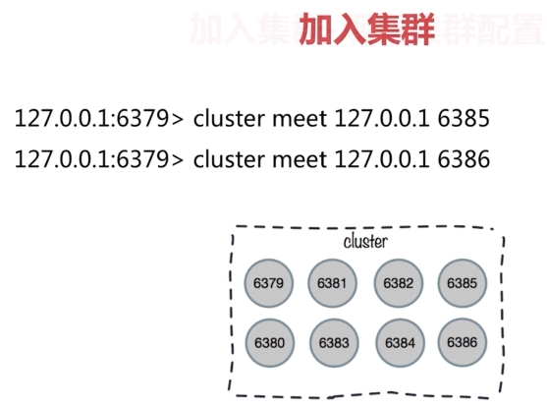

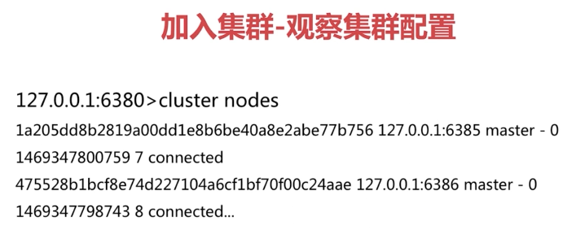



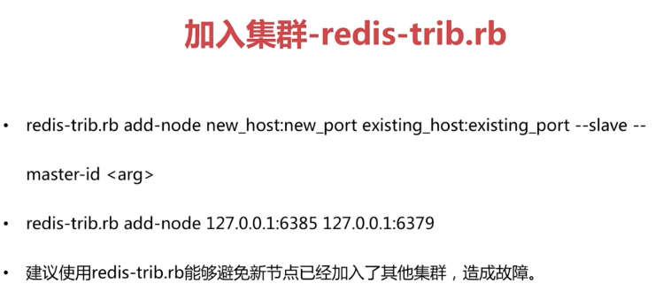

3）迁移槽和数据



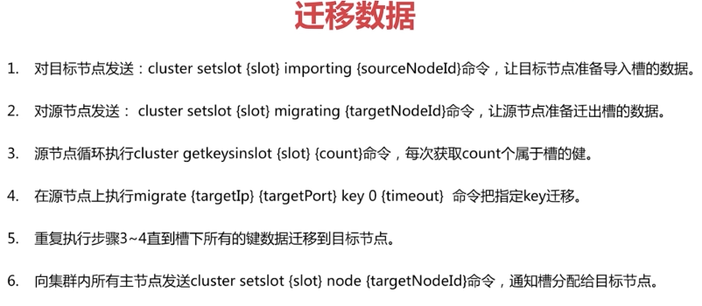

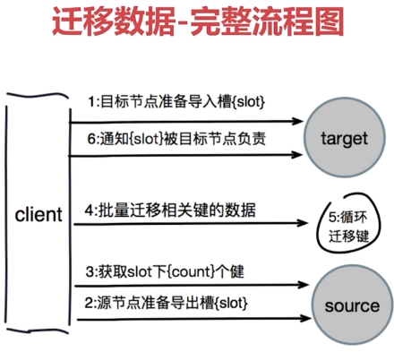

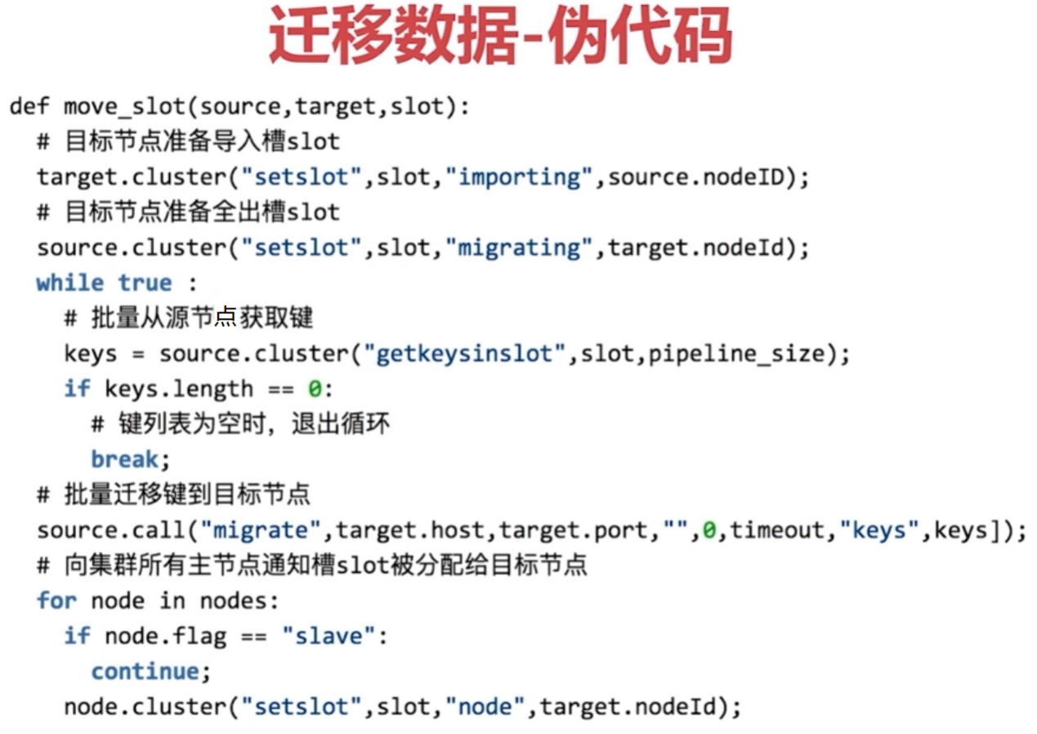

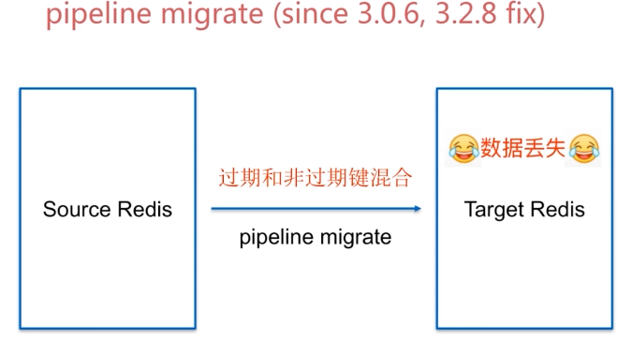



### 10.3集群扩容演示

1）添加一组主从节点

|  |
| --- |
| 1037 cd ../conf/  1038 ll  1039 sed 's/8000/8006/g' redis-8000.conf > redis-8006.conf  1040 sed 's/8000/8007/g' redis-8000.conf > redis-8007.conf  1041 cat redis-8006.conf  1042 redis-server redis-8006.conf  1043 redis-server redis-8007.conf  1044 redis-cli -p 8006 cluster nodes  1045 redis-cli -p 8000 cluster meet 192.168.0.111 8006  1046 redis-cli -p 8000 cluster nodes  1047 redis-cli -p 8000 cluster meet 192.168.0.111 8007  1048 redis-cli -p 8007 cluster replicate e757b40ffbb9013bc5a43db01a4cf2b4e9b8c93c  1049 redis-cli -p 8000 cluster nodes |

2）添加槽

|  |
| --- |
| redis-trib.rb reshard 192.168.0.111:8000  #4096  #8006的ID  #yes  [centos@s200 /soft/redis-3.0.7/conf]$redis-cli -p 8000 cluster slots  1) 1) (integer) 6827  2) (integer) 10922  3) 1) "192.168.0.111"  2) (integer) 8001  4) 1) "192.168.0.111"  2) (integer) 8004  2) 1) (integer) 12288  2) (integer) 16383  3) 1) "192.168.0.111"  2) (integer) 8002  4) 1) "192.168.0.111"  2) (integer) 8005  3) 1) (integer) 1365  2) (integer) 5460  3) 1) "192.168.0.111"  2) (integer) 8000  4) 1) "192.168.0.111"  2) (integer) 8003  4) 1) (integer) 0  2) (integer) 1364  3) 1) "192.168.0.111"  2) (integer) 8006  4) 1) "192.168.0.111"  2) (integer) 8007  5) 1) (integer) 5461  2) (integer) 6826  3) 1) "192.168.0.111"  2) (integer) 8006  4) 1) "192.168.0.111"  2) (integer) 8007  6) 1) (integer) 10923  2) (integer) 12287  3) 1) "192.168.0.111"  2) (integer) 8006  4) 1) "192.168.0.111"  2) (integer) 8007  [centos@s200 /soft/redis-3.0.7/conf]$redis-cli -p 8000 cluster nodes | grep master  2f9b9e098e35f0df4f4a5da5140953a0f9a750b2 192.168.0.111:8001 master - 0 1547138068258 2 connected 6827-10922  86ed2a76a98daedf3f2eedda27b8f3079874b536 192.168.0.111:8002 master - 0 1547138072278 3 connected 12288-16383  ea8a80e648f4ac7cabe30a53c566bc6e194e2582 192.168.0.111:8000 myself,master - 0 0 1 connected 1365-5460  e757b40ffbb9013bc5a43db01a4cf2b4e9b8c93c 192.168.0.111:8006 master - 0 1547138070269 8 connected 0-1364 5461-6826 10923-12287 |

### 10.4集群收缩

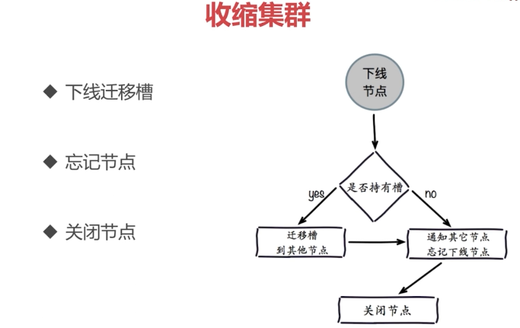

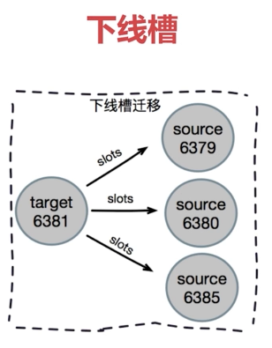

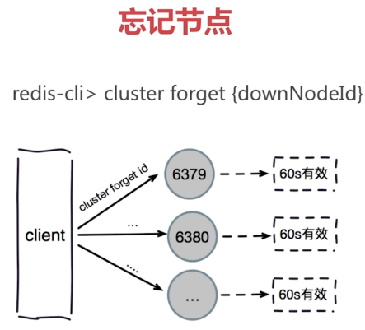

### 10.5集群收缩演示

1）槽和数据的迁移

|  |
| --- |
| redis-cli -p 8000 cluster nodes  redis-trib.rb reshard --from ${redis-8006-node-id} --to ${reids-8000-node-id} --slots 1366 192.168.0.111:8006  redis-trib.rb reshard --from ${redis-8006-node-id} --to ${reids-8001-node-id} --slots 1366 192.168.0.111:8006  redis-trib.rb reshard --from ${redis-8006-node-id} --to ${reids-8002-node-id} --slots 1366 192.168.0.111:8006  # 查看槽的迁移状况  redis-cli -p 8000 cluster nodes |

2）忘记节点

|  |
| --- |
| # 首先下线从节点，忘记从节点，防止首先下线主节点后，从节点成为主节点  redis-trib.rb del-node 192.168.0.111:8000 ${redis-8007-node-id}  # 查看是否忘记8007节点  redis-cli -p 8000 cluster nodes  #下线主节点  redis-trib.rb del-node 192.168.0.111:8000 ${redis-8006-node-id} |

### 10.6客户端路由



#### 10.6.1moved异常说明和操作

1）moved重定向

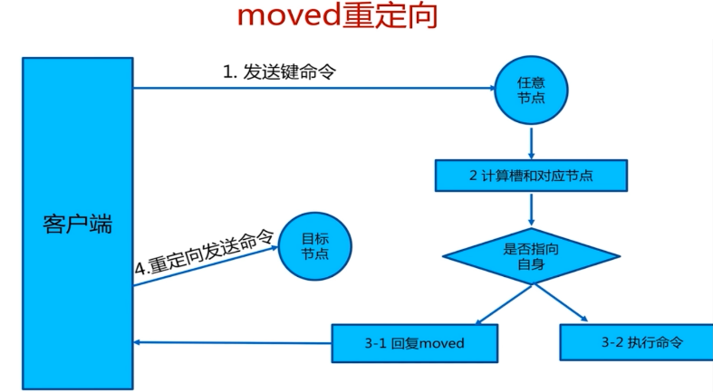

2）槽命中：直接返回

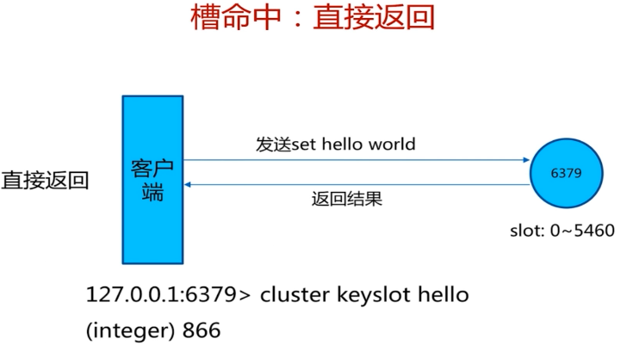

3）槽不命中：moved异常

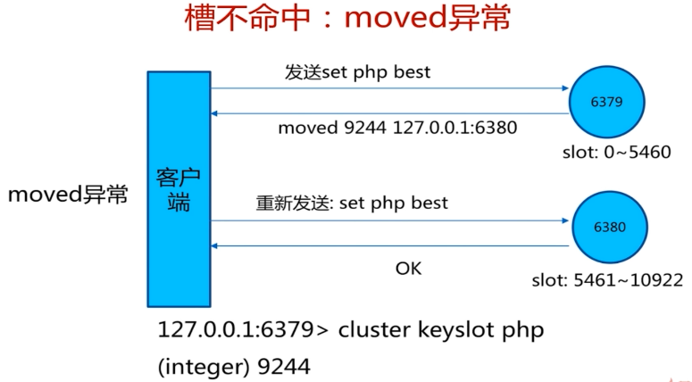

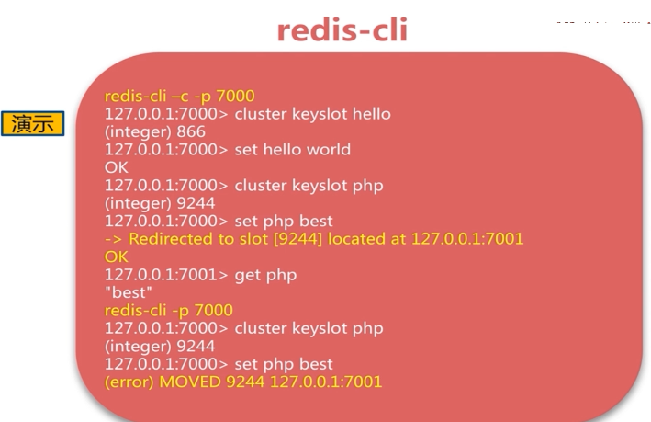

|  |
| --- |
| redis-cli -p 8000  127.0.0.1:8000> set hello world  OK  127.0.0.1:8000> cluster keyslot hello  (integer) 866  127.0.0.1:8000> cluster slots  127.0.0.1:8000> set php best  (error) MOVED 9244 192.168.0.111:8001  [centos@s200 /soft/redis-3.0.7/conf]$redis-cli -c -p 8000  127.0.0.1:8000> set php best  -> Redirected to slot [9244] located at 192.168.0.111:8001  OK  192.168.0.111:8001> get php  "best" |

#### 10.6.2ASK重定向

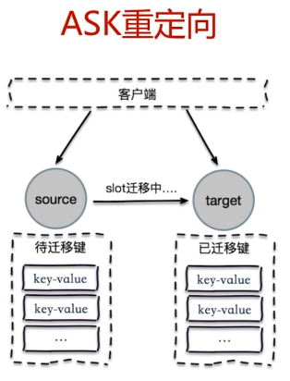

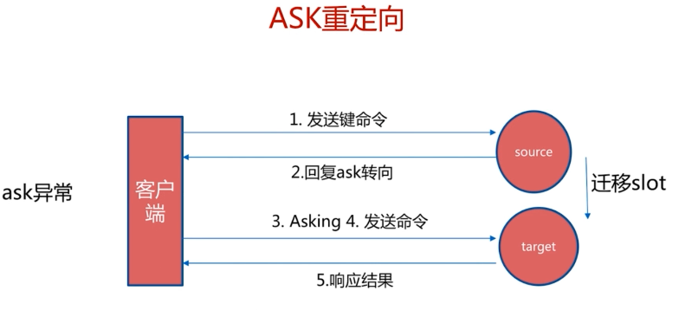





#### 10.6.3Smart客户端

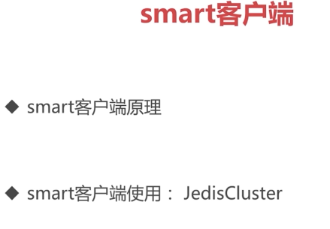

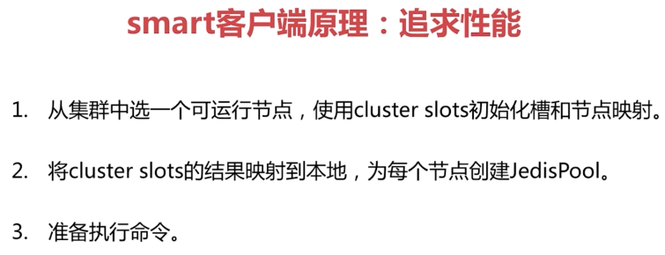

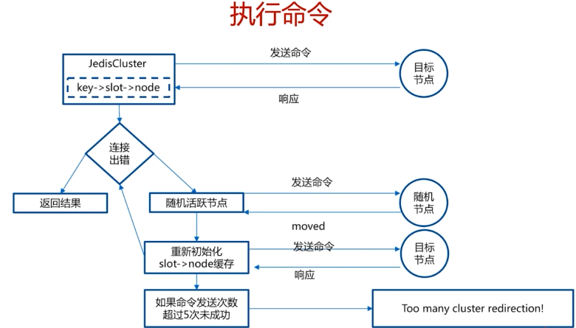



#### 10.6.4JedisCluster执行源码

### 10.7Smart客户端JedisCluster

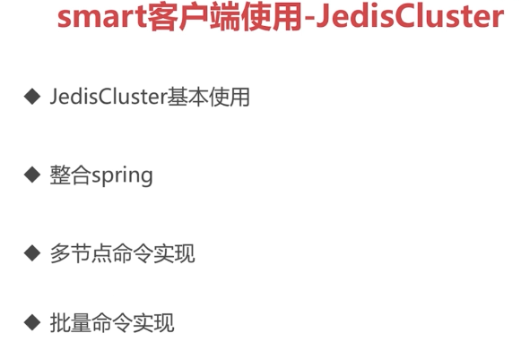

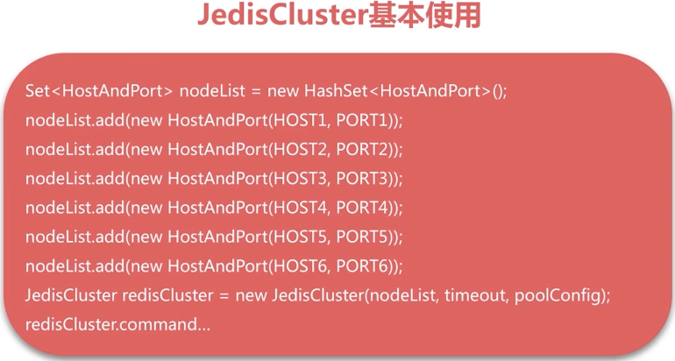



#### 10.7.1整合Spring

|  |
| --- |
| **public** **class** JedisClusterFactory {  **private** JedisCluster jedisCluster;  **private** List<String> hostPortList;  **private** **int** timeout;  **private** Logger logger = LoggerFactory.*getLogger*(JedisClusterFactory.**class**);  **public** **void** init() {  JedisPoolConfig jedisPoolConfig = **new** JedisPoolConfig();  Set<HostAndPort> nodeSet = **new** HashSet<HostAndPort>();  **for** (String hostPort : hostPortList) {  String[] arr = hostPort.split(":");  **if** (arr.length != 2) {  **continue**;  }  nodeSet.add(**new** HostAndPort(arr[0], Integer.*parseInt*(arr[1])));  }  **try** {  jedisCluster = **new** JedisCluster(nodeSet, timeout, jedisPoolConfig);  } **catch** (Exception e) {  logger.error(e.getMessage(), e);  }  }    **public** **void** destory() {  **if**(jedisCluster != **null**) {  **try** {  jedisCluster.close();  } **catch** (IOException e) {  logger.error(e.getMessage(), e);  }  }  }    **public** JedisCluster getJedisCluster() {  **return** jedisCluster;  }  **public** **void** setHostPortList(List<String> hostPortList) {  **this**.hostPortList = hostPortList;  }  **public** **void** setTimeout(**int** timeout) {  **this**.timeout = timeout;  }      } |

|  |
| --- |
| <bean id=*"jedisCLusterFactory"* class=*"com.byf.redis.JedisClusterFactory"*  init-method=*"init"* destroy-method=*"destory"*>  <property name=*"hostPortList"*>  <list>  <value>192.168.0.111:8000</value>  <value>192.168.0.111:8001</value>  <value>192.168.0.111:8002</value>  <value>192.168.0.111:8003</value>  <value>192.168.0.111:8004</value>  <value>192.168.0.111:8005</value>  </list>  </property>  <property name=*"timeout"* value=*"1000"*/>  </bean>    <bean id=*"jedisCluster"* factory-bean=*"jedisClusterFactory"*  factory-method=*"getJedisCluster"*></bean> |

### 10.8批量操作优化





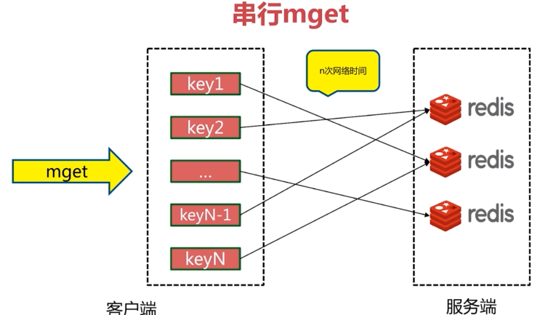

CRC 16383 取余

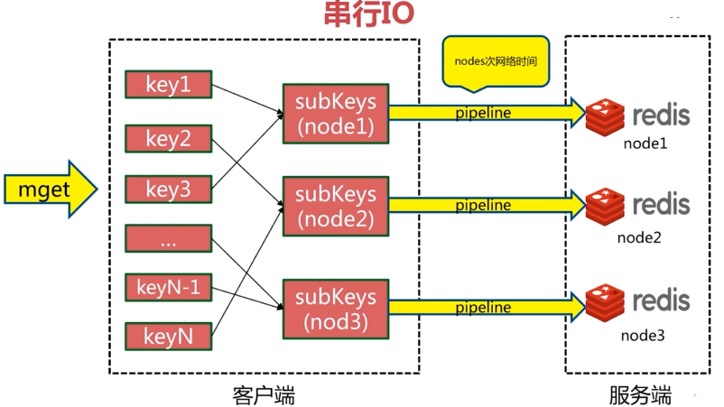

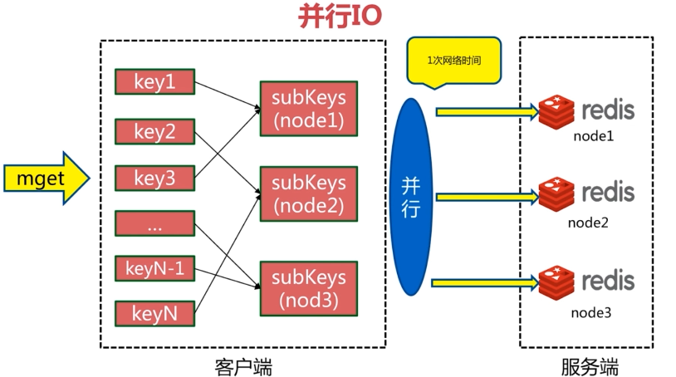

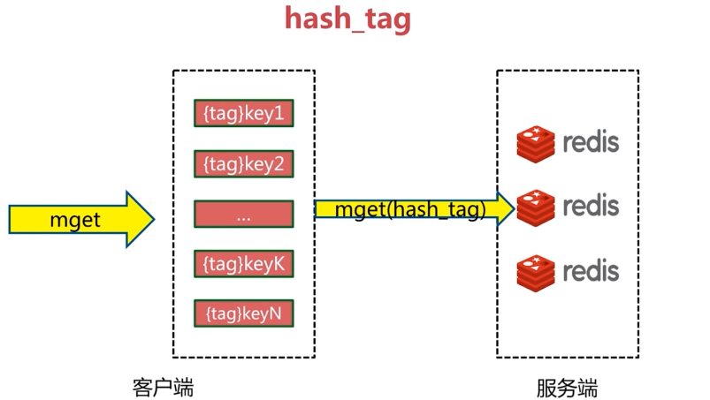

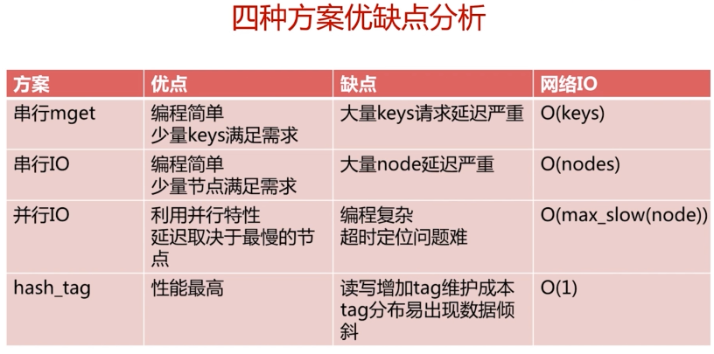

### 10.9RedisCluster故障转移



#### 10.9.1故障发现

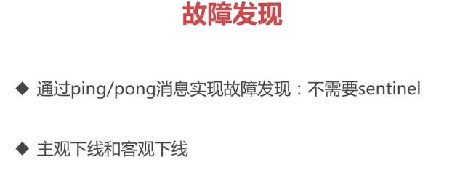

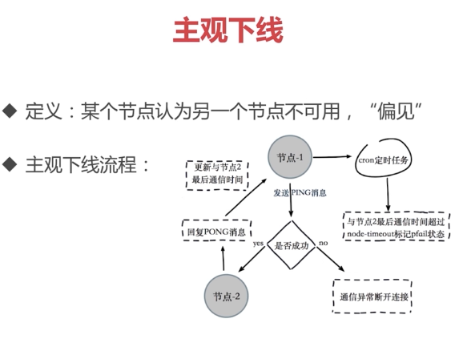

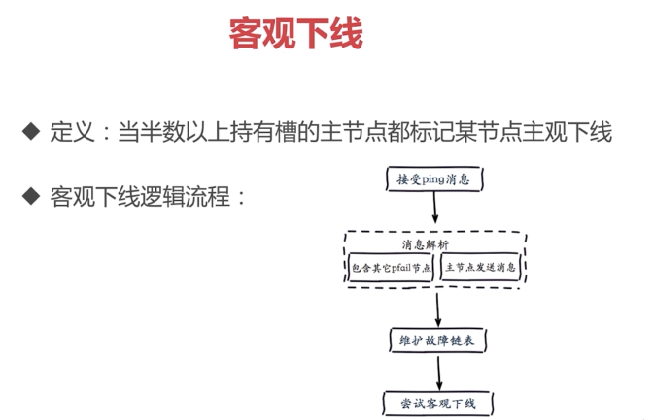

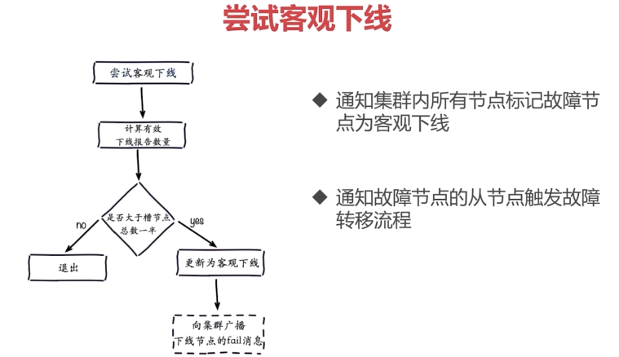

#### 10.9.2故障恢复



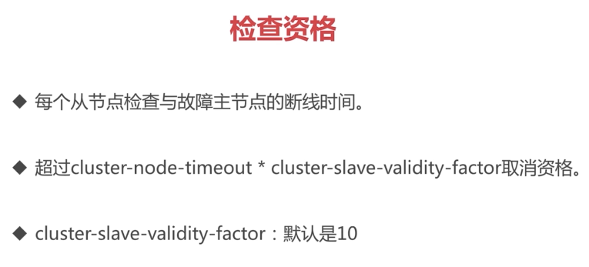

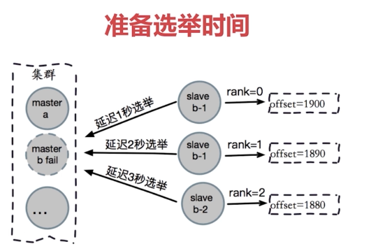

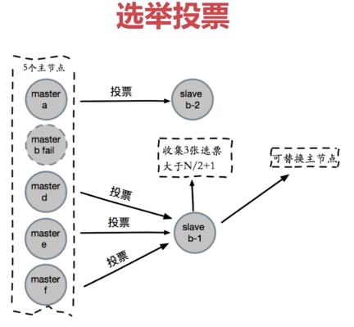

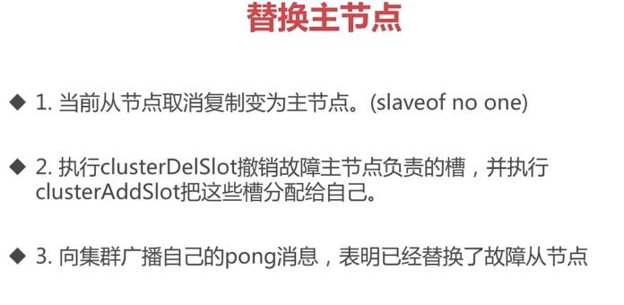

#### 10.9.3故障转移演练

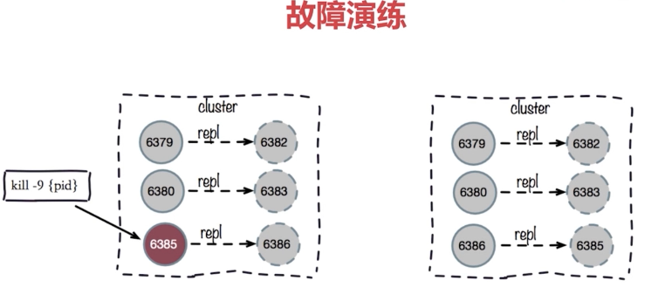



[centos@s200 /soft/redis-3.0.7/conf]$redis-trib.rb info 192.168.0.111:8000

192.168.0.111:8000 (ea8a80e6...) -> 1 keys | 5462 slots | 1 slaves.

192.168.0.111:8001 (2f9b9e09...) -> 1 keys | 5461 slots | 1 slaves.

192.168.0.111:8002 (86ed2a76...) -> 0 keys | 5461 slots | 1 slaves.

[OK] 2 keys in 3 masters.

0.00 keys per slot on average.

[centos@s200 /soft/redis-3.0.7/conf]$redis-cli -p 8000 info server | grep process_id

process_id:51450

[centos@s200 /soft/redis-3.0.7/conf]$kill -9 51450

### 10.10Redis Cluster开发运维常见问题

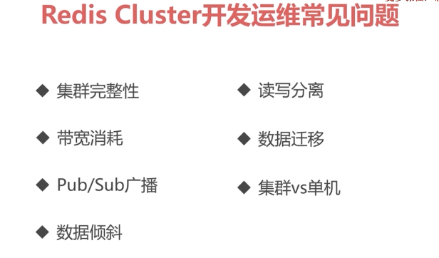

#### 10.10.1集群完整性

创建redis cluster集群【9000、9001、9002、9003、9004、9005】，关闭9000、9003主从节点同时关闭，测试集群完整性

|  |
| --- |
| 1008 cp redis-8000.conf redis-9000.conf  1009 vi redis-9000.conf  1010 ps -ef | grep -v grep | grep redis-server | grep 800 | awk '{print $2}' | xargs kill  1011 sed 's/9000/9001/g' redis-9000.conf > redis-9001.conf  1012 sed 's/9000/9002/g' redis-9000.conf > redis-9002.conf  1013 sed 's/9000/9003/g' redis-9000.conf > redis-9003.conf  1014 sed 's/9000/9004/g' redis-9000.conf > redis-9004.conf  1015 sed 's/9000/9005/g' redis-9000.conf > redis-9005.conf  1016 cat redis-9000.conf  port 9000  daemonize yes  pidfile /var/run/redis-9000.pid  logfile "9000.log"  dir "/soft/redis/data"  dbfilename "dump-9000.rdb"  cluster-enabled yes  cluster-config-file nodes-9000.conf  cluster-require-full-coverage yes  1017 redis-server redis-9000.conf  1018 redis-server redis-9001.conf  1019 redis-server redis-9002.conf  1020 redis-server redis-9003.conf  1021 redis-server redis-9004.conf  1022 redis-server redis-9005.conf  1023 ps -ef |grep -v grep | grep redis  1025 vi /etc/profile  1026 sudo vi /etc/profile  1027 source /etc/profile  1029 redis-trib.rb create --replicas 1 192.168.0.111:9000 192.168.0.111:9001 192.168.0.111:9002 192.168.0.111:9003 192.168.0.111:9004 192.168.0.111:9005  1030 redis-cli -p 9000 cluster info  1031 redis-cli -p 9000 shutdown  1032 redis-cli -p 9003 shutdown  1033 redis-cli -p 9002  127.0.0.1:9002> cluster info  cluster_state:ok  cluster_slots_assigned:16384  cluster_slots_ok:16384  cluster_slots_pfail:0  cluster_slots_fail:0  cluster_known_nodes:6  cluster_size:3  cluster_current_epoch:6  cluster_my_epoch:3  cluster_stats_messages_sent:421  cluster_stats_messages_received:183  127.0.0.1:9002> set hello world  (error) CLUSTERDOWN The cluster is down  127.0.0.1:9002> exit |

#### 10.10.2带宽消耗

Redis cluster定期交换Gossip消息，并进行心跳检测

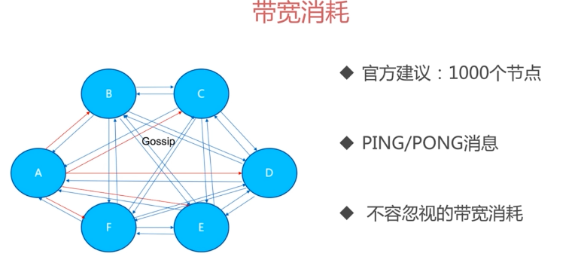

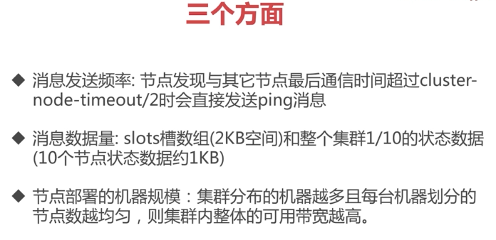

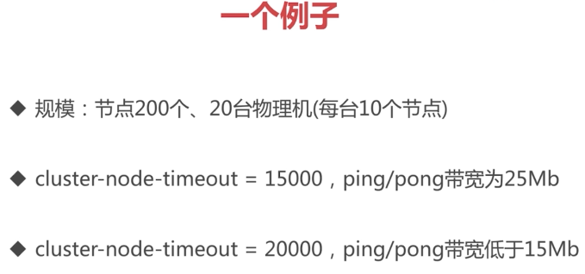

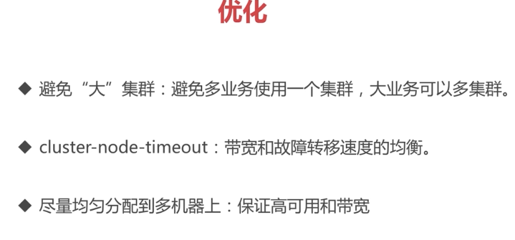

#### 10.10.3Pub/Sub广播

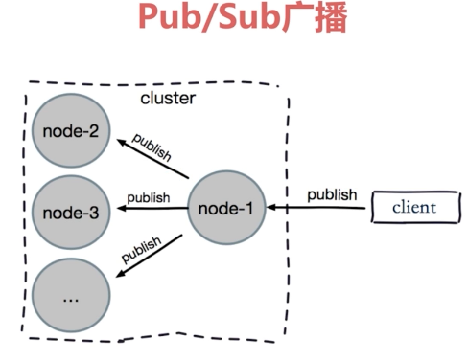



#### 10.10.4集群倾斜

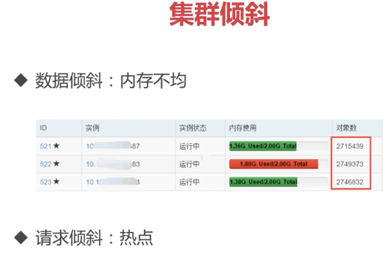

数据倾斜



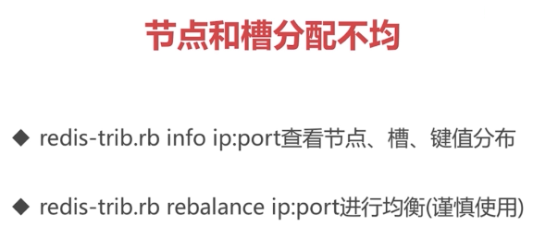

[centos@s200 /soft/redis/conf]$redis-trib.rb info 192.168.0.111:9002

192.168.0.111:9002 (0ec4a921...) -> 0 keys | 5461 slots | 1 slaves.

192.168.0.111:9001 (651b8d52...) -> 0 keys | 5462 slots | 1 slaves.

192.168.0.111:9000 (26b2ff84...) -> 0 keys | 5461 slots | 1 slaves.

[OK] 0 keys in 3 masters.

0.00 keys per slot on average.

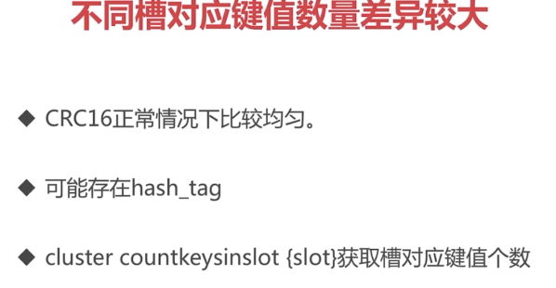

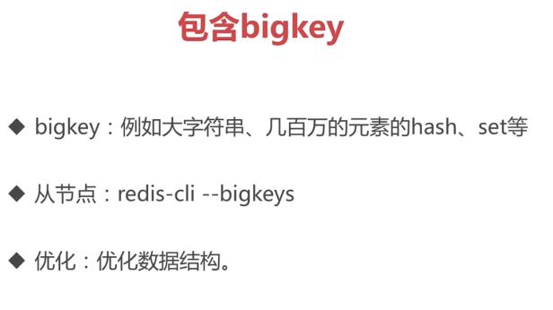

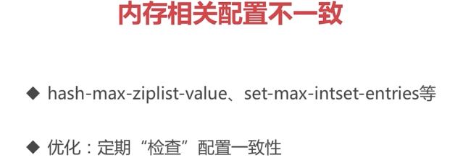

请求倾斜（热点Key）

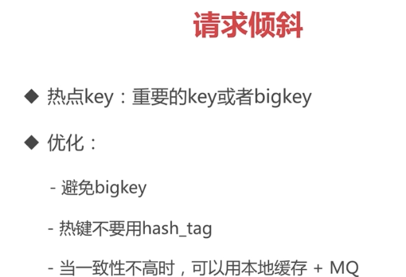

Hash_tag很多数据落到一点上

#### 10.10.5读写分离

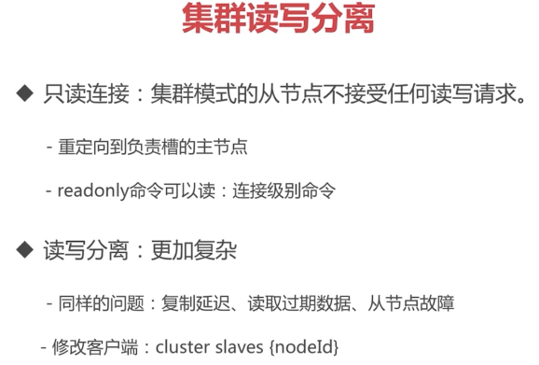

[centos@s200 /soft/redis/conf]$redis-cli -c -p 9000

127.0.0.1:9000> set hello world

OK

127.0.0.1:9000> exit

[centos@s200 /soft/redis/conf]$redis-cli -c -p 9003

127.0.0.1:9003> get hello

-> Redirected to slot [866] located at 192.168.0.111:9000

"world"

192.168.0.111:9000> exit

[centos@s200 /soft/redis/conf]$redis-cli -c -p 9003

127.0.0.1:9003> readonly

OK

127.0.0.1:9003> get hello

"world"

集群模式下不推荐使用读写分离

#### 10.10.6数据迁移

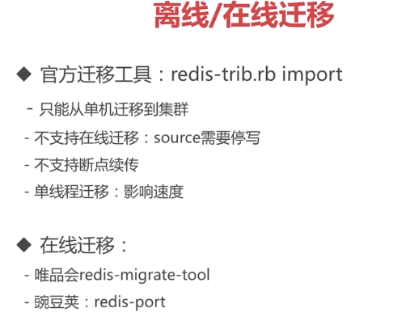

|  |
| --- |
| [centos@s200 /soft/redis/makedata]$cat create_date_shell.sh  #!/bin/bash  for ((i=0;i<100000;i++))  do  echo -en "helloworld" | redis-cli -p 9000 -x set name$i >>redis.log  Done  [centos@s200 /soft/redis/makedata]$cat create_date_python.py  #!/usr/bin/python  for i in range(100000):  print 'set name'+str(i),'helloworld'  #!/bin/bash    while read CMD; do  # each command begins with *{number arguments in command}\r\n  XS=($CMD); printf "*${#XS[@]}\r\n"  # for each argument, we append ${length}\r\n{argument}\r\n  for X in $CMD; do printf "\$${#X}\r\n$X\r\n"; done  done < redis_commands.txt  [centos@s200 /soft/redis/makedata]$head -2 redis_commands.txt  set name0 helloworld  set name1 helloworld  [centos@s200 /soft/redis/makedata]$head -7 redis_data.txt  *3  $3  set  $5  name0  $10  Helloworld |

#### 10.10.7集群vs单击

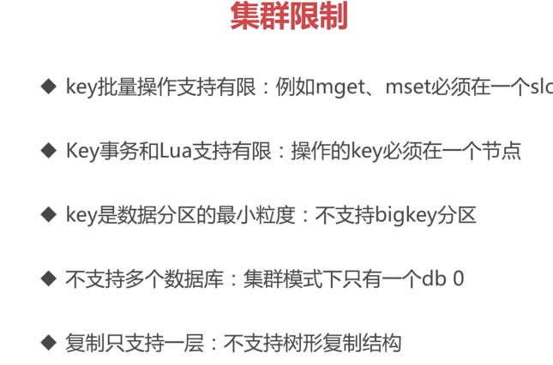

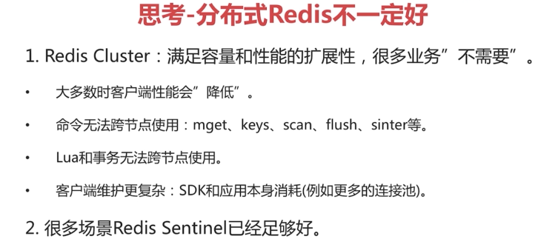

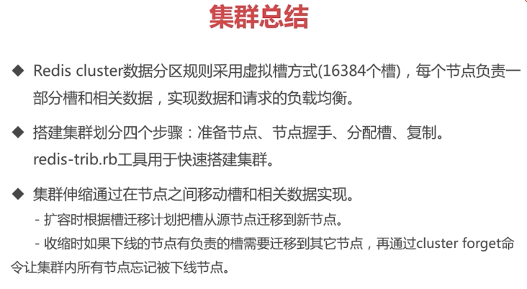

直连，每种语言需要客户端实现集群的映射



## 第11节缓存设计与优化



### 11.1缓存的受益和成本

·缓存的受益于成本

·受益

·成本

·使用场景

·受益

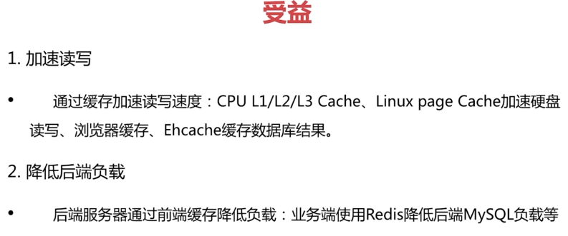

·成本



·使用场景

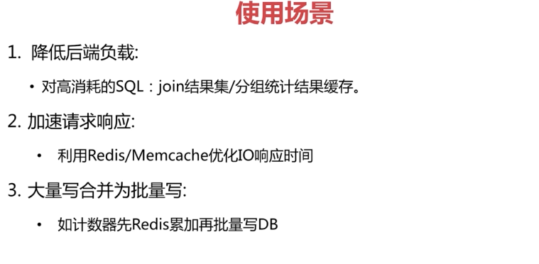

### 11.2缓存更新策略



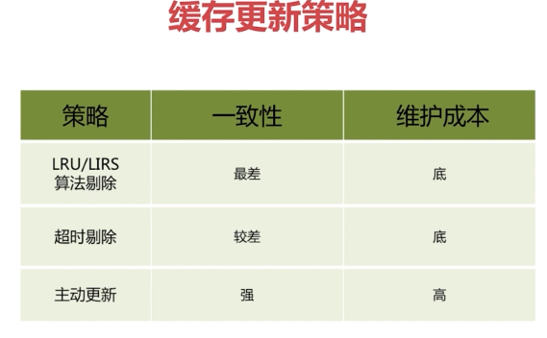



### 11.3缓存粒度控制

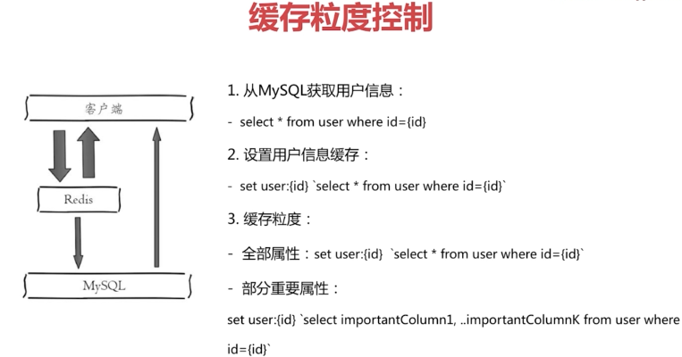



### 11.4缓存穿透问题

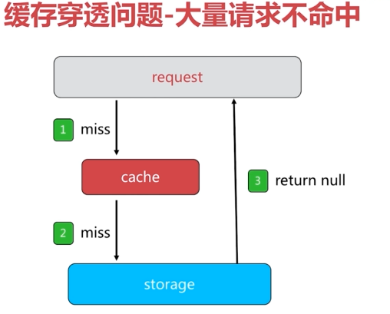

·原因

·业务代码自身问题

·恶意攻击、爬虫等



·如何发现

·业务的响应时间

·业务本身问题

·相关指标：总调用数、缓存层命中数、存储层命中数

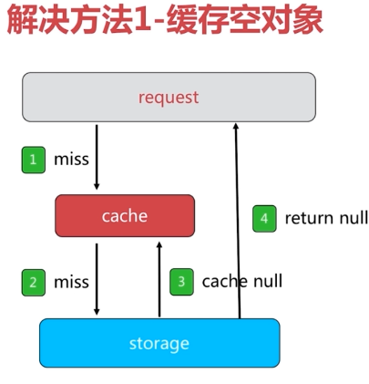

·两个问题

·需要更多的键

·缓存层和存储层“短期”不一致（有数据时，如何防止客户端请求空）

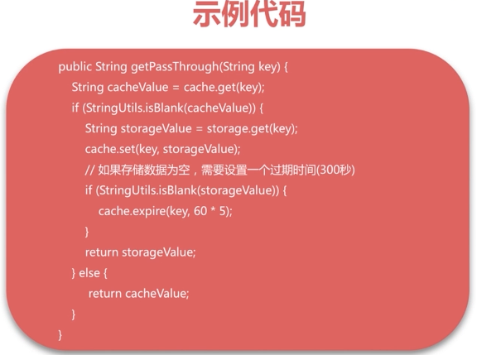

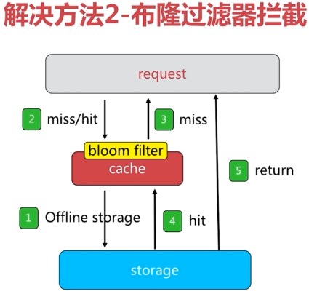

频繁更新的场景需要考虑布隆过滤器的设计

### 11.5无底洞问题优化



·无底洞问题关键点

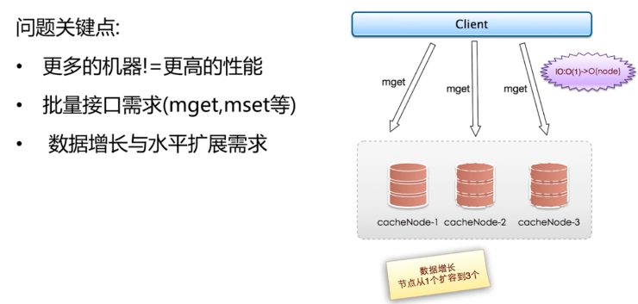



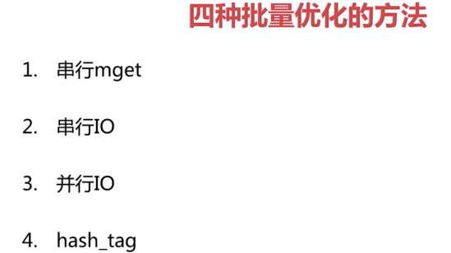

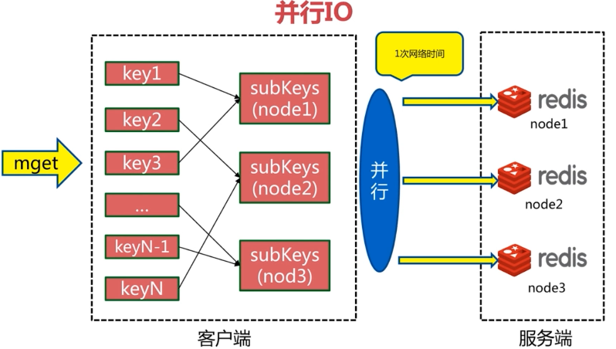

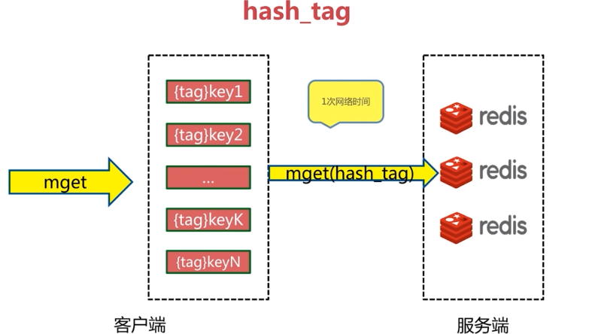

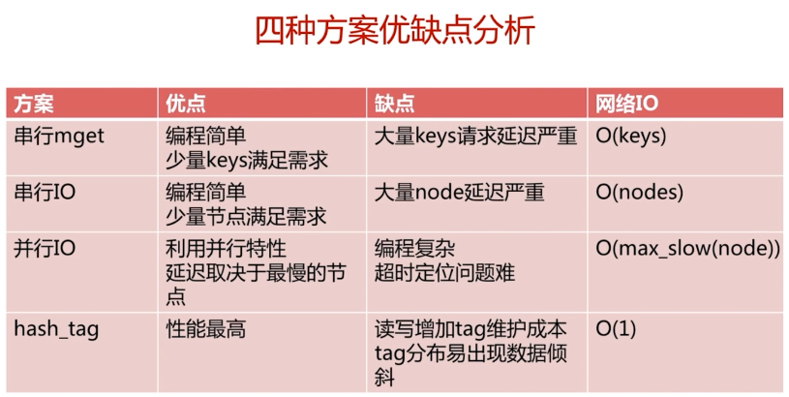

### 11.6热键key的重建优化

·微博大V重要消息

·很多线程（API、底层接口）参与重建

高并发的场景

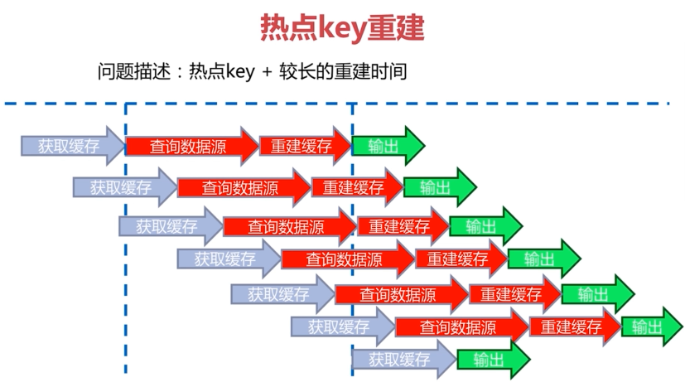

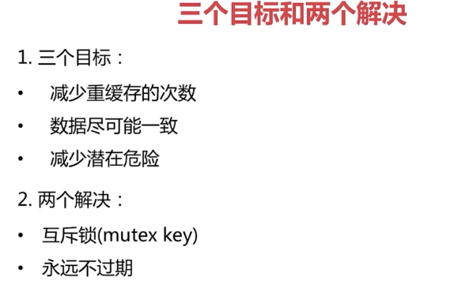

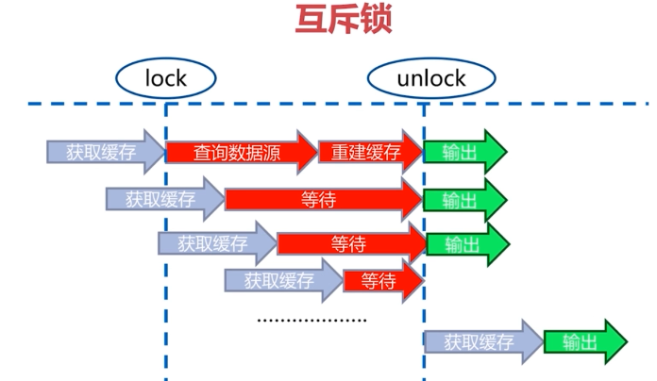

大量线程等待，线程池被夯住

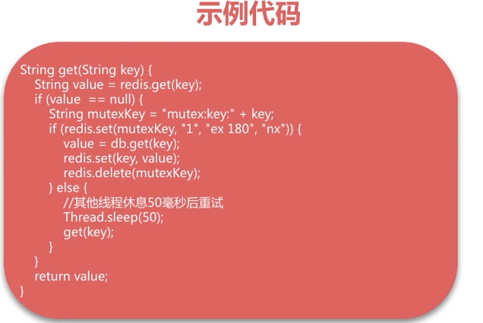



问题：会存在数据不一致的问题；

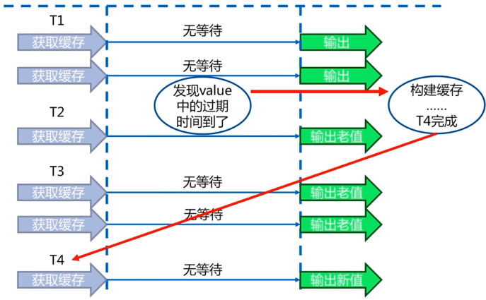

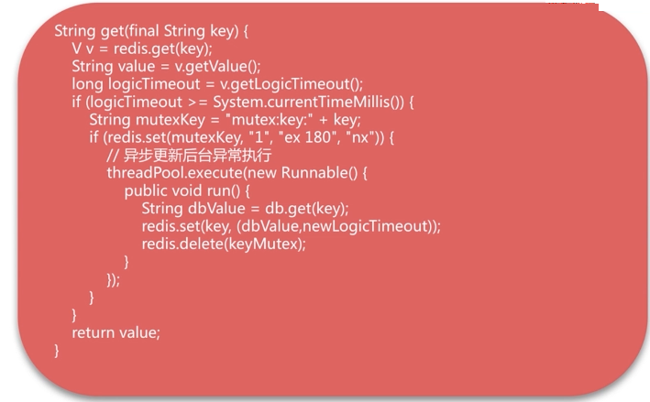

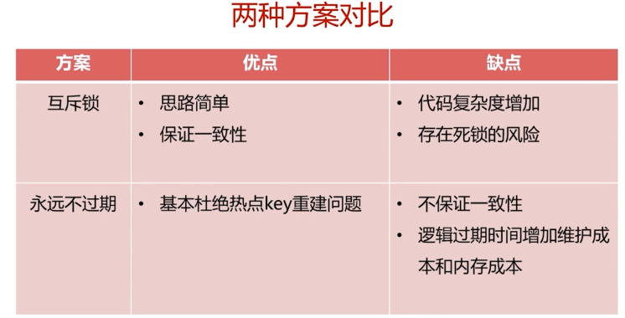



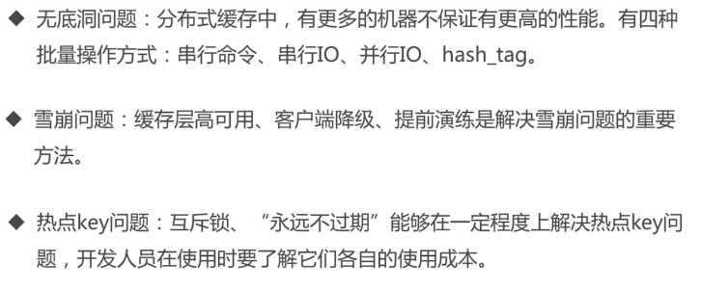

## 第12节Redis云平台CacheCloud

### 12.1Redis规模化困扰



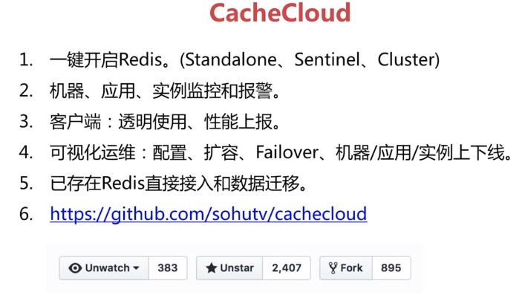

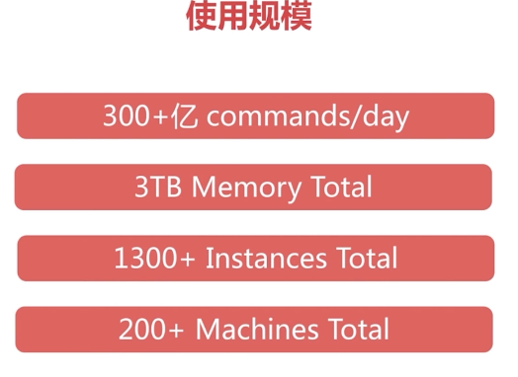

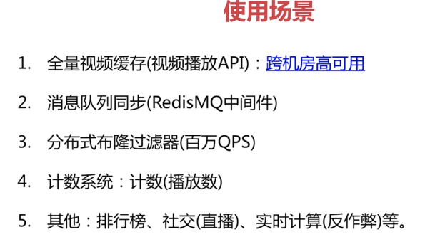

### 12.2快速构建CacheCloud

<https://github.com/sohutv/cachecloud/wiki/>

下载对应release版本的环境，例如[1.2](https://pan.baidu.com/s/1nvTv90l)，将其在/opt下解压，解压后文件目录如下

cachecloud-open-web-1.0-SNAPSHOT.war: cachecloud war包

cachecloud.sql: 数据库schema，默认数据名为cache_cloud，可以自行修改

jdbc.properties：jdbc数据库配置，自行配置

start.sh：启动脚本

stop.sh： 停止脚本

logs：存放日志的目录

登录确认

(1) 访问：<http://127.0.0.1:9999/manage/login> (9999是tomcat的端口号，具体要参考第三节中的online.properties和local.properties中的web.port)

(2) 如果访问正常，请使用用户名:admin、密码:admin访问系统，跳转到应用列表下：

添加机器

1. 运行脚本:

       cachecloud项目中的cachecloud-init.sh(目录：cachecloud-open-web\src\main\resources\script\cachecloud-init.sh)脚本是用来初始化服务器的cachecloud环境，主要工作如下：

(a). 创建cachecloud项目用户：因为cachecloud项目的部分功能(redis启动、服务器监控)是通过ssh完成的，所以这里的用户和密码要和项目中的相对应，具体详见第三节。

(b). 创建cachecloud项目的工作目录、数据目录、配置目录、日志目录、redis安装目录、临时目录等等。(/opt/cachecloud/data、/opt/cachecloud/conf、/opt/cachecloud/logs、/opt/cachecloud/redis、/tmp/cachecloud)



(c). 安装最新的release版本的Redis

2. 脚本执行

(a). 使用root登录目标服务器。

(b). 将cachecloud-init.sh脚本拷贝到目标服务器当前用户目录下。

(c). 执行 sh cachecloud-init.sh ${yourusername}

(d). 两次确认密码

(e). 一路安装直到成功。

请确保机器和用户名与cachecloud后台中系统配置一致，如下图所示

